HIGH POINT FURNITURE MARKET 2018
Design Center D729

COOL – Table
Design Giorgio Soressi

The lightness and transparency of Murano blown glass are the design features of the dining table Cool. The base is composed of a bundle of glass rods that creates a sculptural effect and combines poetry and aesthetic research. The light they emanate refers to an ideal of simplicity and beauty: it highlights the extraordinary skill of the Murano glass masters and conceals the steel core that gives solidity to the structure.
The top, rectangular in shape and with a profile of ample thickness, is available in 8 different wood essences and reveals Costantini's special attention to quality details. It comes in three standard sizes and can be customized up to 310 x 120 cm. Dimensions and variety of materials are designed to offer the ideal solution for every living environment.

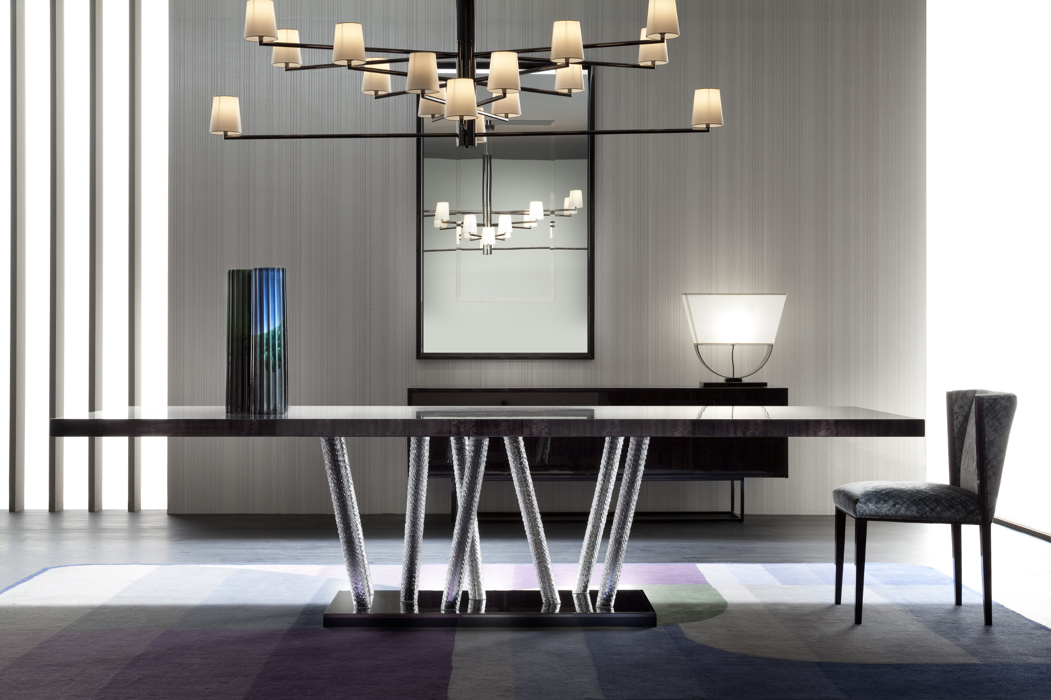

In the photo: COOL, top and base in Graphite high gloss and Black metal trim.

COSTANTINI PIETRO PRESS OFFICE
Adriana Cruciatti
acruciatti@caltpr.it
tel. 0039 335 6853775

