FOR IMMEDIATE RELEASE Media Contact: Tara Hackman
tara@gefenmarketing.com
336.884.5020

ALDEN PARKES GOES CLEAN AND SERENE WITH OCTOBER 2018 HIGH POINT MARKET INTRODUCTIONS
Silvery Metallics, Cool Painted Finishes, and Understated Details Capture Today’s Quiet Mood

Jacksonville, Florida (September 27, 2018)—Alden Parkes, a high-end furniture maker known for interpreting trends with a twist, offers its take on elegant simplicity this market with new pieces for the bedroom, dining room, and home office.

“Our customer travels, is interested in art, design, architecture, and fashion,” said Lynne McArdle, President of the Jacksonville, Florida-based company. “They want their home to be a retreat but also want to draw on their many experiences. Our new pieces translate that dual desire by combining a cool-toned palette with subtle artisanal details.”

Crisp, clean white takes center stage at Alden Parkes this market with a number of the new pieces in Glacial, a bright white painted finish. Among the stand-outs in white are the Fortuna Nightstand, an angular two drawer side table with the surprise of a raised veneer overlay across the front; the Mid-Century-inspired Williams Sideboard with a fretwork overlay across its two center door fronts (the sideboard is available in an all-white Glacial finish with brushed brass hardware, or a combination of white and walnut with brushed stainless steel hardware); the Glacial white Triangle Sideboard with a hand painted geometric pattern in gold leaf with black accents (the sideboard is also available in black with gold and silver leaf); Savannah Dresser and Savannah Nightstand come in two finishes, Glacial with shagreen drawer fronts and Greystone on Oak veneer, both accented with brushed stainless hardware, beautifully simple and highly functional, offering abundant storage; and the casual Clearwater Dining Table, a round table on a conical base, available in Glacial or in a walnut veneer on a burnished brass base.

Continuing the light and airy mood, Alden Parkes is also introducing several pieces that incorporate glass in fresh and interesting ways. True to its name, the Seaglass Console marries a top of aqua glass set in a carved frame with slender legs finished in silver leaf; the Galaxy Dresser has six painted glass drawer fronts framed in burnished brass leaf; and two new mirrors—the elaborate segmented Victoria Mirror, framed in white, and the Clifton Floor Mirror, a single panel of mirror glass held in place with eight clips, finished in either gold leaf or silver leaf.

Rounding out the new introductions are two stand-alone pieces that showcase Alden Parkes' expertise with wood and metal—the Etna Bar Table, a useful tall pedestal table in kona wood accented with hammered metal, and the Suffolk Work Station, with four drawers and shelves in a driftwood finish with a stainless-steel top.

###

About Alden Parkes:
Alden Parkes is a high-end furniture manufacturer based in Jacksonville, FL owned by entrepreneurial veterans Lynne and Khrys McArdle. Alden Parkes offers an extensive line of home furnishings: upholstery, chairs, occasional tables, dining, cabinetry, bedrooms, and mirrors. Their commitment to quality begins with materials. Premium woods, from solid mahogany to weathered driftwood acacia, are masterfully carved by hand and paired with solid brass hardware. Finishes range from deep brilliant sheens to subdued, casual distressed applications.

Alden Parkes Product Information
Sharefile link: https://gefenmarketing.sharefile.com/d-s6dfb816a19040f1a

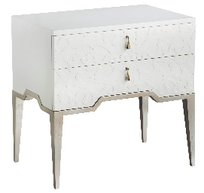
Fortuna Nightstand

Product Description: This graceful piece was inspired by the Fortuna Sideboard. The French overlay design on the front adds subtle dimension, while the stepped-up front makes the lightly brushed stainless steel base pop.

Finish Available: Glacial with Silver Leaf

Williams Sideboard

Product Description: The Williams Sideboard embodies understated elegance, with its clean, simple lines and fretwork overlay on the two center doors which add dimension to the front of this sideboard. There are two adjustable shelves behind each door to provide plenty of storage.

Finish Available: Glacial with Brushed Brass, Glacial, Walnut with Brushed Stainless Steel

Triangle Sideboard

Product Description: Triangle sideboard is a work of art. Its hand painted door fronts were inspired by a geometric fabric design. Two shelves behind each door offer ample storage in the piece.

Finish Available: Glacial with Gold Leaf and Black or Black with Gold Leaf and Silver Leaf

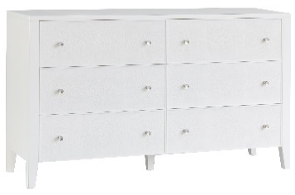
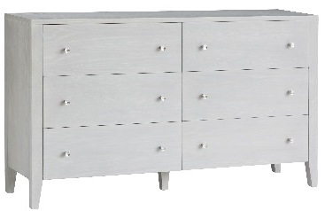

Savannah Dresser

Product Description: Simplicity defines the Savannah dresser with its six generously sized deep drawers for plenty of storage space.

Finish Available: Limestone Ceruse with lightly brushed Stainless Steel or Glacial with Faux Shagreen and lightly brushed Stainless Steel

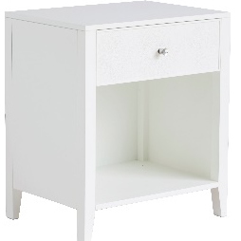
Savannah Nightstand

Product Description: Simplicity defines the Savannah nightstand which has an open space for display and one drawer.

Finish Available: Limestone Ceruse with lightly brushed Stainless Steel or Glacial with Faux Shagreen and lightly brushed Stainless Steel

Clearwater Dining Table

Product Description: The Clearwater Dining Table has a cone shaped base and strong round top. Perfect for any casual dining setting.

Finish Available: Glacial or Walnut veneer with a dark Truffle finish with a burnished brass base

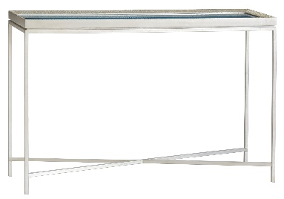
Seaglass Console

Product Description: This delicate console looks like it just rolled up onto the shore with its scallop carved edge, glistening silver finish and aged sea glass colored top.

Finish Available: Silver Leaf with Aqua blue glass

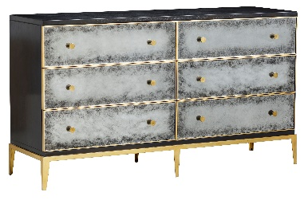
Galaxy Dresser

Product Description: The Galaxy dresser was inspired by the Galaxy nightstand with its celestial pattern hand painted on glass drawer fronts. The glass design is highlighted by gold leaf trim and brass knobs. This modestly size dresser has six drawers for plenty of storage.

Finish Available: Charcoal, with painted glass drawer fronts framed in burnished brass leaf and sitting atop a steel base with a burnished brass leaf finish

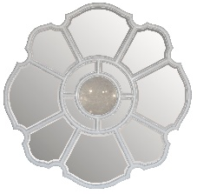
Victoria Mirror

Product Description: Elegant, yet simple design with round center mirror, convex in shape bordered by two additional round mirror panels surrounding the center mirror. Made of hand-carved mahogany.

Clifton Floor Mirror

Product Description: A single panel of mirror glass held in place with eight clips, finished in either gold leaf or silver leaf.

Finish Available: Silver or gold leaf

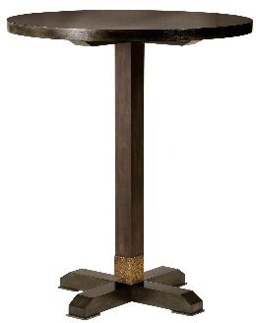
Etna Bar Table

Product Description: Desirable and functional this 36” round bar table is finished in a kona wood finish with a hammered metal collar with a brass finish at the pedestal base. Pair it with several kona barstool options in the Alden Parkes line.

Finish Available: Kona with a hammered metal collar in an aged brass finish

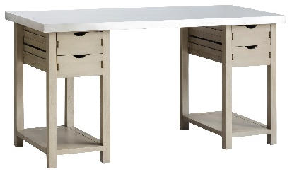
Suffolk Work Table

Product Description: The functional, straight lines of the Suffolk Workstation are made of heavily distressed aged wood in a driftwood finish with a finely brushed high grade (304), rustproof, stainless steel top surface. Counter height with plenty of storage and work space, the workstation is ideal for the kitchen, office or design studio.

Finish Available: Driftwood with a finely brushed stainless-steel top

