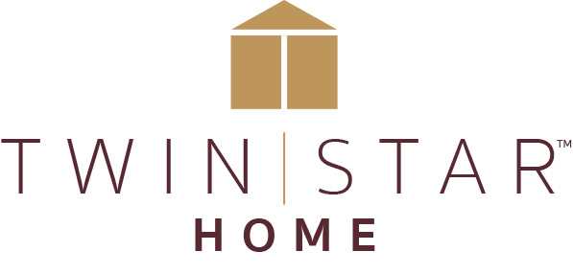

FOR IMMEDIATE RELEASE Media Contact: Ellen Gefen or Tara Hackman
ellen@gefenmarketing.com or tara@gefenmarketing.com
336.884.5020

TWIN STAR HOME CONTINUES REBRAND LAUNCH AT 2018 SPRING HIGH POINT MARKET
Showroom displays show retailers creative ways to incorporate electric fireplaces and other innovative products into their retail environments

Delray Beach, Fla. (April 13, 2018) - The leader in electric fireplaces is returning to the High Point Market with a new name, new furniture collections, and a redesigned showroom. The former Twin-Star International has been relaunched as Twin Star Home to reflect its expanded merchandising strategies and new comprehensive lifestyle collections. The redesigned showroom features strategically accessorized vignettes in on-trend colorways.

Twin Star Home teamed up with award-winning designer and creative strategist Jena Hall to come up with a consumer-driven program that takes full advantage of Twin Star Home’s unique expertise. The company then turned to Connie Post to interpret Twin Star Home’s vision in eye-catching showroom displays designed to give retailers achievable ideas for their own stores.

“We’re very excited to build upon the legacy and leadership we have built around our core electric fire products to create home furnishings that combine beauty, innovation, and function for the way consumers live now,” said Lori Gonzalez, Twin Star Home CEO. “We are fortunate to have partnerships with two furniture industry icons like Jena and Connie as we grow.” Jena Hall, an inductee in the American Home Furnishings Hall of Fame, has been involved in over 40,000 individual successful home furnishings products and lifestyle programs. Connie Post is an award-winning retail design strategist and author whose design philosophy emphasizes affordability and return-on-investment.

Introductions showcased in the redesigned Twin Star Home showroom include the City Dweller™ collection, a follow-up to the popular Modern Dweller™ collection, both inspired by 1960s design and scaled for compact urban spaces. In addition, the company is introducing several mini collections that complement some of Twin Star Home’s most popular fireplaces. Mini collections include the Carrara Collection™, the Wright Collection™ and The Hamilton™ Collection.

Twin Star Home’s remodeled High Point showroom is located in Market on Green, #602.

###

About Twin Star:
Twin Star Home of Delray Beach, FL is an award-winning manufacturer of home furnishings, including electric fireplaces and furniture, many with integrated media solutions. Twin Star Home combines the latest trends with consumer-driven innovation and design-rich style to create lasting products that enhance consumers’ lives. Twin Star Home is recognized for its trusted national brands: ClassicFlame®, Duraflame, Bell’O, Tresanti and ChimneyFree. Find out more at www.twinstarhome.com.

