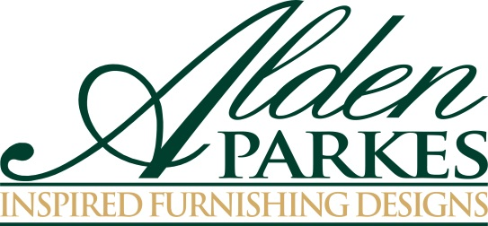
FOR IMMEDIATE RELEASE Contact: Nicole Howley
Gefen Marketing
336.884.5020
Nicole@gefenmarketing.com

ALDEN PARKES UNVEILS NEW SHOWROOM AT SPRING HIGH POINT MARKET
Alden Parkes to Debut New Showroom, Designs and Host Thought-Provoking Seminar at 200 N. Hamilton Street, Suite 110
Jacksonville, FL – High-end furniture manufacturer Alden Parkes is relocating their showroom for the April 2016 High Point Market, taking place on April 16-20, 2016. Alden Parkes will be showcasing their new introductions and hosting a panel discussion with the industry’s most influential interior designers in their new space, located at N. Hamilton Street, Suite 110.
To commemorate Alden Parkes’ new showroom, International Market Centers (IMC) will host a ribbon cutting ceremony on Saturday, April 16th at 9:00 a.m.
“We are excited about our new showroom and everything Alden Parkes has to offer High Point Market attendees this spring,” said Lynne McArdle, President and owner of Alden Parkes. “From an extensive introduction of accent chairs, occasionals and casegoods, as well as our panel discussion, Alden Parkes will be a destination place at the High Point Market.”
On Monday, April 18th at 2:00 p.m., Alden Parkes will be hosting a panel discussion led by interior designers Kati Curtis, Shay Geyer, Kerrie Kelly, and Paula Grace, moderated by Kristin Drohan. The seminar, called “Mix Masters: Balancing Successful Design Strategies,” will discuss balancing design strategies and how designers move beyond their comfort zones to create statement-making spaces by balancing high end and lower cost pieces, incorporating sustainable design, and using American-made with import products to manage and satisfy client demands. Coffee and desserts will be served.
Lunch is served daily in the Alden Parkes showroom, which includes a salad and juice bar. Lunch is served from 11:30 a.m. to 1:00 p.m. daily.
###

About Alden Parkes:
Alden Parkes is a high-end furniture manufacturer based in Jacksonville, FL owned by entrepreneurial veterans Lynne and Khrys McArdle. Alden Parkes offers an extensive line of home furnishings: upholstery, occasional tables, dining, cabinetry, mirrors, and accessories. Made from meticulously chosen premium materials, hand carved wood, and USA-manufactured upholstery, Alden Parkes designs are notable for their artisanal attention to detail. Whether its case goods, upholstery or occasional furniture paired with formal traditional or classic modern designs, Alden Parkes has mastered the art of fine living.

Media Note: To schedule a tour of the Alden Parkes showroom or to receive images and information on their products, please contact Nicole Howley at Nicole@gefenmarketing.com or at 336.884.5020.

