For immediate release

Castelle and Barclay Butera Outdoor Collaboration Expands With 2019 Introduction
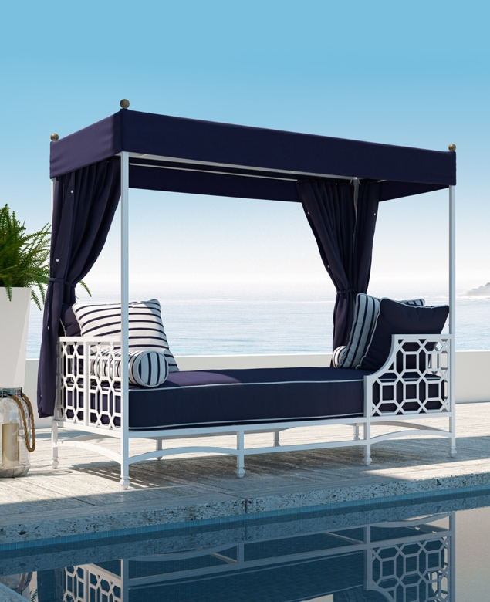
Ft. Lauderdale, Fla.- – The successful collaboration of celebrity designer, Barclay Butera and custom cast aluminum manufacturer Castelle will grow with the launch of all new additions to his Signature collection from the designer. The Barclay Butera Outdoor Collection for Castelle will expand to include a show stopping day bed with canopy as well as a double chaise lounge.

The collaboration with Butera, which is in its second year, has produced one of the best-selling introductory collections in the history of Castelle. With the tremendous response from retailers, designers and consumers, the anticipation for the new collection is high.

Due to its extreme popularity, the Signature Collection, which was introduced in 2017, will have the assortment expanded with luxury lounging and entertainment pieces including bar stools, a double chaise lounge with custom shade and an impressive daybed also with a shade component.

“On the heels of the tremendous success of the recent Butera introductions, we are excited to once again present Barclay’s creative vision in outdoor furnishings,” said Mark Stephens, president, Castelle. “The pieces speak to Barclay’s strength as a designer and his ability to view potential needs within the outdoor marketplace without compromising on his design sensibilities. With Castelle’s custom capabilities, we are able to execute Barclay’s original design concepts and incorporate the luxury vision for which both of our brands are known.”

The collection will be available to consumers beginning in the spring of 2019. For more information about Castelle and luxury casual furniture, visit www.castelleluxury.com.
# # #

High Resolution images available. Contact: lrudd@pridefamilybrands.com ; Pictured: Barclay Butera for Castelle Signature Collection Daybed with Canopy;

About CASTELLE®.
For over 40 years, CASTELLE has distinguished itself in the manufacturing of award-winning luxury casual furniture. Innovation, state of the art manufacturing, and superior quality products are the trademark of CASTELLE and the reason CASTELLE is recognized as a leader in the casual furniture industry. CASTELLE has been the recipient of multiple Manufacturing Leadership awards for the Cast Aluminum category.

