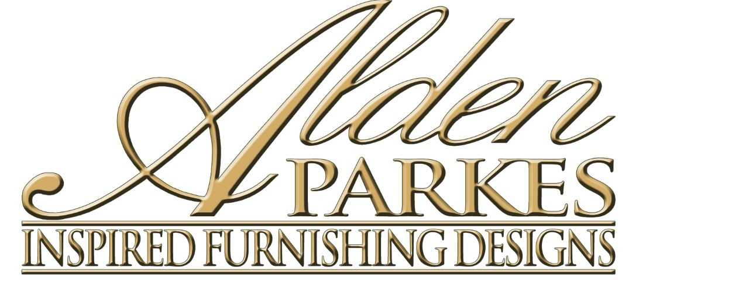

FOR IMMEDIATE RELEASE Media Contact: Calla Starr
calla@gefenmarketing.com
336.884.5020

ALDEN PARKES DOES THE MATH WITH APRIL 2019 HIGH POINT MARKET INTRODUCTIONS
Defined Corners, Straight Lines, and Geometric Shapes Dominate

Jacksonville, Florida (March 26, 2019) - Alden Parkes plays all the angles at the April 2019 High Point Market with contemporary and traditional pieces that put geometric shapes front and center. A high-end furniture maker known for its imaginative use of materials and finishes, Alden Parkes explores strong lines, bold shapes, and minimal ornamentation this market.
“As life becomes more filled with distractions many of us long for simplicity at home,” said Lynne McArdle, President of the Jacksonville, Florida-based company. “But simple doesn’t mean austere. Our customers come to us for designs that will help them pare down without sacrificing the beauty of fine materials and detailed craftsmanship.”
The striking Radial Bar Cabinet features a bold circle of hand-hammered brass overlaid on the two front doors. The simple Asian-inspired wooden case is finished in rich Truffle and inset with a black glass top for mixing and serving. The doors swing open to reveal storage for hanging glasses, wine bottles, and liquor bottles, black glass shelves, and a drawer for bar supplies. For traditionalists the handsome Sheraton Sideboard celebrates symmetry and precision. Inspired by the airy neo-classical Sheraton designs of the late 18th century, the beautifully proportioned four-door breakfront sideboard is veneered in swirl mahogany and inlaid with lighter veneer borders and includes both cabinet and drawer storage.
Several of Alden Parkes’s market’s introductions play with the multi-sided polygonal shapes that are making waves in everything from fashion to architecture. True to their name, the Hexter Accent Table and End Table have inset hexagonal tops supported on metal frames. The tables come in three options: a lightly hammered brass frame with an antique brown top; a textured steel frame with a top pieced of six wedges of radial cut sawn oak veneer in a rich charcoal stain; and an iron frame with a faux shagreen top in pale ash. The beautifully crafted Joinery End Table and Cocktail Table have octagonal tops in oak veneer with a pale painted finish; the top of the end table includes a removable tray. The new Trey Table, a useful and versatile occasional table, gives a subtle nod to the octagon as well, with elongated octagonal designs at the joints of the black iron base. The top of the table is in oak veneer finished in Newton.
The rectangle never goes out of style: the handsome Sawyer Sideboard pairs a simple case in a rich Charcoal finish with four doors in pale Newton, adorned only with slender stainless-steel door pulls wrapped in Newton-toned veneer. The coordinating Console is supported on four Parson’s table-style square legs and the top is veneered in sawn oak; the Dining Table comes with a 24” wide self-storing leaf and can be extended to seat up to ten people comfortably. The dining table and console are available in Newton or Charcoal.
And for those who are still intrigued with curves, there is the new Vero collection of Bar Cabinet, Desk, Nightstand, Dresser, and Vanity Mirror with softened corners, a rosy brown finish, and custom stainless-steel drawer pulls inspired by a woman’s necklace.

###

About Alden Parkes:
Alden Parkes is a mid to high-end furniture manufacturer based in Jacksonville, FL owned by entrepreneurial veterans Lynne and Khrys McArdle. Alden Parkes offers an extensive line of home furnishings: upholstery, chairs, occasional tables, dining, cabinetry, bedrooms, and mirrors. Their commitment to quality begins with materials. Premium woods, from solid mahogany to weathered driftwood acacia, are masterfully carved by hand and paired with solid brass hardware. Finishes range from deep brilliant sheens to subdued, casual distressed applications.

Sharefile Link to New Product Images: https://gefenmarketing.sharefile.com/d-s4c41388b982412eb

