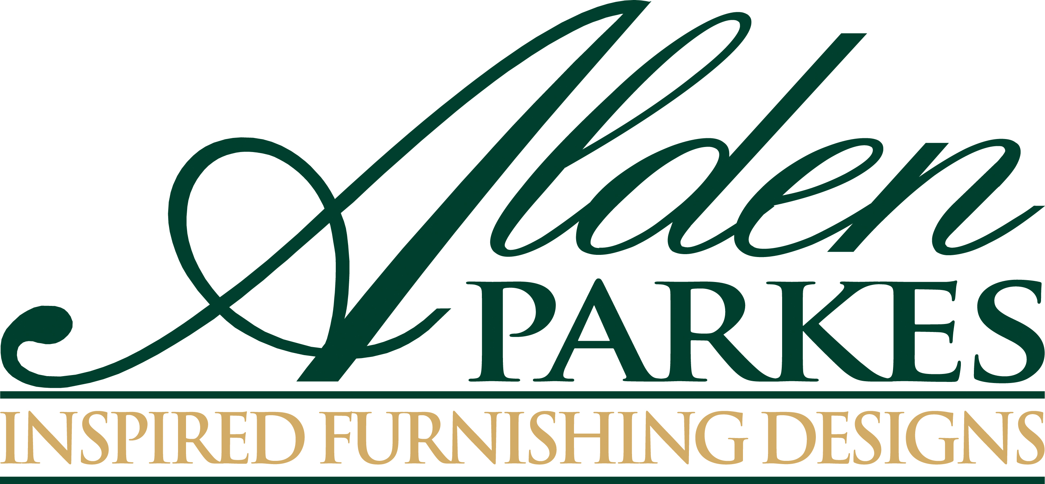

FOR IMMEDIATE RELEASE
Contact: Nicole Howley
Gefen Marketing
336.884.5020
Nicole@gefenmarketing.com

SPRING 2016 HOME FURNISHINGS TREND REPORT
Alden Parkes shares the leading trends for 2016

Jacksonville, FL (April 16, 2016)—The High Point Market Spring 2016 is all about evolution, not revolution: the next big thing is the next better thing. Expect to see beautiful detailing and deft refinements on styles with proven staying power in Alden Parkes’ new introductions at the spring 2016 High Point Market.

Mid-Century for the 21st Century: The glamorous style moderne of the mid-twentieth century has been updated with warm wood tones and brass accents for today’s more relaxed living. Alden Parkes has expanded its mid-century Monaco collection to include a nightstand, a sliding door cabinet, king and queen bed frames as well as a dining armchair, side chair, bar chair and lounge chair that reflect this interpretation.

Distressed for Success: Look for complex finishes that show the artistry of hand application to mimic the wear of age. Among the best this season is the subtle distressed detail of nickel-plated brass nail heads on the new Lyons king and queen headboards, complementing frames of acacia in a driftwood finish.

Paint: Look for furniture that was designed for a painted finish—simple lines that show off the color, plus artful details that give the piece depth and elegance. Case in point – the Elliott collection embellished with dentil molding and subtle fluting. This market the Elliott collection has been expanded to include a breakfront buffet, a two-door cabinet, dining table, dining arm and side chairs, and an accent table with a pull-out tray.

Happy Reflections: Nothing wakes or livens up a room like a beautiful mirror—the bigger and more embellished the better. Among the best this season from Alden Parkes are the new beveled Harmonie mirror framed in brilliant leaf, and the ornate Kuru mirror in a hand-carved solid mahogany frame with a warm fruitwood finish.

Unexpected Leather: Tanned and treated leather—both faux and genuine—is nothing new in furniture design, but the freshest trend shakes up our expectations with less-familiar leathers and leather finishes. The new Naples cocktail table from Alden Parkes,
for instance, features shagreen accents on brass legs; also from Alden Parkes, the Lesley mirror and the Canton cabinet, both finished in vellum.

Exotic Veneers: Every wood has its own signature, often expressed most beautifully through artfully matched and applied veneers. The new Ducayne dresser, buffet, round dining table and nightstand are all veneered in figurative cerejeira from Brazil and Argentina. Also in cerejeira, the new Ascott occasional pieces—accent table, three-tier table, cocktail table, console, end table, and étagère—in solid brass with veneered accents.

###

About Alden Parkes:
Alden Parkes is a high-end furniture manufacturer based in Jacksonville, FL owned by entrepreneurial veterans Lynne and Khrys McArdle. Alden Parkes offers an extensive line of home furnishings: upholstery, occasional tables, dining, cabinetry, mirrors, and accessories. Made from meticulously chosen premium materials, hand carved wood, and USA-manufactured upholstery, Alden Parkes designs are notable for their artisanal attention to detail. Whether its case goods, upholstery or occasional furniture paired with formal traditional or classic modern designs, Alden Parkes has mastered the art of fine living.

Media Note: To schedule a tour of the Alden Parkes showroom, please contact Nicole Howley at Nicole@gefenmarketing.com or at 336.884.5020.

