FOR IMMEDIATE RELEASE

The Rug Market Kids Debuts Expanded Catalog In Time for High Point Market Promotion

Culver City, CA –January 23, 2014 -- The Rug Market Kids, a division of The Rug Market America, announces the launch of its latest product catalog of baby, youth and family rug designs in time for the 2014 Spring High Point Furniture Market. The catalog boasts images of the company's extensive designer rug line including over 180 patterns from eight collection types.

"Our marketing team has worked to present each and every design within our Kids lines in not only the most advantageous light; but also to meet consumer lifestyle choices," said Andrew Shabtai, vice president, The Rug Market America, manufacturer of multi-category interior and exterior designer rugs."With the 2014-2015 catalog, the full scope of our youth collections is available in a quality presentation that is designed to be utilized by our sales representatives, designers, retail partners and consumers alike."

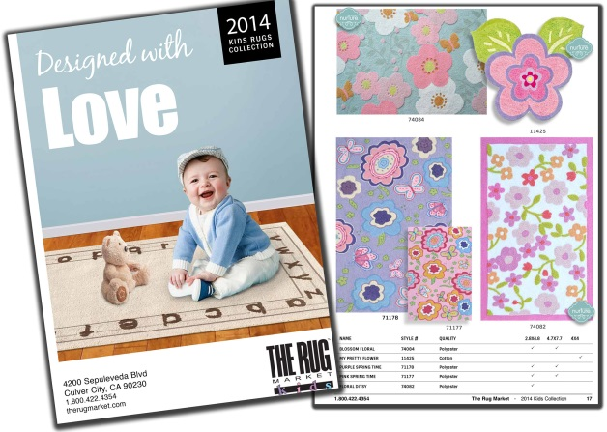
Page layouts within the catalog include eight themed groupings to assist retailers in merchandising with related products. From “My First Rug” collection of nursery room rugs designed for play and repose to the retro “Shag” Collection offering a deep selection of colors and styles reminiscent of the retro era, each rug from The Rug Market Kids is hand-crafted and constructed for easy care.

"In response to our customers, we have created these marketing materials to highlight the fun and often whimsical designs and variety of construction techniques available to our retailer network, while maintaining an attractive and moderate price structure,” Shabtai said.

A separate bound catalog is available for The Rug Market America’s collections of interior and exterior designs. Catalogs and pricing information are available by contacting a Rug Market America independent sales representative or The Rug Market America's corporate offices in Culver City, Cal. at 310-841-0111. All items in The Rug Market America's catalog ship within 30 days or less.

For more information about The Rug Market Kids, or The Rug Market America and its lines of interior and exterior rugs, contact: info@therugmarket.com or visit www.therugmarket.com.
# # #

ABOUT The Rug Market America
The Rug Market is an innovative designer and manufacturer of quality interior and exterior rugs. In 1985, The Rug Market entered the home accessories market with its first line of decorative handmade rugs. Owned by Mike Shabtai, the company's success has been a result of providing designer, fashion-forward looks at affordable mid-range pricing. The Rug Market, where quality is better than size, is represented nationwide.

Company Contact: Andrew Shabtai 310-841-0111, fax 310-841-0126 andrew@therugmarket.comPublicity Contact: Laurie Rudd, 252-714-5377 laurieruddpr@suddenlink.net

