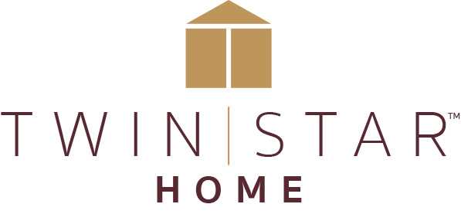

FOR IMMEDIATE RELEASE Media Contact: Calla Starr
calla@gefenmarketing.com
336.884.5020

TWIN STAR HOME CONTINUES EXPANSION AND REACHES OUT TO CONTEMPORARY AND TRADITIONAL CUSTOMERS WITH TWO NEW COLLECTIONS
‘Downtown Loft’ and ‘French Country’ furniture collections make their High Point debuts

Delray Beach, FL (March 18, 2019)—Visitors to Twin Star Home’s newly designed High Point Market showroom at Market on Green will get a first High Point look at Downtown Loft™, a sophisticated urban collection of multi-functional entertainment and storage pieces, several of which can be fitted with electric fireplaces, and will be introduced to the more traditional French Country™ capsule collection. Twin Star Home is the market leader in electric fireplaces and a premier designer and manufacturer of home furnishings.

“We are in constant dialogue with the consumer to inform and drive our product development,” said Lisa Cody, Twin Star Home’s Vice President of Marketing. “Every collection we do fills a specific niche and reflects what we have learned through careful research. Downtown Loft and French Country customers have different styles, but they are looking for the same level of quality and innovation in their home furnishings.”

Designed for the space-conscious consumer, Downtown Loft combines pared down simplicity with the warmth of a grayed Clayton Oak finish and textured glass. The signature piece of the collection is a TV Stand that can support most flat screen televisions up to 70” and has two integrated Bluetooth™ speakers that can stream audio from anywhere in the room; in addition, the TV Stand has a center cabinet covered with textured glass sliding doors that comes standard with an adjustable shelf but can be upgraded to hold a 26” 3D Infrared Quartz Electric Fireplace with a patent pending three dimensional flame effect and a 5200 BTU heater. A smaller version of the TV stand is designed for televisions up to 55” with a central cabinet designed to hold an 18” electric fireplace and heater with a choice of contemporary fire glass media or a realistic log and ember option.

Other multi-functional pieces in the Downtown Loft collection include a four shelf Bookshelf Room Divider with a gray metal frame and textured glass accents, finished on all sides for maximum freedom of placement; a 35” wide Wine Cabinet with X dividers for bottle storage and hanging stemware racks; and a 47” wide Wine Cabinet with two side cabinets and an open wine storage compartment with space for fifteen bottles.

The French Country collection is composed of eleven accent pieces in a clean, sophisticated version of the perennially popular European provincial style. Inspired by the French countryside, this collection captures the casual simplicity of a rustic farmhouse. Warm wood textures and weathered metal accents paired with bold hues create a peaceful lived-in feeling that makes gatherings at home warm and cozy.
The collection’s mix of materials and finishes gives it a casually collected feeling: French Country Truffle finish on Birch veneers, Mindi Wood veneers in a darker Riviera Brown finish, Paon Blue finish, powder-coated metal, and tile, and glass. Centerpieces of the collection include two generously proportioned TV Stands with side cabinets and full-extension drawer; the center opening in one can be fitted with an 18” 3D Infrared Quartz Electric Fireplace, and the other can hold a 26” electric fireplace. The collection also includes a carved architectural-style wall mantel in Birch veneer with a reversible surround finished in French Country Truffle on one side and faux concrete slate on the other. The mantel opening is sized to accommodate a 28” 3D Infrared Quartz Electric Fireplace.

###

About Twin Star:
Twin Star Home of Delray Beach, FL is an award-winning manufacturer of home furnishings, including electric fireplaces and furniture, many with integrated media solutions. Twin Star Home combines the latest trends with consumer-driven innovation and design-rich style to create lasting products that enhance consumers’ lives. Twin Star Home is recognized for its trusted national brands: ClassicFlame®, Duraflame, Bell’O, Tresanti and ChimneyFree. Find out more at www.twinstarhome.com.

Sharefile link for image: https://gefenmarketing.sharefile.com/d-scf3d303aa21480e9

