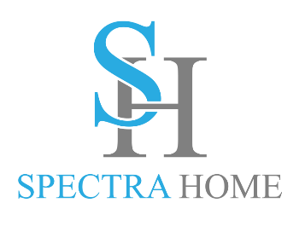

Contact: Cathy Lloyd
The Media Matters, Inc.
336.707.4462
cathy@tmm.agency

Kick Back and Relax in Spectra Home Style
Spectra Home is expanding their recliner selection to meet retailer and customer demands
High Point, NC, April 13, 2024 – Spectra Home, known in the industry for their superbly tailored upholstery, is expanding their comfort seating selections to include transitional and traditionally styled recliners in fabrics and leathers, some with decorative nailhead trims. Try out the recliners in the Spectra Home High Point showroom, 200 N Hamilton #213, April 13-17.
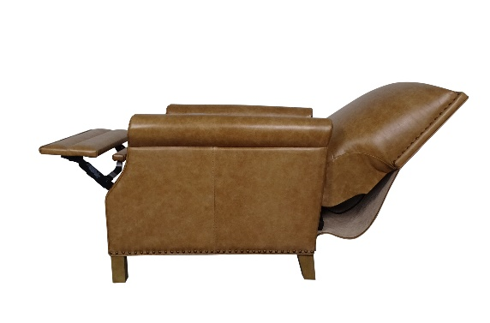
“Motion is king, whether it’s swivel or reclining, customers want chairs that are comfortable and have movement,” stated Jim Telleysh, president of Spectra Home. “Our swivel chairs are already best sellers, so we added more recliners in both push back and power models to meet the motion requests. The power recliners have hidden power buttons with USB outlets for multi-position reclining and charging electronics while relaxing. And with our Custom Design Program customers can select from over 185 fashion fabric and leather covers along with a variety of nailhead trim finishes to coordinate with their room decor.”

Added to the comfort seating line up are:
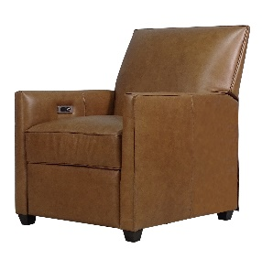
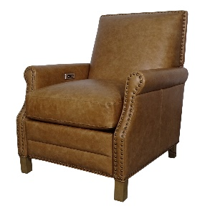
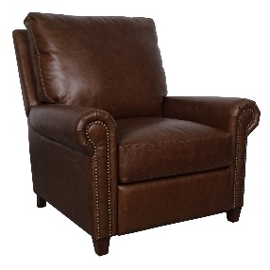

Dixon, Iceberg Cognac
Beard, Chaps Havana Brown
Brixton, Crystal Sand
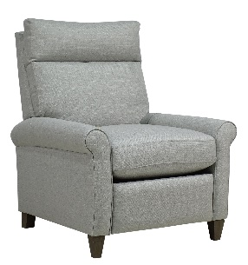
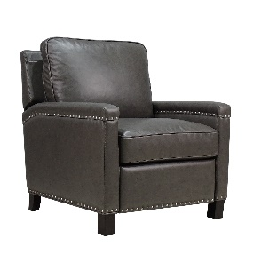
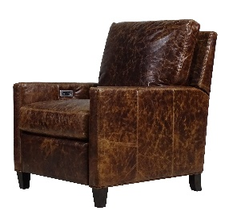

Tartt, Milestone Smoke
Nathan, Brompton Brown
Eddi, Hash Natural fabric

# # #

About Spectra Home:
Spectra Home designs and manufactures luxuriously comfortable, fashion-forward, and exquisitely tailored upholstered furniture using time-honored construction techniques including hand-cut and -sewn fabrics and leathers. The company is based and warehouses product in High Point, NC. For more information, visit spectrahomefurniture.com, Facebook, Instagram, Pinterest.

