

Contact: Cathy Lloyd
The Media Matters, Inc.
336.707.4462
cathy@tmm.agency

Company Coming? Spectra Home is Ready
with the Introduction of Comfortable Sleep Sofas
Create an instant guest room with Spectra Home’s new Pasadena and Curry sleep sofas
High Point, NC, April 13, 2024 – In response to retailer needs, Spectra Home is launching a new sleep sofa line based on their two best bestselling sofas, Pasadena and Curry. See them in the Spectra Home High Point showroom, 200 N Hamilton #213, April 13-17.

“We have had requests from several retail partners to add a bed option to our sofas,” stated Jim Telleysh, president of Spectra Home. “They said that many of their customers have requested comfortable sofas with the ability to accommodate overnight visitors. To address that need we added a 5” memory foam mattress and an easy-open-and-close mechanism to our 75” Curry and our 85” Pasadena sofas. The sleep sofas will continue to have the blend down seats and hardwood frames that make them so comfortable. Plus, with our Custom Design Program designers and retailers can select from over 185 designer fabrics and leathers with contrasting throw pillows and welts at no additional charge along with nailhead trims in a variety of finishes.”

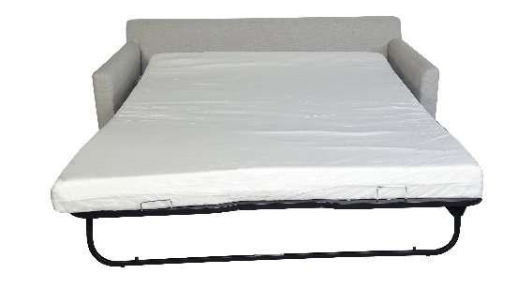
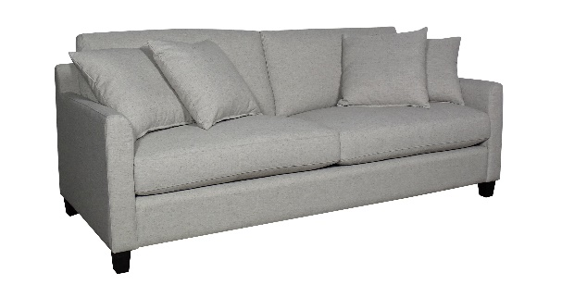

Curry Sleep Sofa

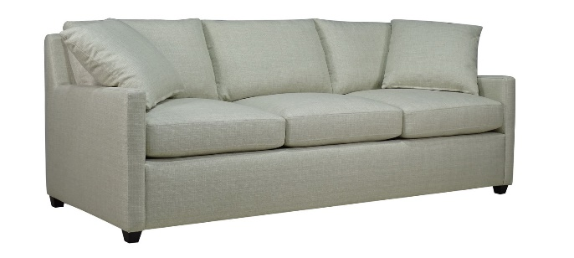
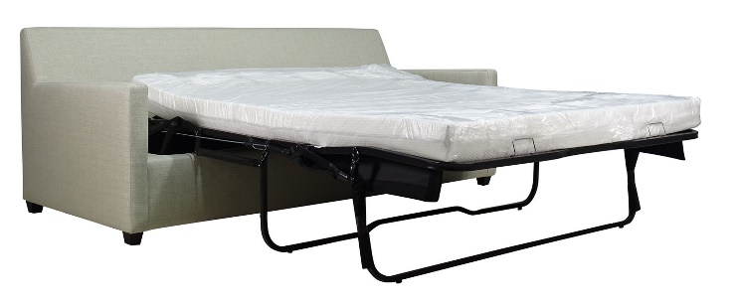

Pasadena Sleep Sofa

# # #

About Spectra Home
Spectra Home designs and manufactures luxuriously comfortable, fashion-forward, and exquisitely tailored upholstered furniture using time-honored construction techniques including hand-cut and -sewn fabrics and leathers. The company is based and warehouses product in High Point, NC. For more information, visit spectrahomefurniture.com, Facebook, Instagram, Pinterest.

