

Contact: Cathy Lloyd
The Media Matters, Inc.
cathy@tmm.agency
336.707.4462

Enter the Tamara Day by Spectra Home
Chair of Hope Raffle
Raffle proceeds aides The Common Thread for the Cure individuals fighting breast cancer
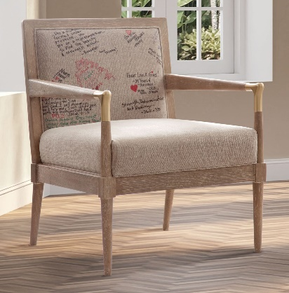
High Point, NC, March 27, 2024 – At the October Market Spectra Home showroom patrons wrote their special healing intentions on fabric and the Tamara Day by Spectra Home Meyer Chair has been upholstered with it. This chair, infused with hopeful, helpful energy, will be raffled off at the April Market with the proceeds benefitting The Common Thread for The Cure Foundation. The distinctive one-of-a-kind Chair of Hope is on display in the Spectra Home showroom, 200 N. Hamilton, #213. All market attendees, visitors and friends can enter to win the chair by visiting the Spectra Home showroom or online at commonthreadforthecure.org/event/chair-of-hope-raffle. Raffle tickets are $10 each or 6 for $50.


The Common Thread for the Cure Foundation, founded in 2000 by the late Suzann Burkhead-Bray and her brother, Scott Burkhead, in honor of their younger sister, Sandra Burkhead Campbell who died from breast cancer, supports individuals fighting breast cancer who are affiliated with the home furnishings and design industries by offering financial assistance through confidential grants. The grants are intended to enhance quality of life and can be used to meet any financial obligations, household needs and transportation to medical appointments.

“When we learned about how The Common Thread for the Cure Foundation assists those in our industry who are battling breast cancer we wanted to help too,” stated Jim Telleysh, president of Spectra Home. “So many of us have friends and family members who have had to deal with breast cancer and the financial stress it causes. In addition to the Chair of Hope raffle we are also donating a portion of the proceeds from the Tamara Day by Spectra Home collection to the Foundation. We hope that our support will ease the burden that families are experiencing.”

The Tamara Day by Spectra Home collection consists of family-friendly upholstered seating that fits into Day’s mantra of being affordable, attainable, and aspirational. The new laid-back luxe collection, covered in fashion fabrics and supple leathers, includes kid and pet friendly sectionals, sofas, chairs, benches, and ottomans designed for how the modern family lives today. “My goal was to design everything to be versatile so you can mix and match and make every space feel special,” Day stated.

“Spectra Home Furniture would like to thank our partners for their generosity in making this Chair of Hope happen,” Telleysh added. “That list includes: Tamara Day and her team for their continued support of The Common Thread for The Cure; Shayne Global for providing the Meyer Chair; Port Orange Upholstery, Thomasville, NC for reupholstering the chair; Studio 323, High Point, NC for providing the chair photography; The Media Matters for introducing us to The Common Thread for The Cure and supporting the raffle; and everyone who took the time to write their heart-felt inspirations and kind words on this work of art. We know that this Chair of Hope will make a difference in someone’s life when they need it the most.”

# # #

About Spectra Home
Spectra Home designs and manufactures luxuriously comfortable, fashion-forward, and exquisitely tailored upholstered furniture using time-honored construction techniques including hand-cut and -sewn fabrics and leathers. The company is based and warehouses product in High Point, NC. For more information, visit spectrahomefurniture.com, Facebook, Instagram, Pinterest.

About Tamara Day
Designer and host, Tamara Day, seeks to make the aspirational attainable for her clients and fans of her renovation projects. Tamara restores neglected Kansas City homes on Bargain Mansions. Bargain Mansions, which originated on DIY spent two seasons on HGTV and now has found its home at Magnolia Network, is going into its sixth season. When Tamara is not in front of the camera, she is committed to her family and design business located in Kansas City. Her style, coined "Laid Back Luxe," is synonymous with blending glamour, comfort, and family into the spaces she designs – something she personally prioritizes. As a busy mother of four, Tamara believes homes should be both beautiful and low maintenance because life is stressful enough. To keep up with Tamara and her projects, follow @tamaraday on Instagram.

