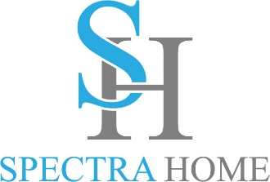

Contact: Cathy Lloyd
The Media Matters, Inc.
cathy@tmm.agency
336.707.4462

Spectra Home is Expanding their Tamara Day Upholstery Collection
A portion of the collection’s proceeds marked for The Common Thread for the Cure Foundation

High Point, NC, April 13, 2024 — Since the Tamara Day by Spectra Home collection was very well received at the October High Point Market Spectra Home is expanding the collection to include more family-friendly upholstery. The new offerings include sectionals, sofas, chairs, benches, and ottomans covered in fresh fashion-forward fabrics and supple leathers. Experience the entire collection in the Spectra Home showroom, 200 N Hamilton, #213.

“Tamara’s collection is a good fit for our retail partners’ needs and what their customers are looking for,” stated Jim Telleysh, president of Spectra Home. “Their customers want furniture that not only looks good and is comfortable but can stand up to the everyday treatment from pets and kids. We used durable fashion and performance fabrics along with top-grain leathers and blend down cushions for comfort. Designers and retailers can select from over 183 fabrics along with welts and nailhead accents through our Custom Design Program.”

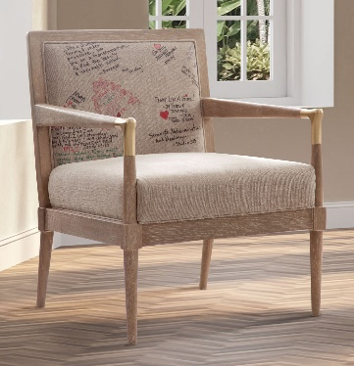
While in the Spectra Home showroom visitors are invited to stop by and see The Chair of Hope. Last Market showroom patrons wrote their special healing intentions on fabric and the Tamara Day by Spectra Home Meyer Chair has been upholstered in it. This chair, infused with hopeful, helpful energy, will be raffled off at the April Market with the proceeds benefitting The Common Thread for The Cure Foundation. “In addition to the chair we are still committed to donating a portion of the proceeds from the Tamara Day by Spectra Home collection to the Common Thread for the Cure Foundation to help provide financial grants to those battling breast cancer in the home furnishings and design industries,” added Jim Telleysh, president of Spectra Home. Visit the commonthreadforthecure.org/event/chair-of-hope-raffle or use the QR code in the showroom. Raffle tickets are $10 each or 6 for $50.

Here is a sample of what is new for this Market:

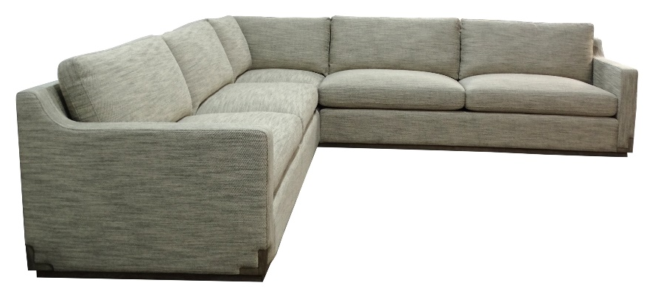
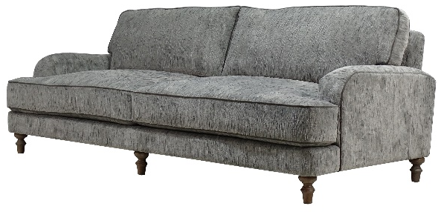
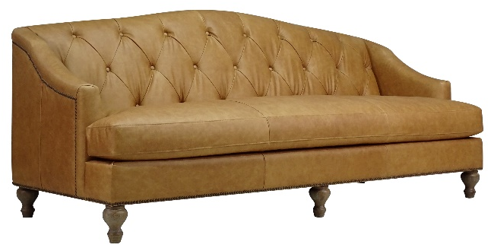
Olivia, Roly Poly Nature
Nall, Friday Linen
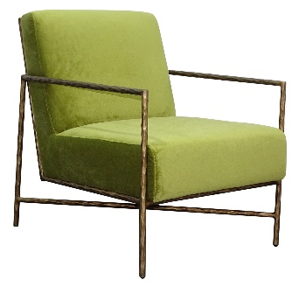
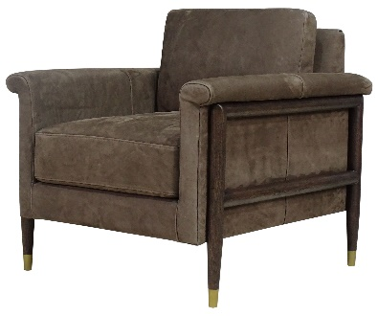
Brody, Ludlow Sesame leather

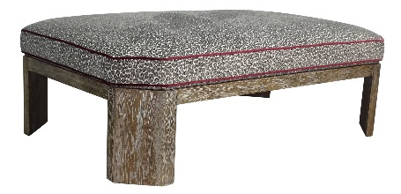
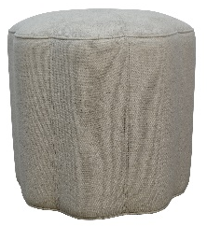
Leo, Anderson Chartreuse
Samuel, Calero Cocoa

Patricia, Hutton Charcoal
Oscar, Hardy Sand

# # #

About Spectra Home
Spectra Home designs and manufactures luxuriously comfortable, fashion-forward, and exquisitely tailored upholstered furniture using time-honored construction techniques including hand-cut and -sewn fabrics and leathers. The company is based and warehouses products in High Point, NC. For more information, visit spectrahomefurniture.com, Facebook, Instagram, Pinterest.

About Tamara Day
Designer and host, Tamara Day, seeks to make the aspirational attainable for her clients and fans of her renovation projects. Tamara restores neglected Kansas City homes on Bargain Mansions. Bargain Mansions, which originated on DIY spent two seasons on HGTV and now has found its home at Magnolia Network, is going into its sixth season. When Tamara is not in front of the camera, she is committed to her family and design business located in Kansas City. Her style, coined "Laid Back Luxe," is synonymous with blending glamour, comfort, and family into the spaces she designs – something she personally prioritizes. As a busy mother of four, Tamara believes homes should be both beautiful and low maintenance because life is stressful enough. To keep up with Tamara and her projects, follow @tamaraday on Instagram.

