
For Immediate Release
IHFC and INTERHALL Unveil Fresh Resources for the Fall 2024 High Point Market
HIGH POINT, NC – August 27, 2024 – Nearly 30 exhibitor updates to International Home Furnishings Center (IHFC) and INTERHALL 350+ permanent showroom and temporary exhibit resources promise effortless sourcing and cutting-edge trends at Fall High Point Market, running October 26-30, 2024.
“Fall 2024 will see a transformed Market experience at IHFC and INTERHALL, thanks to significant updates from our exhibitors,” said Dorothy Belshaw, ANDMORESM president. “More than 20 refreshed resources make October an unmatched opportunity to explore, discover and source across every category.”
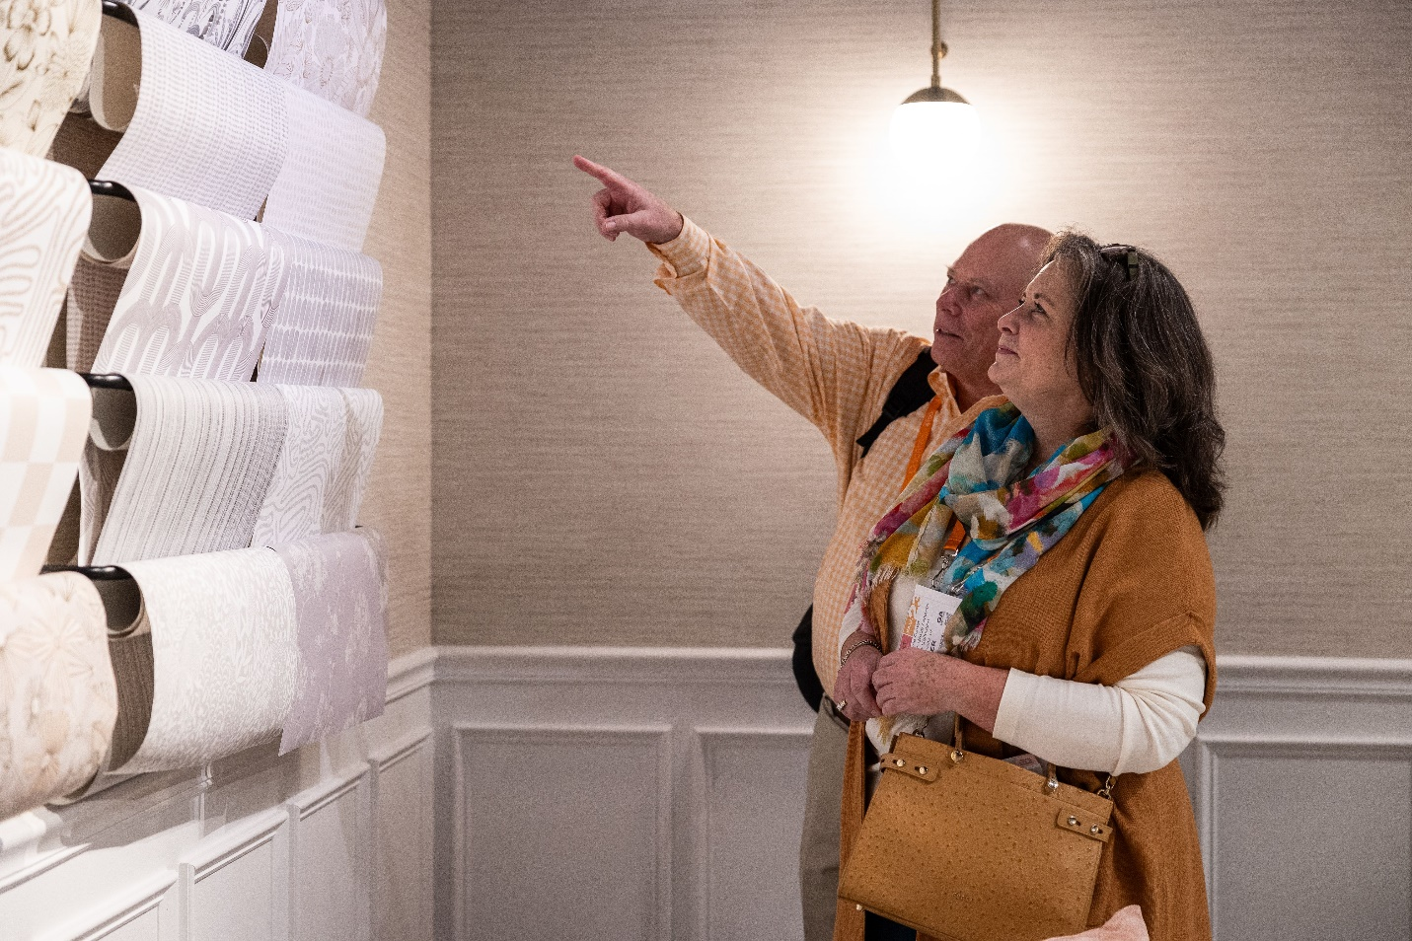

INTERHALL Introductions Spark Inspiration
INTERHALL, a juried assortment of up-and-coming furniture and home décor exhibitors, welcomes 12 new and expanded resources at the Fall 2024 Market, supplementing a 70+ permanent showroom and temporary exhibit collection on the first floor of IHFC.
INTERHALL’s new temporary exhibits include: Casa Magna (Portuguese furniture); Franco Ferri Italia (authentic Italian sofas); Home Spirit (high-end furniture); Le Présent (interior and exterior accessories); Louee Vega (wallcoverings and fabrics); Neos & Co. (Greek home furnishings); Pacific Green (resort furniture); Stephanie Parisi Collections (casegoods and home decor); Terrazza Outdoor (outdoor and patio furniture); Uultis (Brazilian high-end furniture); and Vincent Sheppard (handcrafted furniture). This Fall, Villa & House (furniture and home decor) expands.
Updates in IHFC Revamp Resources Across Categories
This October, 17 updates bring new, expanded and relocated resources to the heart of High Point. Some 13 floors of furniture and accessories make IHFC a must-see destination for Fall Market sourcing.
Art & Frame Mart (fine paintings and frames); Coast Lamp (table and floor lamps) Lucas + McKearn (home lighting); Renwil (artisan home decor); The Import Collection (designer wall decor and accessories) are new this Fall. Celadon Art (fine framed art prints) and Rug & Kilim (antique, vintage, modern and custom rugs) expand. Accent Decor (floral and ceramic decor); Banyan Designs Limited (coastal and contemporary decor); Couristan (carpets and area rugs); Decorum Home (contemporary, transitional and traditional pillows); Eikones (photographic wall art); Fibre by Auskin (natural fibers and wool skin products); Howard Elliott (mirrors and accent furniture); Meridian Furniture (traditional home furnishings); Simon Blake (lighting); and Streamline Art (art prints) present relocated and expanded collections within IHFC.
High Point Market is the largest and longest running furnishings industry trade show in the world, featuring an extensive selection of exhibitors spanning every category, style, and price point for the home. The twice-yearly Markets attract tens of thousands of domestic and international retail home furnishings buyers, interior designers, architects, and others in the home furnishings industry. ANDMORE, formerly International Market Centers, owns 17 buildings spanning 7 million square feet in the heart of the market district, housing both permanent showrooms and the market’s only temporary exhibit space. ANDMORE also presents a wide variety of educational, trend and networking opportunities featuring industry leaders and tastemakers. Fall 2024 Market is scheduled for October 26-30, 2024. For more information about events and exhibitors presented by ANDMORE at High Point Market, visit ANDMOREHighPointMarket.com.
About ANDMORESM: ANDMORE, formerly International Market Centers, is an omnichannel wholesale marketmaker that fuels opportunities for wholesale buyers and sellers to connect, grow and prosper through physical markets, design centers and digital channels. The company owns and operates more than 20 million square feet of premium event and showroom space, hosting live events in Atlanta, High Point, N.C., Las Vegas and New York City. By pairing face-to-face events with always-on digital tools, ANDMORE provides truly omnichannel business platforms for its global wholesale customer base. ANDMORE.com.
###
Media Contacts:
Morgan Ford, 412.877.0576 or mford@ANDMORE.com
Cathy Steel, 203.340.9251 or cathysteel@cathysteelassociates.com

