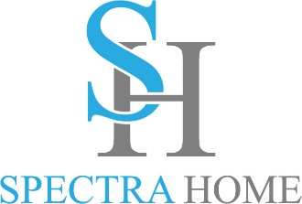

Contact: Cathy Lloyd
The Media Matters, Inc.
cathy@tmm.agency
336.707.4462

Spectra Home Teams with Tamara Day
to Share Expert Tips on Upholstery and Accent Chairs
Join Bargain Mansions host, Tamara Day, as she takes the mystery out of selecting upholstery
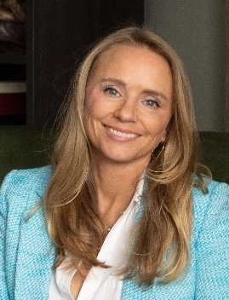
High Point, NC, March 14, 2025 — How do you select the perfect fabric, sofa, and accent chairs for your rooms? There are so many choices today. Join us in the Spectra Home showroom as we welcome Tamara Day, host of Magnolia Network’s top renovation show Bargain Mansions, for an exclusive design session. In Tips from Tamara: Design Secrets for Selecting the Perfect Upholstery & Accent Chairs, Day will share her design secrets for mixing fabrics and upholstery styles to create impressive glam and cozy lifestyle looks for showroom floors, customer homes, and on Bargain Mansions. She’ll reveal her family-friendly design strategies for her popular Tamara Day by Spectra Home Furniture collection, TV show, and design projects. Get a behind-the-scenes look at how she selects upholstery and accent chairs. What does she look for in the construction of upholstered furniture? Performance fabrics vs non-performance fabrics, which is best? Mark your calendars for Saturday, April 26 at 11:30 am in the Spectra Home showroom, 200 N Hamilton, #213.
“We are looking forward to having everyone join us for another informative presentation by our design partner, Tamara Day,” stated Jim Telleysh, president of Spectra Home. “Tamara’s style, like her Tamara Day by Spectra Home furniture collection, is very relatable with a relaxed and down-to-earth design aesthetic. She enjoys mixing fabrics and design styles to create rooms that not only look good but are easy-to-care for and very livable with kids and pets.”
While in the showroom, Spectra Home invites visitors to participate in the Great Accent Chair Challenge. Try out the top-selling Meyer, Leo, and Walker accent chairs, then cast your vote for your favorite one. Spectra Home will donate to The Common Thread for The Cure Foundation for every entry submitted. Stop by and cast your vote for a good cause today!


The Common Thread for the Cure Foundation supports individuals fighting breast cancer affiliated with the design and furnishings industry by offering financial assistance through confidential grants. The grants are intended to enhance the quality of life and can be used to meet any financial obligations, household needs, and transportation to medical appointments.

# # #

About Spectra Home: Spectra Home designs and manufactures luxuriously comfortable, fashion-forward, and exquisitely tailored upholstered furniture using time-honored construction techniques including hand-cut and -sewn fabrics and leathers. The company is based and warehouses products in High Point, NC. For more information, visit spectrahomefurniture.com, Facebook, Instagram, Pinterest.

About Tamara Day
Designer and host, Tamara Day, seeks to make the aspirational attainable for her clients and fans of her renovation projects. Tamara restores neglected Kansas City homes on Bargain Mansions. Bargain Mansions, which originated on DIY spent two seasons on HGTV and now has found its home at Magnolia Network, is going into its sixth season. When Tamara is not in front of the camera, she is committed to her family and design business located in Kansas City. Her style, coined "Laid Back Luxe," is synonymous with blending glamour, comfort, and family into the spaces she designs – something she personally prioritizes. As a busy mother of four, Tamara believes homes should be both beautiful and low maintenance because life is stressful enough. To keep up with Tamara and her projects, follow @tamaraday on Instagram.

