FOR IMMEDIATE RELEASE

Thayer Coggin Unveils UFO Ottomans by Rick Lee at Spring 2025 High Point Market
HIGH POINT, NC — Thayer Coggin is set to launch a new interstellar addition to its collection at the Spring 2025 High Point Furniture Market: the UFO Ottoman, designed by Rick Lee. With a design inspired by mid-century comic books and sci-fi classics such as The Day the Earth Stood Still and Flying Saucer, the UFO Ottoman merges playful nostalgia with modern sophistication.
“It’s a bird, it’s a cloud—no, it’s a UFO!” says designer Rick Lee. “I wanted to create something that felt like it hovered in place—soft, inviting, and unmistakably unique. The UFO Ottoman is my tribute to the era of futurism and imagination.”
The UFO Ottoman is available in two sizes: a smaller, taller version that functions as a footrest or stool and a larger model that serves as a footrest, seating option, or even a table surface. The ottoman’s silhouette features a rounded, upholstered seat reminiscent of a flying saucer, supported by a conical wooden base that evokes the iconic ‘tractor beam’ aesthetic.
In addition to its sculptural presence, the UFO Ottoman offers versatility. A swivel option allows it to pair seamlessly with Thayer Coggin’s renowned lounge chairs, sofas, and sectionals, including the Mona Lounge Chair, the Good Egg Swivel Chair, and the Playing Hooky Sectional.
The UFO Ottoman will make its official debut at the Thayer Coggin showroom during the Spring 2025 High Point Market, where attendees can experience its gravity-defying charm firsthand.
For more information, visit thayercoggin.com or stop by the showroom at High Point Market.
Media Contact:
Phil Miller
Vice President of Sales and Marketing
336-841-6000
phil@thayercoggin.com

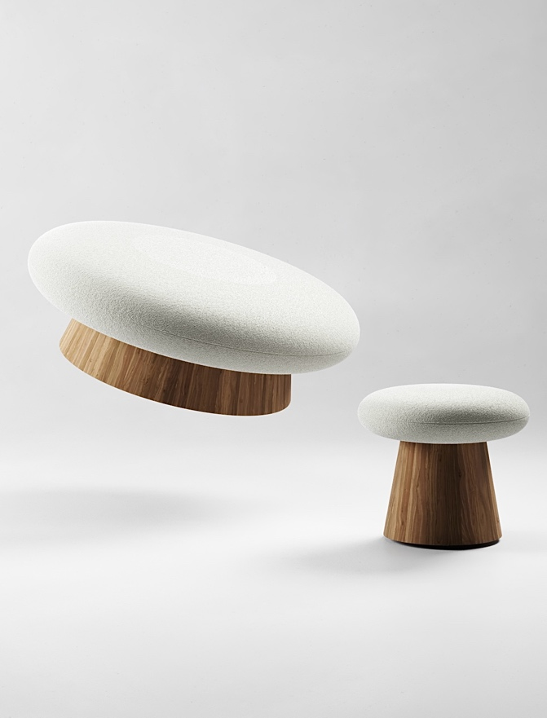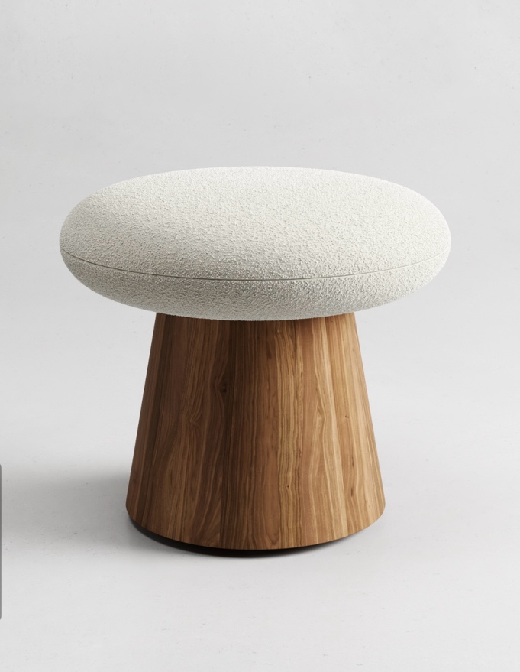
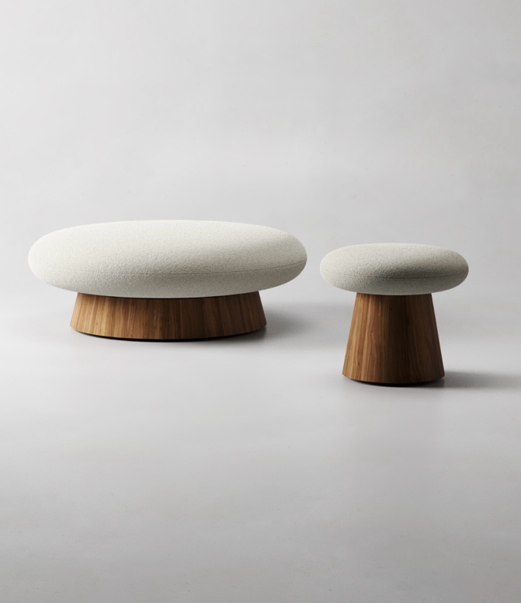
UFO Ottomans from Thayer Coggin furniture

