FOR IMMEDIATE RELEASE

Thayer Coggin Introduces the Cloud Drum Table by Rick Lee at the Spring 2025 High Point Furniture Market
High Point, NC – Thayer Coggin unveiled the Cloud Drum Table, a striking new cocktail table designed by Rick Lee, at the Spring 2025 High Point Furniture Market. Inspired by the ancient rain drum tables, this sculptural piece reimagines organic forms with a contemporary edge, bringing a sense of movement and artistry to modern interiors.
Composed of interlocking silver drums, the Cloud Drum Table creates the illusion of multiple tables merging into one, offering a dynamic focal point from every angle. Its fluid form evokes the shifting shapes of clouds, stirring both imagination and emotion with its abstract yet harmonious silhouette. Available in polished stainless steel or any of eight Thayer Coggin powder coat finishes, this piece seamlessly blends geometry with an ethereal touch, making it a versatile statement for a variety of interiors.
“Bring nature into the environment with the Cloud Drum Cocktail Table,” says designer Rick Lee. “By fusing the various sized drums into one form, the design seemingly functions as a group table on a single surface, while the shape becomes more abstract and organic. Like the cloud formation, the Cloud Drum Cocktail Table stirs the imagination and emotion when viewing from all angles.”
Thayer Coggin invites attendees to experience the debut of the Cloud Drum Table at their showroom during the Spring 2025 High Point Market. As a brand renowned for its commitment to innovative design and craftsmanship, Thayer Coggin continues to push the boundaries of modern furniture with bold, artful creations that elevate contemporary living spaces.
For more information, contact:
Phil Miller, Vice President of Sales and Marketing
336-841-6000
phil@thayercoggin.com
For more details, visit www.thayercoggin.com.
About Thayer Coggin
Thayer Coggin has been a leader in modern furniture design for over 70 years, producing iconic, handcrafted pieces in High Point, NC. With a legacy of collaboration with visionary designers, Thayer Coggin remains dedicated to timeless craftsmanship, superior materials, and groundbreaking design.

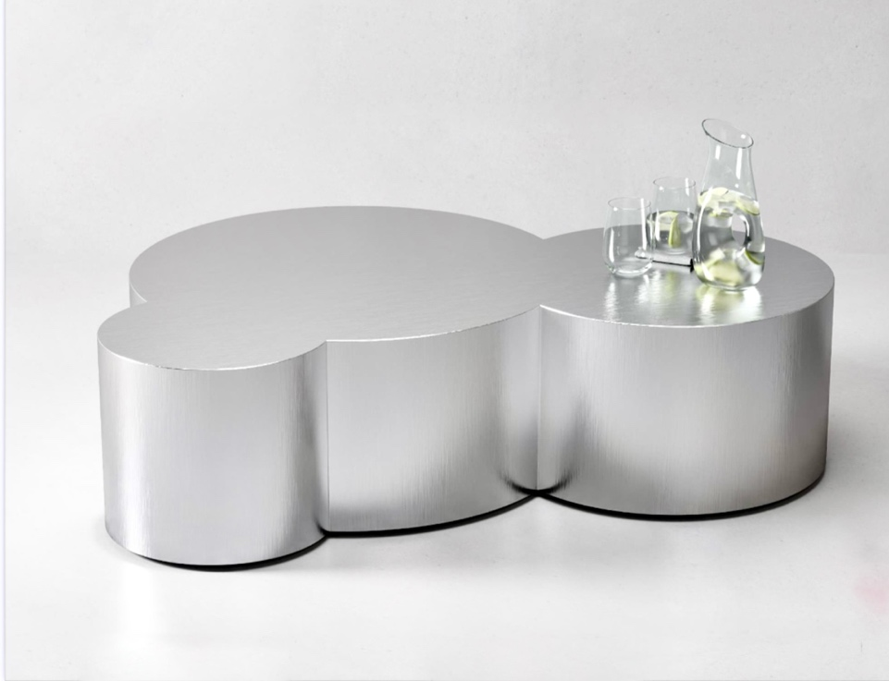
Cloud Drum Table from Thayer Coggin

