FOR IMMEDIATE RELEASE
Media Contact:
Falls & Co.
Olivia Fraser | 216.696.5710 | ofraser@fallsandco.com
Kelly Maughan | 216.696.5694 | kmaughan@fallsandco.com

In Full Bloom: Kalco Lighting Brings a Fresh Take on Color to High Point Market
Spring Designs Reinvent Elegance with Splashes of Soft Pink, Rich Brown and Deep Navy
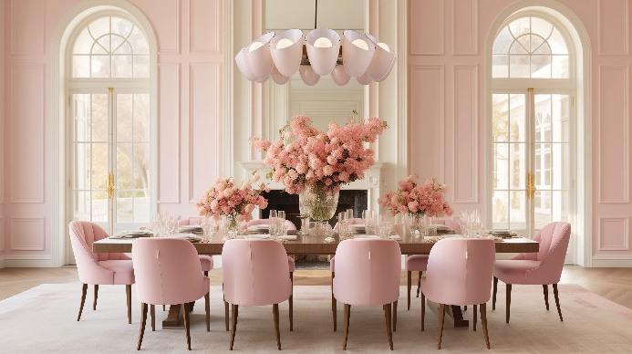
HIGH POINT, North Carolina (Tuesday, April 8, 2025)— From soothing hues to statement shades, Kalco Lighting, a leading manufacturer of casual luxury lighting and furniture designs, explores a kaleidoscope of color in collections launching at its showroom, IHFC H232, during Spring High Point Market, April 26-30.
“This season, we’re reimagining luxury lighting with an infusion of calming and vivid color stories,” says Riki Lent, Senior Vice President of Kalco Lighting and Allegri Crystal by Kalco. “Our love for natural elements in design has brought soft pinks and earthy tones to the forefront of our handcrafted lighting to create grounding spaces while the deep blues and greens offer a bold, sophisticated look.”
Standouts from Kalco’s Spring introductions include:
- Inspired by silk cocoons, the Cocoon Collection features Sakura Pink glass backed by a layer of soft white glass for a luminous effect. Elegantly blending softness with geometric precision, each piece is meticulously crafted from stainless steel and finished in a refined Winter Brass.
- The contemporary and compact Embrace Collection draws inspiration from delicate fabric. The textured bone china shade is accented with rich mahogany leather straps and a sleek dark brown cord, allowing light to filter through with an elegant glow.
While the colorful collections from Kalco are subtle, debuts from Allegri Crystal, a luxury crystal lighting line by Kalco Lighting, offer a vibrant color palette:
- A timeless design elevated with bold color, the Tinta Collection features Firenze Crystal elements that transition from soft light green to deep navy blue, creating a striking ombré effect. Warm brass accents complement the cool hues, while the Winter Brass finish adds a touch of classic elegance.
- Mid-century-inspired design meets a hint of Hollywood glam in the Constellation Colorata Collection, which includes Firenze Crystal accents with a mix of blue, green and yellow.
- The minimalist Tonalita Esterno outdoor wall sconce offers vibrant LED lighting through customizable light colors and an option to cycle through RGBW settings, controlled via a Bluetooth phone app. Its matte black fluorocarbon finish endures even the most severe weather conditions.
“We carefully curated a color palette that balances light and dark hues,” says Takayuki Ishii, Vice President of Design and Development at Kalco Lighting and Allegri by Kalco. “Whether customers gravitate toward softer tones or dramatic shades, these styles allow them to personalize their space with color in a way that feels unique to them.”
Additionally, Kalco Lighting will host Champagne & Chandeliers: Designer Showcase from 3 to 5 p.m. on Sunday, April 27. Moderated by Senior Associate Editor at Houzz Suzanne Ennis, the panel--interior designers Christopher Grubb, Theresa Ory and Vanessa DeLeon and Kalco Lighting designer Claire Kessler-- will discuss the hottest home projects and styles shaping the world of casual luxury design. Attendees are also invited to discover the latest design trends and network with the Kalco team over a catered breakfast at Morning Mimosas with the Media from 9 to 11 a.m. on Saturday, April 26.
For more information, visit Kalco.com and AllegriCrystal.com.
###
About Kalco Lighting
With its passion and commitment to design, service and quality, Kalco Lighting offers an array of casual luxury designs. Its collection of Allegri Crystal luxury chandeliers, pendants, sconces and flush mounts feature quality handcrafted materials. Allegri’s exacting standards for precision cut, machine polished jewels create unparalleled shine and refraction. Kalco’s designs are inspired by timeless trends, new innovations, and advancements in technology. From their state-of-the-art manufacturing facilities, their designers and engineers take great pride to seamlessly integrate the latest in energy efficient technology into their lighting designs and manipulate the industry’s most advanced LED lamping to fit their fixtures’ unique aesthetic.

