

Contact: Cathy Lloyd
The Media Matters, Inc.
cathy@tmm.agency
336.707.4462

Spectra Home Refreshes Best-Selling Upholstery With Stylish New Looks
New multiple-size sofas and sectional configurations
plus accent chairs broaden the brand’s award-winning lineup
High Point, NC, April 26, 2025 — Spectra Home is unveiling a new perspective on its showroom floor this Market, featuring innovative transitional seating groups and accent chairs alongside a collection of updated best-selling frames enhanced by new vibrant, textured fabrics and leathers that introduce a modern elegance to living spaces. These additions merge the comfort and familiarity of customer favorites with luxurious fabrics, eye-catching textures, and stylish designs, providing retailers and shoppers with more ways to appreciate the brand's award-winning aesthetic. Discover it all in the Spectra Home showroom, 200 N Hamilton, #213, April 26-30.

“For this Market, we added rich new fabrics and leathers to some of our most popular Spectra Home and Tamara Day collections to create the warmer looks that our customers are asking for,” stated Jim Telleysh, president of Spectra Home. “Updating the fabric selections to a warmer palette and adding details like nailhead trim and button tufting lends a more stylish, custom upholstery feel. We are stocking these frames with the new custom-look fabrics at our North Carolina warehouse, so they ship within 48 hours for faster delivery and quicker floor placement.”

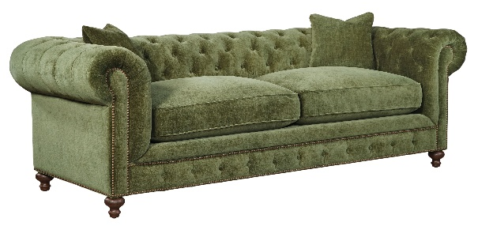
The new Spectra Home upholstery showcases warm greens, plush blues, rich browns, and versatile neutrals, all in a variety of textures such as linens, velvets, boucles, and leathers. Here’s a sneak peek at a few new looks:
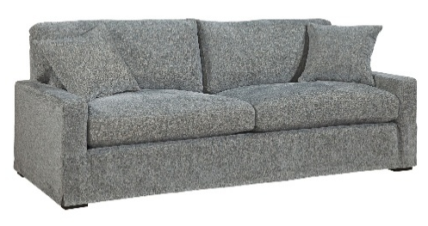
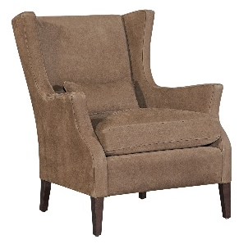
Peyton Sofa, Plushtone Mineral
Chip Chair, Calero Cocoa leather
Greenwich Sofa, Andrew Forest
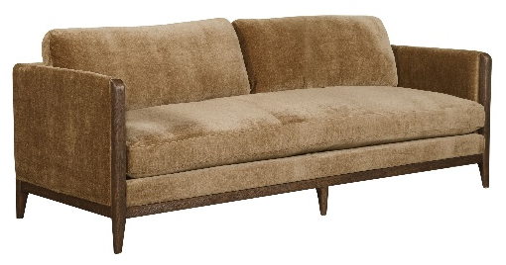
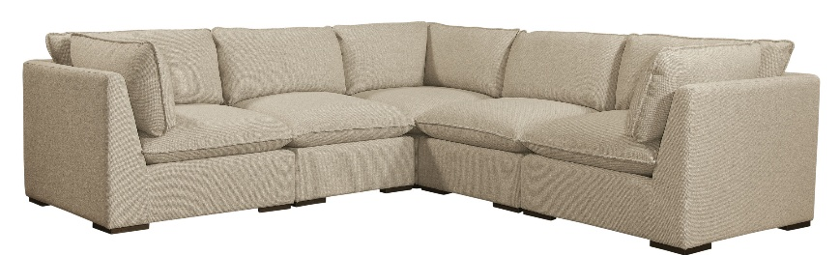
Burbank Sectional, Boucle Pebble
Tamara Day Benjamin Sofa, Andrew Driftwood

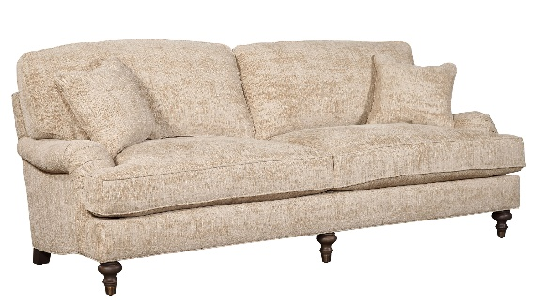
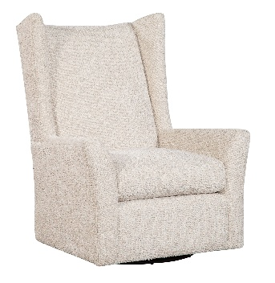
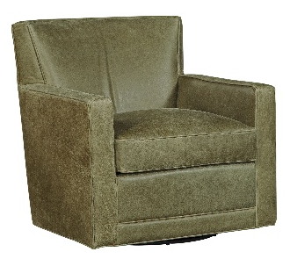

Sloane Sofa, Churchill Driftwood
Kent Swivel, Disk Linen
Jaxson Swivel, Keystone Moss leather

While the updated silhouettes and rich textures provide plenty of enjoyment, Spectra Home also invites guests to make the most of their time in the showroom—for a good cause. In celebration of being named the Best Accent Chair Supplier and the Best Upholstery Supplier, Spectra Home wants to discover which accent chair is your favorite. During the Spring Market, visit the showroom to try out their three top-selling accent chairs: Meyer, Leo, and Walker, and then vote for your favorite in the Great Accent Chair Challenge. For every entry submitted, Spectra Home will donate to The Common Thread for The Cure Foundation.


“We are proud to continue supporting the Common Thread for the Cure Foundation because it assists those in our industry battling breast cancer,” Telleysh continued. “To help further, we are also donating a portion of the proceeds from the Tamara Day by Spectra Home collection to the Foundation. We hope our support will alleviate some of the burdens that families are facing.” The Foundation aids individuals fighting breast cancer in the design and furnishings industry by providing confidential grants for financial assistance. These grants aim to enhance quality of life and can be used to meet various financial obligations, household needs, and cover transportation costs to medical appointments.

# # #

About Spectra Home: Spectra Home designs and manufactures luxuriously comfortable, fashion-forward, and exquisitely tailored upholstered furniture using time-honored construction techniques, including hand-cut and -sewn fabrics and leathers. The company is based in High Point, NC, and warehouses products there. For more information, visit spectrahomefurniture.com, Facebook, Instagram, and LinkedIn.

