Koncept's Z-Bar Titan Floor Lamp and Combi Table Lamp
Honored with Prestigious Red Dot Design Awards
FOR IMMEDIATE RELEASE

Monrovia, CA, April 1, 2025– Koncept is proud to announce that its Z-Bar Titan Floor Lamp has been awarded the esteemed Red Dot: Best of the Best award, while the Combi Table Lamp has received a Red Dot award. The Best of the Best distinction is reserved for groundbreaking design quality and is awarded to only the top 0.8% of entries, making this recognition an extraordinary achievement for our team.

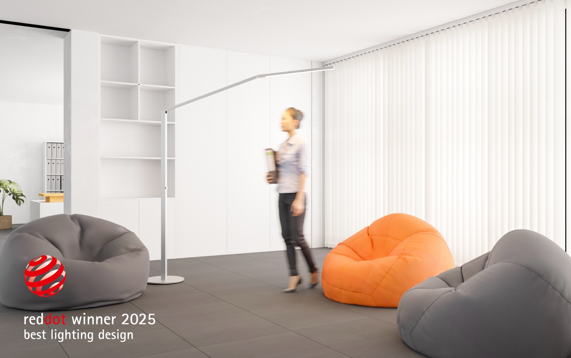

"We are thrilled and deeply honored to receive both the 'Red Dot: Best of the Best' for our Z-Bar Titan Floor Lamp and the Red Dot award for our Combi Table Lamp," said Kenneth Ng, Co-Founder and Designer at Koncept. "This is our first time receiving the 'Best of the Best' award, and it underscores our commitment to innovative design and excellence. We are grateful to the Red Dot jury for recognizing our dedication and hard work."

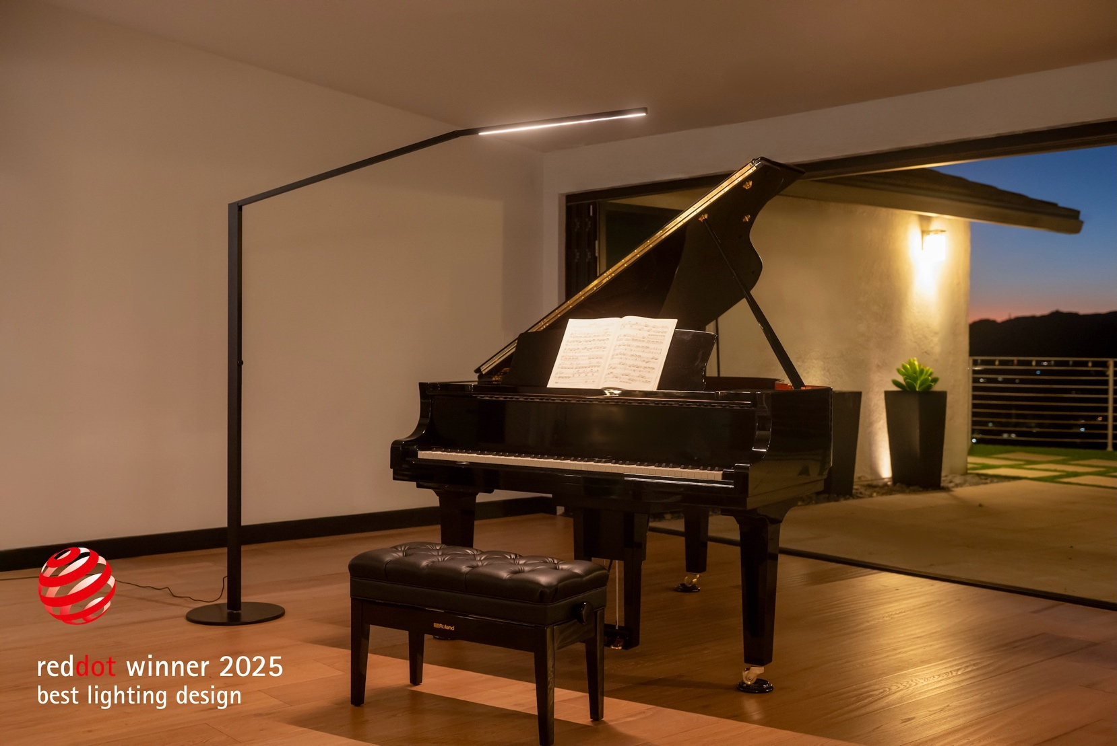

Designed for executive settings, the Z-Bar Titan Floor Lamp offers precision lighting with seamless adjustability. Its sleek, minimalist design enhances a variety of workspaces, from private offices to collaborative areas and lobby spaces, providing users with an intuitive lighting experience tailored to their needs. Conceived as a statement-making floor lamp, it balances its imposing dimensions (78" wide and up to 84" tall) with effortless adjustability. Its rotatable LED head and base provide unmatched flexibility, allowing users to direct light precisely where needed. By combining size, style, and functionality, the Z-Bar Titan stands out in the premium task lighting market as both a striking design piece and a highly practical lighting solution.
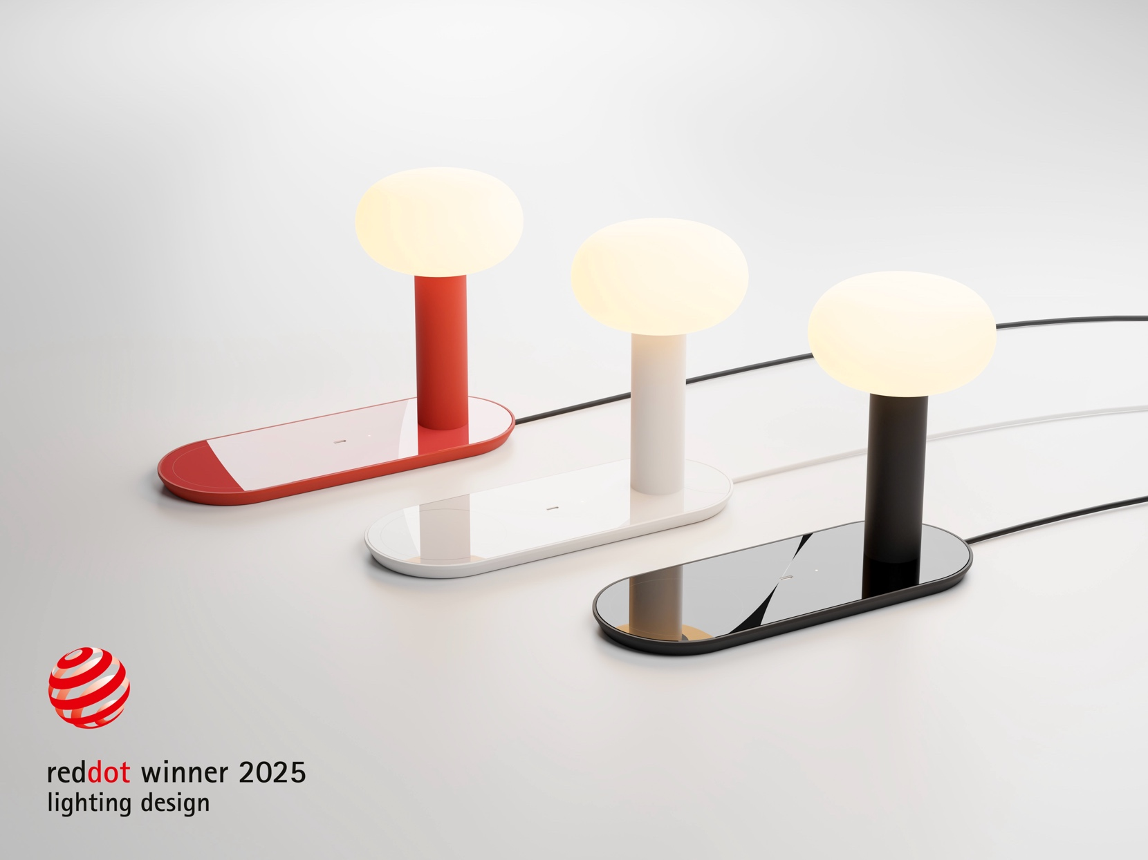

The Combi Table Lamp is a multifunctional lighting solution that integrates advanced charging technology, including a high-power USB-C port and wireless charging for Qi-enabled devices. Designed for modern commercial and residential spaces, it provides seamless illumination while addressing the increasing reliance on smartphones, tablets, and laptops. Its compact yet stylish form makes it ideal for environments such as hotel rooms, offices, and living spaces. The lamp’s 45-watt USB-C charging port and 5-watt Qi wireless charging capability set it apart from standard lamps, while a hidden mounting hole in the base offers secure installation to prevent theft in public settings. Available in Matte Red, Matte Black, and Matte White finishes, the Combi Table Lamp combines aesthetics with functionality, catering to both design-conscious consumers and commercial clients, reinforcing Koncept’s dedication to innovation and versatility.

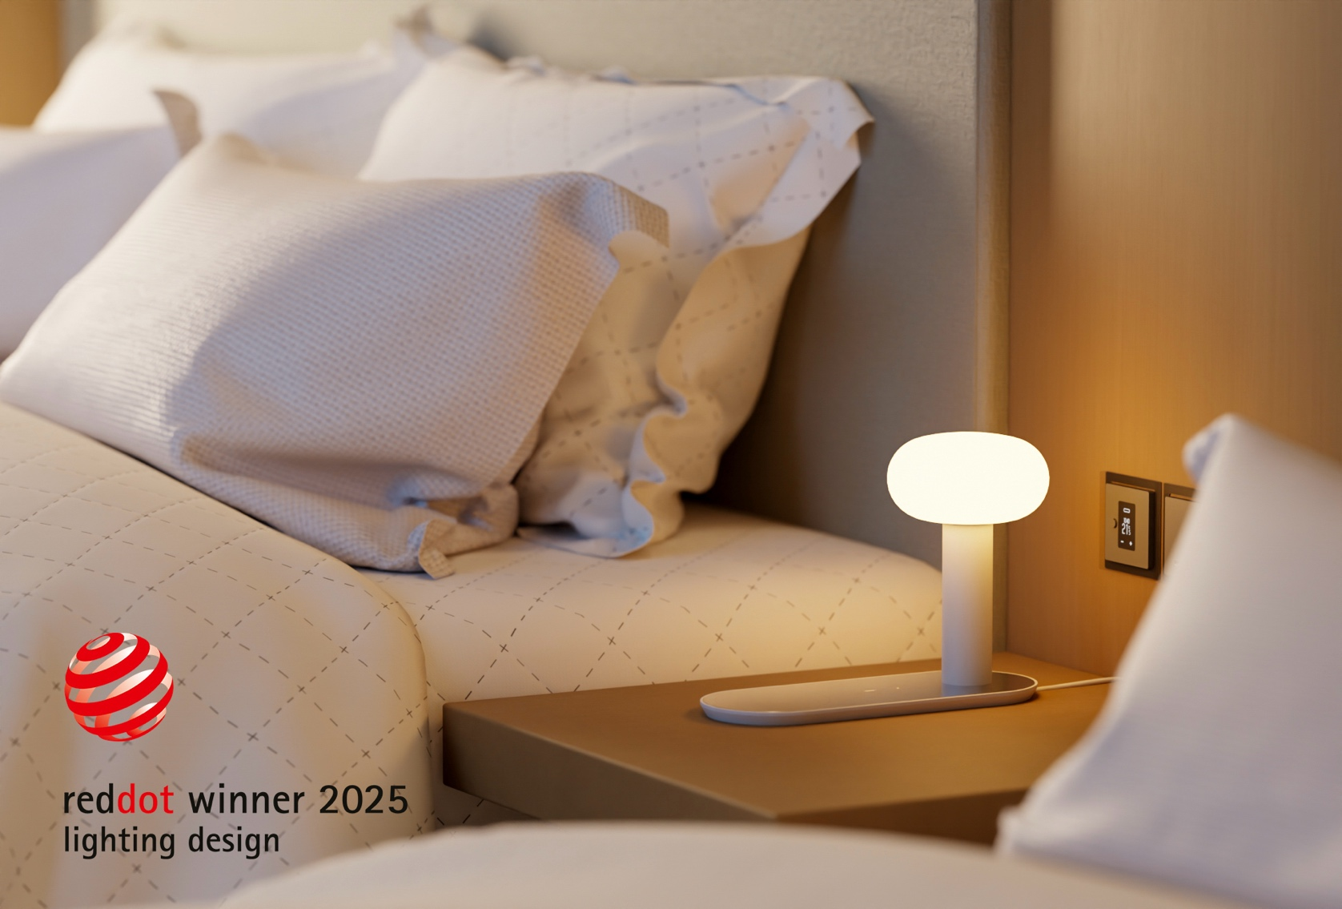

The Red Dot Design Award is one of the world's largest and most renowned design competitions, dating back to 1955. Organized by Design Zentrum Nordrhein Westfalen, the award evaluates submissions based on criteria such as degree of innovation, functionality, formal quality, ergonomics, durability, and ecological compatibility. The Red Dot: Best of the Best is the highest distinction, awarded for groundbreaking design quality to only a select few entries each year.

Further information about the Z-Bar Titan Floor Lamp and Combi Table Lamp can be found below:

- https://koncept.com/Combi-Table

- https://koncept.com/Z-Bar-Titan

For more information about Koncept Lighting and its award-winning products, visit https://koncept.com/About

For media inquiries and further information, please contact:
Leonel Tirado
Email: leonel.tirado@koncept.com
Phone: (323) 261-8999 ext 117

About Koncept:
Koncept is a forward-thinking company dedicated to creating innovative lighting solutions that enhance the way people live and work. With a focus on sustainability, functionality, and aesthetics, Koncept's products bring cutting-edge technology and modern design together to elevate spaces and improve the quality of life. Visit www.koncept.com to explore the full range of products and learn more about the company's commitment to design excellence.

