Interiors brand Corston Architectural Detail returns to show USA product offerings during High Point Market

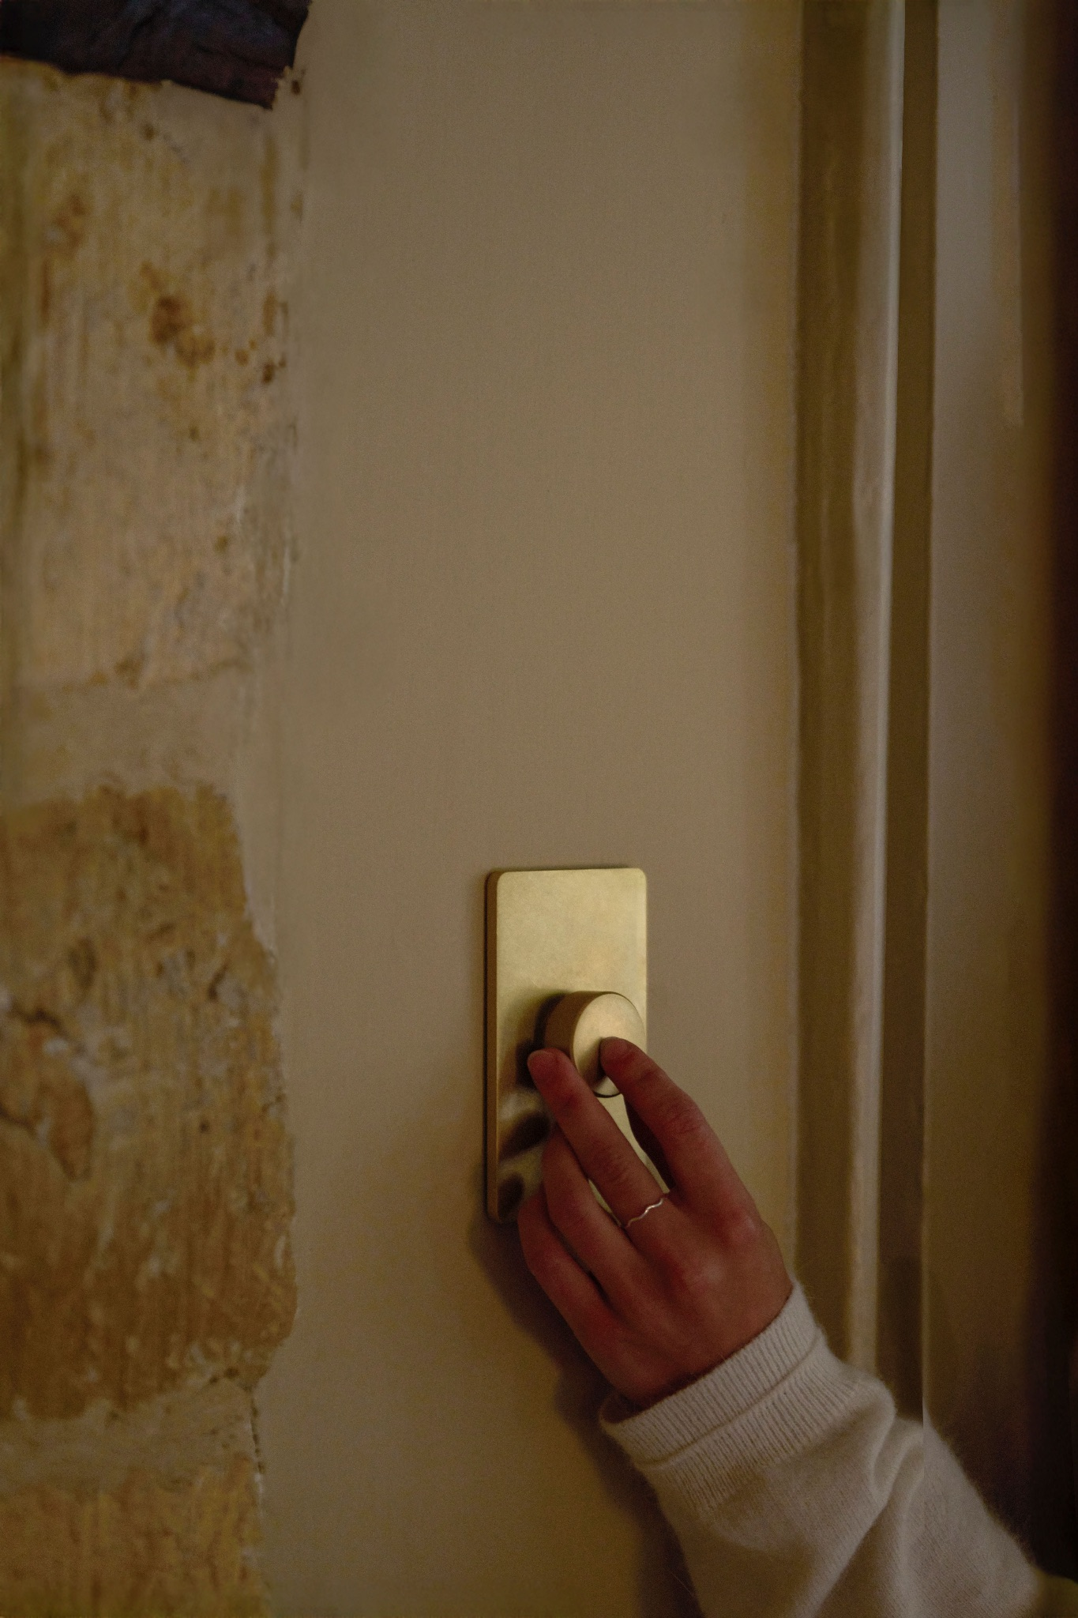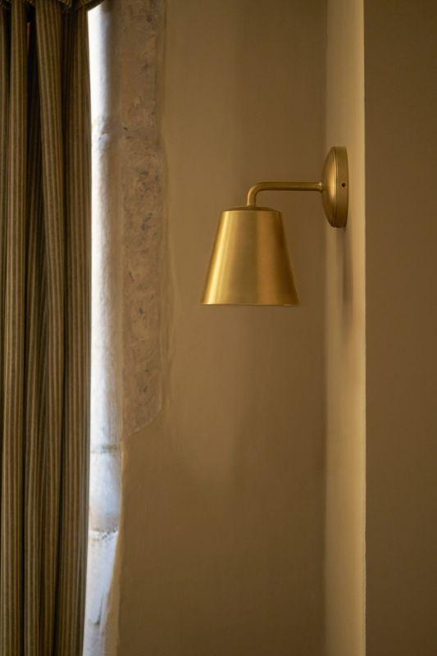

- Originating from England, Corston will exhibit its premium collection of hardware, lighting, switches and outlets at the North Carolina-based design destination event

(NORTH CAROLINA - OCTOBER 2025) Corston Architectural Detail, the distinguished creator of architectural details, will be returning to High Point Market this October. Including its expertly crafted range of wall lighting, the team of creative designers and engineers will be showcasing the latest offering of Corston products from October 25th - 29th. This presentation follows the recent opening of its first North American showroom, located at the prestigious New York Design Center, and marks a significant step in the brand’s global expansion. With products shipping swiftly within the US in just 1–5 days, Corston continues to make its distinctive blend of thoughtful design and quality craftsmanship more accessible than ever to the American market.

Designed and engineered in the UK, Corston specializes in producing high-quality solid brass switches and outlets, hardware and lighting – promising to elevate your interior projects.
Instead of following changing trends, the brand focuses on creating perfectly proportioned, timeless designs to suit both modern and traditional retail and commercial properties. The collections are available in three signature finishes – antique brass, polished nickel and bronze – to ensure that the products from all three categories coordinate seamlessly.
This autumn, Corston’s offering aligns with growing industry interest in authentic materials, heritage-inspired details, and layered lighting. As designers look ahead to 2026, the brand’s focus on longevity, sustainability, and versatility speaks to broader movements in interiors, where enduring design and investment pieces are favored over disposable trends. With brass and natural textures gaining prominence for fall/winter interiors, Corston’s collections deliver timeless warmth and understated luxury.
Featured products include:
- 2G, 3G, and 4G Two-Way Toggle Switches in Bronze, Polished Nickel, and Antique Brass finishes
- Rocker, Toggle, and Dimmer Switches in Clear finish
- Malvern Large Wall Light in Pleated Natural Beige with a Polished Nickel finish
- Claremont and Richmond Medium Wall Lights in Fluted Glass with Bronze finish
- A curated selection of brackets, coat hooks, and door furniture in Antique Brass

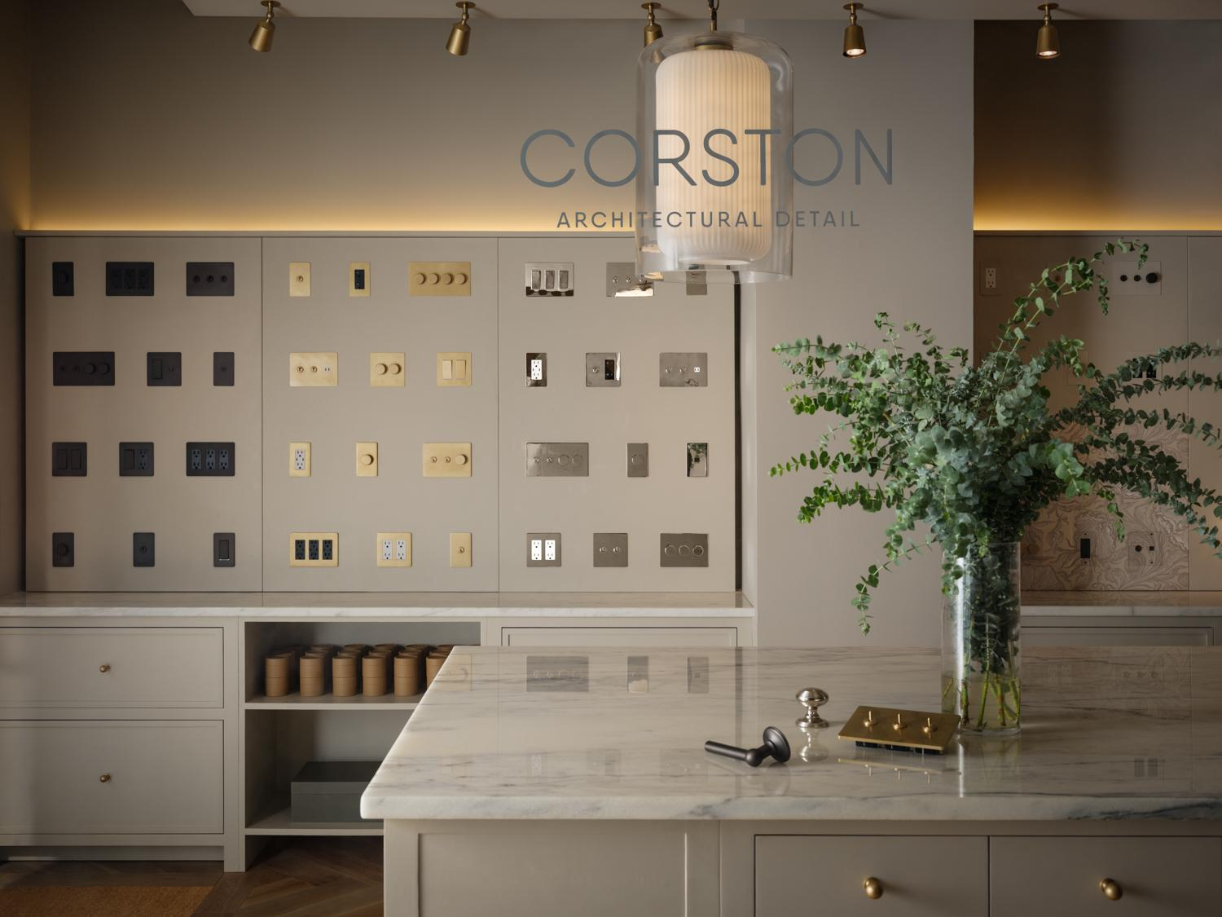
David Gray, co-founder and product director says, “The response from the US has been incredible. Designers and homeowners alike appreciate the craftsmanship and cohesion of our collections, as well as the ease of working with products that arrive quickly and seamlessly. Customers tell us our pieces bring a level of refinement they haven’t found elsewhere, which is exactly what we set out to achieve. It’s rewarding to see Corston becoming a trusted detail in American interiors.”

To view the full product range from Corston Architectural Detail, please visit www.corston.us

ABOUT CORSTON
Based in Wiltshire, England, Corston Architectural Detail was founded by Giles Redman and David Gray in September 2019. Corston is a company of in-house designers and engineers dedicated to supplying customers with quality products that are affordable and timeless.

What began with the dedicated duo has now grown to over 100 skilled professionals. The company believes that the switches, outlets, hardware, and lighting that you use everyday are important and should be developed to the highest standard.
PRESS CONTACT
For further information and images, please contact:
Alpha Kilo
Gabbi Gard / Liza Read
+44 7918702517
gabbi.g@alphakilo.com / liza.r@alphakilo.com

