

FOR IMMEDIATE RELEASE

Sarreid Ltd. Hosts Exclusive Panel: The Modern Design Leader’s Strategies for Long-Term Success

High Point, NC, September 8, 2025 – Sarreid Ltd. is helping professional interior designers expand their business success with an exclusive panel presentation, Business Mastery: The Modern Design Leader’s Strategies for Long-Term Success, at the upcoming High Point Market on Saturday, October 25, at 12:30 PM in the Sarreid showroom on the 3rd floor of the C&D Building. Designers attending the presentation are invited to enjoy a complimentary lunch at 12:00 noon before the discussion begins. RSVPs are appreciated and can be made through Sarreid here.

This dynamic and insightful event will feature four industry titans that will share hard-earned lessons on building a resilient pipeline, crushing it in the booming multifamily design market, and creating airtight billing systems that protect your bottom line. Learn the truth about launching your own product line and learn the signals and timing for scaling—and when smart downsizing is right. For today’s design business pro, this is your blueprint for a stronger, smarter, more sustainable design business.

Panelists are:
Gail Doby, Co-Founder, Pearl Collective – Discover essential financial strategies from the leader of the premier interior design business consultancy.
Christi Spangle, Co-Owner, Barbour Spangle Design & The BSD Group – Learn how to streamline procurement and logistics for increased efficiency and profitability.
Dwayne Bergmann, Founder, Dwayne Bergmann Interiors & Barrett Bergmann Home – Explore innovative revenue-building opportunities beyond traditional design projects.
Tiffany Brown, Founder, Brown Builders Design – Gain firsthand knowledge on successfully collaborating with top builders to elevate your business from someone who is both a professional designer and a luxury custom home builder.

The discussion will be moderated by Mickey Sharpe, VP of Design & Creative at Sarreid Ltd., whose extensive career includes founding and operating his own successful interior design firm, as well as leading creative and product development for Sarreid, a renowned manufacturer of furniture, accessories, and accents for professional designers and high-end home retailers worldwide.

Join us for a lively and idea-filled conversation designed to empower interior designers with actionable strategies to elevate their business leadership and financial success. Don’t miss this opportunity to learn from the best and gain the tools to finally master the complex business of design.

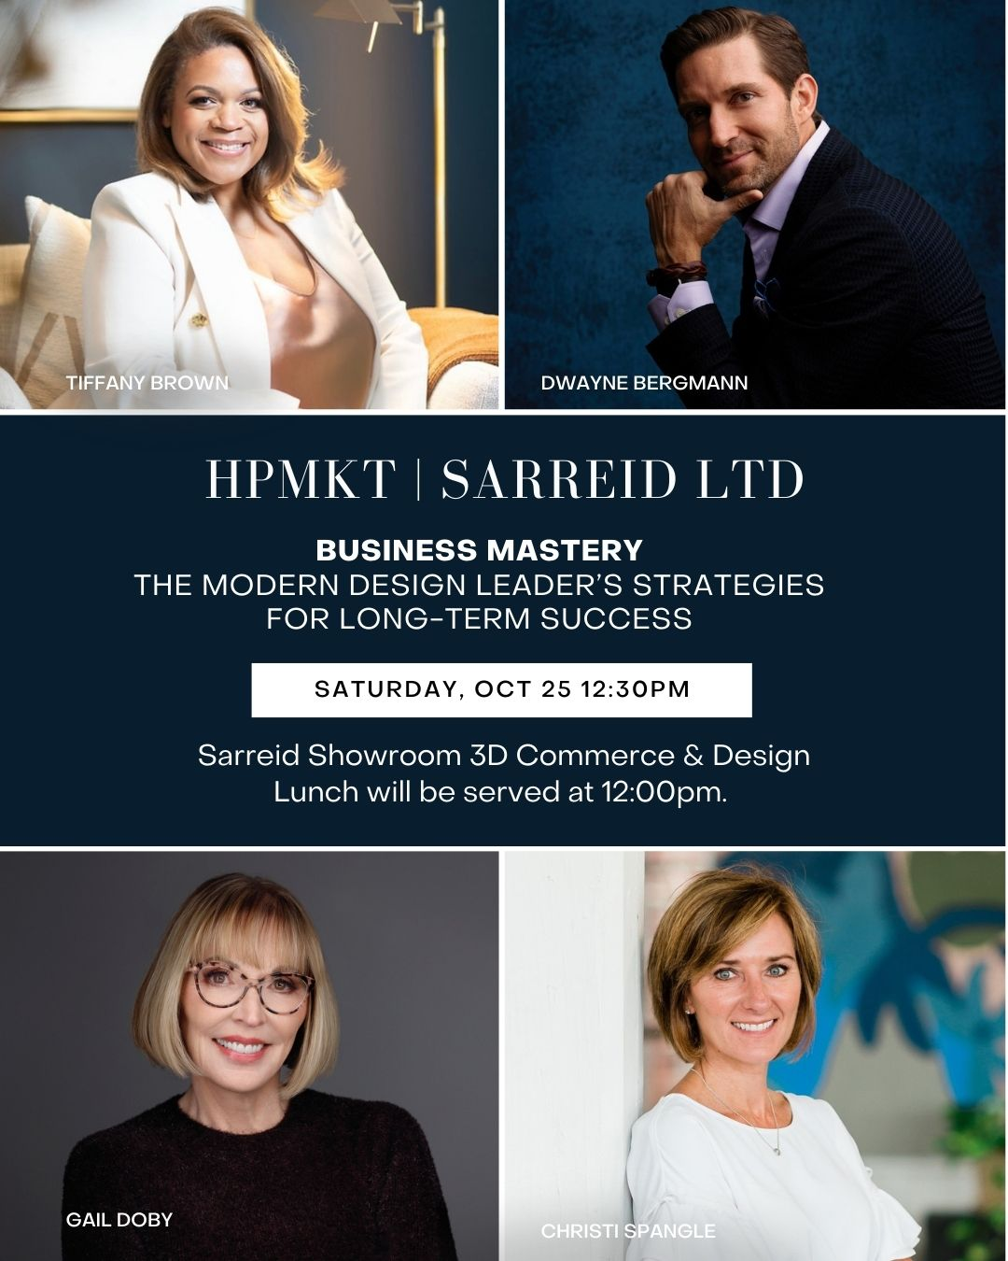

About Sarreid Ltd.
For nearly 60 years, Sarreid Ltd. has been creating heirloom-quality furniture that blends timeless craftsmanship with inspired design. From their home base in Wilson, North Carolina, and their showroom in High Point, they proudly serve designers and retailers around the world. Known for their signature Jupe dining tables — celebrated for their innovative engineering and classic style — as well as finely crafted casegoods, leather seating, and accents, every Sarreid piece is built to be as enduring as it is beautiful. Learn more www.sarreid.com

# # #

Media Contact:
Steadman Lanier
Sarreid Ltd
Director of Marketing
sll@sarreid.com

