

FOR IMMEDIATE RELEASE
Sarreid Ltd. Unveils One-of-a-Kind Pink Jupe Dining Table to Benefit Susan G. Komen at October High Point Market
Wilson, NC, September 8, 2025 – Sarreid Ltd is proud to announce a special philanthropic initiative debuting at the October 2025 High Point Market. The company has created a one-of-a-kind Pink Giselle Jupe Dining Table, to be auctioned with proceeds benefiting the Susan G. Komen Foundation in the fight against breast cancer.
The custom Jupe Table—finished in the signature Susan G Komen pantone pink—showcases Sarreid’s unmatched craftsmanship and innovative design. Known for their signature Jupe dining tables with self-storing leaves, Sarreid has reimagined this timeless design to support a cause that touches countless lives.
The Designing for a Cure campaign will take center stage in Sarreid’s High Point showroom, located in the Commerce & Design Building, 3rd Floor, throughout Market (October 24–29). Visitors will have the opportunity to view the Pink Jupe Table in person and learn more about the auction process.
Bidding will be conducted online throughout the entire month of October, making the table accessible to buyers and supporters nationwide. Proceeds will directly benefit Susan G. Komen, funding life-saving breast cancer research, advocacy, and support programs.

Auction Details:
- Table: One-of-a-kind Pink Giselle Jupe Dining Table
- Where to See: Sarreid Ltd. Showroom – C&D Building, 3rd Floor, High Point Market
- When: Bidding will be the entire month of October. Table will be on display in the Sarreid Showroom October 24–29, 2025
- How to Bid: For more information, please visit the auction site.
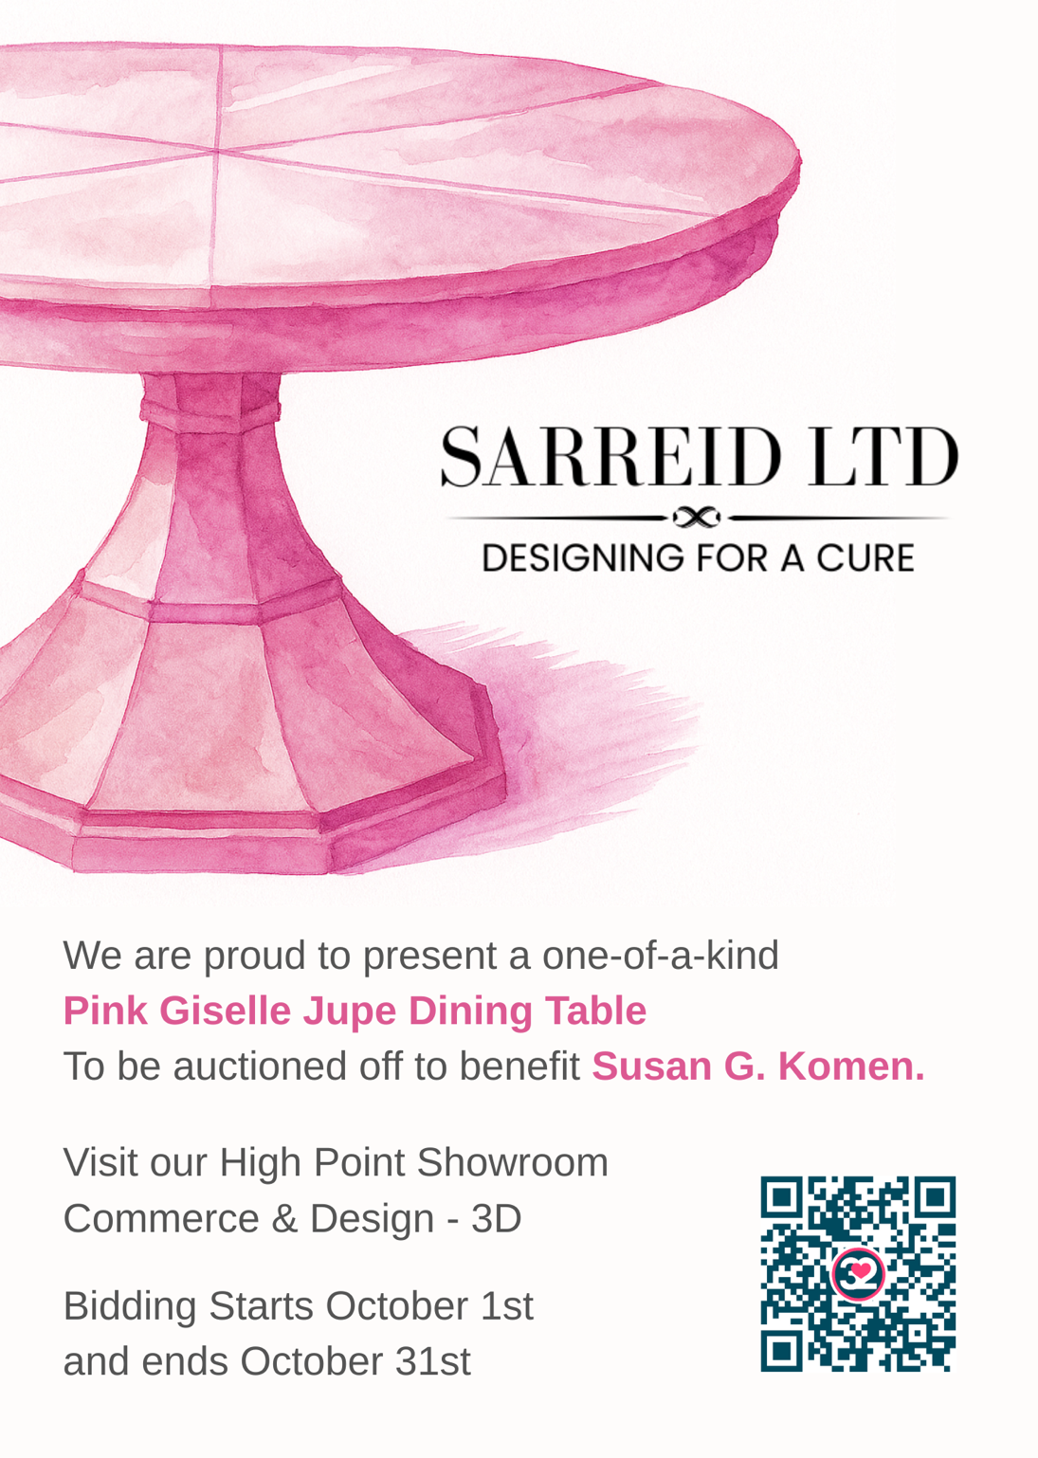

About Sarreid Ltd.
For nearly 60 years, Sarreid Ltd. has been creating heirloom-quality furniture that blends timeless craftsmanship with inspired design. From their home base in Wilson, North Carolina, and their showroom in High Point, they proudly serve designers and retailers around the world. Known for their signature Jupe dining tables — celebrated for their innovative engineering and classic style — as well as finely crafted casegoods, leather seating, and accents, every Sarreid piece is built to be as enduring as it is beautiful. Learn more www.sarreid.com

# # #

Media Contact:
Steadman Lanier
Sarreid Ltd
Director of Marketing
sll@sarreid.com

