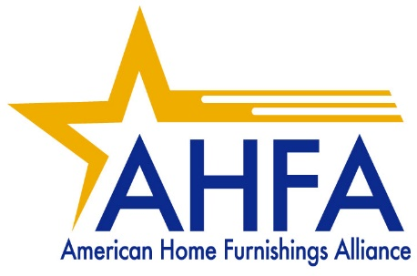

FOR IMMEDIATE RELEASE: FOR MORE INFORMATION:
October 10, 2025 Patricia Bowling, 336/881-1006, pbowling@ahfa.us

FURNITURE SAFETY WEEK SPOTLIGHT:
GET ON BOARD FOR 2026 CAMPAIGN TO MAKE HOMES SAFER
Mystery Safety Advocate Will Join Effort in 2026!
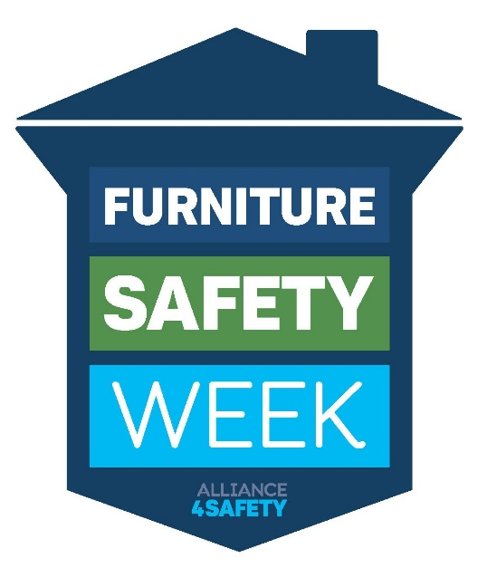
HIGH POINT, N.C. – The American Home Furnishings Alliance (AHFA) and Alliance4Safety today announced that the dates for next year’s Furniture Safety Week will be October 5-10, 2026.

Furniture-related accidents in the home cause thousands of injuries every year, with children under age six and the elderly being especially vulnerable. The annual Furniture Safety Week public awareness campaign aims to educate families about the most common hazards and simple steps that can reduce the possibility of accidents.

“Dozens of furniture companies joined the campaign in 2025. In 2026, we hope to extend participation to include more retail stores,” says Patricia Bowling, AHFA vice president of communications. “We are extending the campaign by one day next year to include a Saturday for store events, and in April we will introduce a new safety advocate that stores can use to help promote those events.”

Bowling said the new safety advocate will be especially appealing to children and add a new dimension to the annual campaign. Guided by retail experts on the Furniture Safety Week Task Group, new resources will be developed to help stores promote the new child-friendly safety advocate. “Stay tuned for more information coming soon!” she added.

Companies interested in participating in the 2026 campaign can sign up now on the Alliance4Safety website.

###

The American Home Furnishings Alliance, based in High Point, North Carolina, represents nearly 300 leading furniture manufacturers and distributors, plus about 150 suppliers to the furniture industry worldwide. The first Furniture Safety Week was held in October 2024. More information is available at https://www.alliance4safety.org/furniture-safety.

