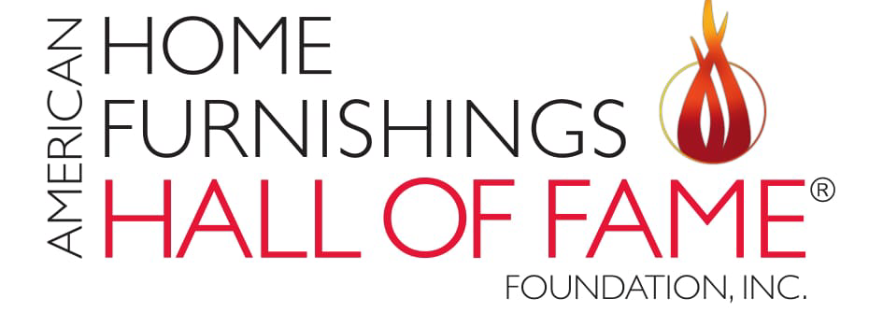

MEDIA ALERT
AMERICAN HOME FURNISHINGS HALL OF FAME® HOSTING SERIES OF EVENTS AT FALL MARKET
HIGH POINT, N.C., Oct. 16, 2025 – The American Home Furnishings Hall of Fame® is hosting several social and educational events during the Oct. 25-29 High Point Market at 311 S. Hamilton St.
Opened in April of 2023, this world-class space provides a place for the home furnishings industry and the public to gather, honor and learn, while also serving as a hub for a host of ongoing activities and events, including workshops, seminars and meetings. For the Fall Market, the American Home Furnishings Hall of Fame also is opening a new lighting exhibit and trend exhibit.
Designed to inspire, the Hall of Fame celebrates leaders and each person who makes the home furnishings industry $150 billion strong. The home furnishings industry holds a unique position at the center of home life.
Where: American Home Furnishings Hall of Fame®, 311 S. Hamilton St., High Point, NC 27260
Schedule of Events:
Ribbon Cutting for New Exhibit: Art of Illumination
Saturday, October 25
11:00 a.m.
Join us for a ribbon-cutting ceremony accompanied by champagne to open a new lighting exhibit exploring the major role that quality lighting plays in delivering fashion and function to homes. The exhibit will show the evolution of lighting over time and is designed to inspire and amaze consumers and industry veterans alike.

American Home Furnishings Hall of Fame Brick Dedication: Pathways of Honor
Saturday, October 25
5:00 – 6:00 p.m.
Join us as we celebrate those newly honored in the Pathways of Honor surrounding the Wanek Family and Ashley Furniture Industries Eternal Flame. The Roll Call of 42 individuals and organizations placing engraved bricks will be acknowledged during a brief ceremony at 5:15 p.m. but the reverential event will last an hour to provide flexibility during busy Market schedules to stop to pay tribute as an “only at the Hall of Fame” moment.

Pinning Ceremony
Sunday, October 26
12:00 – 12:30 p.m.
The American Home Furnishings Hall of Fame Foundation will start the induction process at a moving ceremony to present the coveted Hall of Fame pin to Inductees, along with uncovering their plaques on the Wall of Fame and dedicating bricks that will be permanently placed in the Walk of Fame.

Induction Celebration
Sunday, October 26
5:30 – 9:00 p.m.
Sheraton Greensboro at Four Seasons
3121 W. Gate City Blvd. at I-40
Greensboro, NC 27407
We honor our leaders through induction into the American Home Furnishings Hall of Fame, the industry’s most prestigious honor. The 2025 Inductees are Jeffrey S. Child, president, R.C. Willey Home Furnishings; William A. Hinks, founder and chairman, Furniture Mart USA; Stanley F. Pauley, former CEO and chairman, Carpenter Co.; and Norman Waxman, Norman Waxman Consulting. Hosts for the evening include Erin and Ben Napier, authors, business owners and television personalities.

Trend Seminar: The AI-Fueled Future of Interiors
Monday, October 27
2:00 p.m.
AI is transforming not only how we design but also how we run our businesses. From sourcing to supply chain to client connections, the technology is changing every link in the value chain. With these advances come risks such as lookalike products, predictable spaces, and brands that lose their competitive edge. Join Leslie Carothers, Principal of Savour Partnership; Mark Feng, President of Markor International Home Furnishings; and Ania Sommerauer, VP of Content Strategy at Future Snoops, for a conversation on how to navigate this new landscape. Moderated by Jaye Anna Mize, Vice President of Advisory and Partnerships at Future Snoops, the panel will explore how AI is reshaping creative direction, operational efficiency, and customer engagement, and share practical ways to harness it without sacrificing originality. Attendees will also receive Future Snoops’ new white paper Active Creation in the Age of AI, offering deeper insights and frameworks to help designers, brands, and showrooms thrive in an AI-driven economy.

For more information, please contact:
Lauren Estep
336.882.5900
lestep@homefurnishingshalloffame.com

