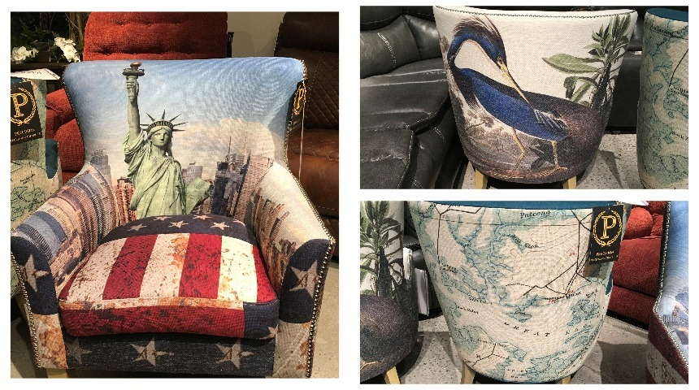
Precision Reclining Chair Co. is introducing new domestic upholstery at High Point Market.
Supplier debuting domestic upholstery, new showroom and chairs as art at High Point
Cindy W. Hodnett //Executive Editor of Brand Development//October 15, 2025

HIGH POINT — In a new iteration of the form and function conversation, Precision Reclining Chair Co. is introducing a line of occasional chairs that can be customized with nearly any art form desired during next week’s High Point Market.
However the list of debuts doesn’t stop with the chairs-as-art products; Precision is also debuting sectionals, motion groups, private-label products, a new showroom and a made-in-America story.
“We are excited to announce our expansion into private-label products for clients seeking exclusivity, as well as OEM design and production services for factories in the United States,” said Michael Parasmo, CEO. “If retailers want private-label and domestic production, we are offering a new option.”
See also:
- HGTV stars set to roll out Artisan & Post bedroom collection at Market
- Upholstery furniture suppliers reimagine home theater and gaming with immersive sound
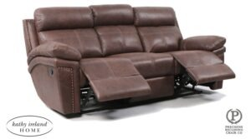Precision is introducing seven new motion groups priced from $1,299 retail.
Parasmo noted that Precision is opening its new showroom in the Centers of High Point|Hamilton building at fall market.
He said that the new space will showcase an expanded product line that includes seven new motion groups priced from $1,299 retail, three new sectionals priced from $2,299 and new occasional chairs priced from $799 to $899. The upholstery features hardwood construction and coil springs, bench-made and produced in U.S. factories.
Parasmo declined to name the location of the U.S. factories, but he noted that he has 20 salespeople and is committed to offering retailers a domestic option during a year that has seen the industry rocked by tariff uncertainty and shifting costs.
“We’re putting a lot of people back to work, and we’re offering retailers more to choose from and a safe, stable option,” he said. “I started in retail, and I know how hard it is. My name is on this product, and I’m a perfectionist, so we’re making sure we do things right. I look forward to talking with retailers about everything we can do.”

