Press Contact: Kameron Lee
Copeland Furniture Marketing and Press Agent
Tel: 616-581-5797
Email: kameron@copelandfurniture.com
“Copeland Furniture Debuts the Whitney Collection designed by Jake Hanson”
High Point, NC - Continuing its tradition of blending natural materials with a minimalist aesthetic, Copeland Furniture proudly introduces the Whitney Collection. This new lounge chair and ottoman was spearheaded by product designer and engineer Jake Hanson, recently recognized by Home Accents Today as one of the industry’s “5 Accent Furniture Creatives to Watch: Up-and-Comers.”
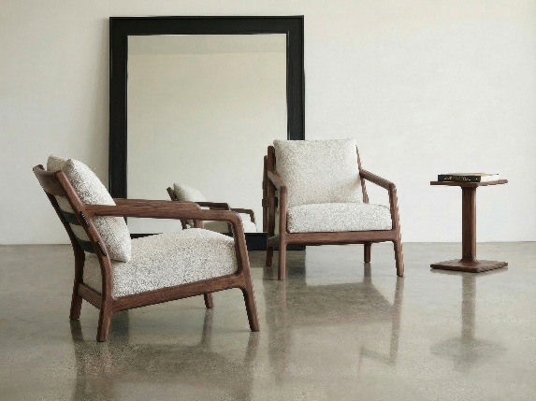
- The Whitney Collection: Defined by a contoured silhouette and flush joints throughout, this new seating line combines advanced CNC technology with traditional craftsmanship for a sophisticated modern aesthetic. The Lounge Chair and Ottoman are crafted from domestically sourced black walnut with a GREENGUARD certified Natural finish. Upholstery options include over 20 in-house fabrics, select Sunbrella collections, and COM.

- About the Designer: Named a rising creative force in furniture design, Jake Hanson brings a profound depth of knowledge and skill to Copeland Furniture. Born and raised in Grand Rapids, Michigan, Hanson began his journey working with local cabinetmakers while still in high school. He later studied at Kendall College of Art and Design, majoring in furniture design, and completing coursework in drafting, woodworking, and metalworking. During his studies, Hanson furthered his understanding of traditional techniques and furniture construction by working alongside Thor and Jorgen Sorensen at Design Quest in Grand Rapids, MI. Driven by a deep appreciation for sustainable practices and the natural beauty of wood, Hanson joined Copeland as a designer and engineer in 2025.
About Copeland Furniture: Copeland Furniture started in the 1970s as a family-owned and operated enterprise. Its mission is to create beautiful wood products from natural hardwood while protecting the beauty of nature. During its many periods of growth, it has evolved from a one-man operation in an old garage in East Corinth, Vermont, to a state-of-the-art manufacturing facility located on the banks of the Connecticut River in Bradford, Vermont. More than four decades later, Copeland Furniture has stayed true to its creed and places high value on quality furniture that lasts multiple generations. It believes that understated, well-designed structures inform our creative sensibilities each day, and continuous improvement allows its company to thrive and excel. For more information, please visit the official website www.copelandfurniture.com.

