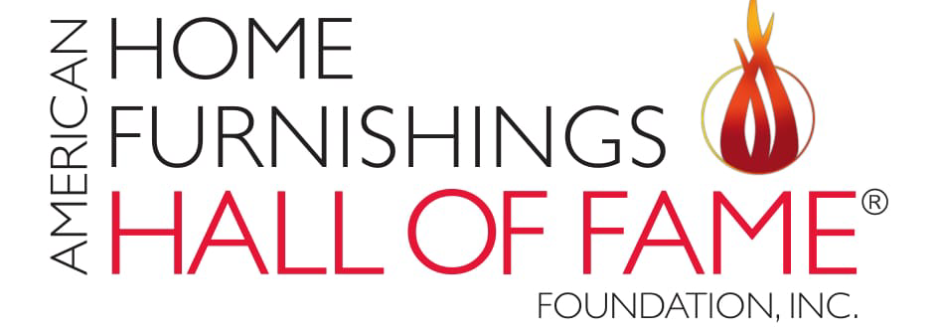
MEDIA ALERT
WHAT’S NEW AT THE AMERICAN HOME FURNISHINGS HALL OF FAME®
HIGH POINT, N.C., April 18, 2026 – Spring Market events at the American Home Furnishings Hall of Fame®, 311 S. Hamilton St., during the April 25-29 High Point Market, include the announcement of the 2026 Hall of Fame inductees, an event honoring five new Paul Broyhill Leaders and the Pathways of Honor brick dedications.
The Hall of Fame also will unveil two new exhibits. The exhibit sponsored by PALECEK focuses on sustainability and the beauty of natural materials. The new trend exhibit from Future Snoops presents Preserve: Designing Cultural Memory Forward.
Opened in April of 2023, the Hall of Fame as the industry’s home, the world-class space provides a place for the home furnishings industry to gather, honor and learn. It has become a living breathing hub for a host of ongoing activities and events, including workshops, seminars and meetings. Designed to inspire, the Hall of Fame celebrates leaders and each person who makes the home furnishings industry $150 billion strong.
Where: American Home Furnishings Hall of Fame®, 311 S. Hamilton St., High Point, NC 27260
Schedule of Events:
Paul Broyhill Leaders Awards Reception and Cocktails
Announcement of the 2026 Hall of Fame Inductees
Thursday, April 23
5:30-6:30 p.m.
Join us as we raise a glass to honor this year’s winners of the Paul Broyhill Leaders Award. Named after one of the industry’s leading families and a company that focused on executive training, the Paul Broyhill Leaders Award is given annually to five emerging young leaders in recognition of their leadership, personal growth, communications skills and commitment to the greater home furnishings industry. The event will end with the announcement of the 2026 Inductees into the American Home Furnishings Hall of Fame.

American Home Furnishings Hall of Fame Brick Dedication: Pathways of Honor
Saturday, April 25
5:00 – 6:00 p.m.
Join us as we celebrate those newly honored in the Pathways of Honor surrounding the Wanek Family and Ashley Furniture Industries Eternal Flame. The Roll Call of individuals and organizations placing engraved bricks will be acknowledged during a brief ceremony at 5:15 p.m. but the reverential event will last an hour to provide flexibility during busy Market schedules to stop to pay tribute as an “only at the Hall of Fame” moment.

Trend Seminar: PRESERVE: Designing Cultural Memory Forward
Monday, April 27
2:00 p.m.
Join us for a seminar as we explore how cultural memory is being reinterpreted across product, space and storytelling today. Jaye Anna Mize, vice president of Advisory and Partnerships at Future Snoops (FS), will moderate a panel discussion among Rydhima Brar, founder of R/terior Studio; Mark Feng, chairman and CEO, Markor International Home Furnishings and sponsor of the event; Christi Barbour, co-founder of Barbour Spangle Design; and Patti Carpenter, Global Trend Ambassador. The Hall of Fame also will unveil its latest Trend Spotter Exhibit from Future Snoops, “Floraison,” a story rooted in heritage, an homage to exploration, timeless artistry and the intricate relationship between humanity and the wilderness.

For more information, please contact:
Lauren Estep
336.882.5900
lestep@homefurnishingshalloffame.com

