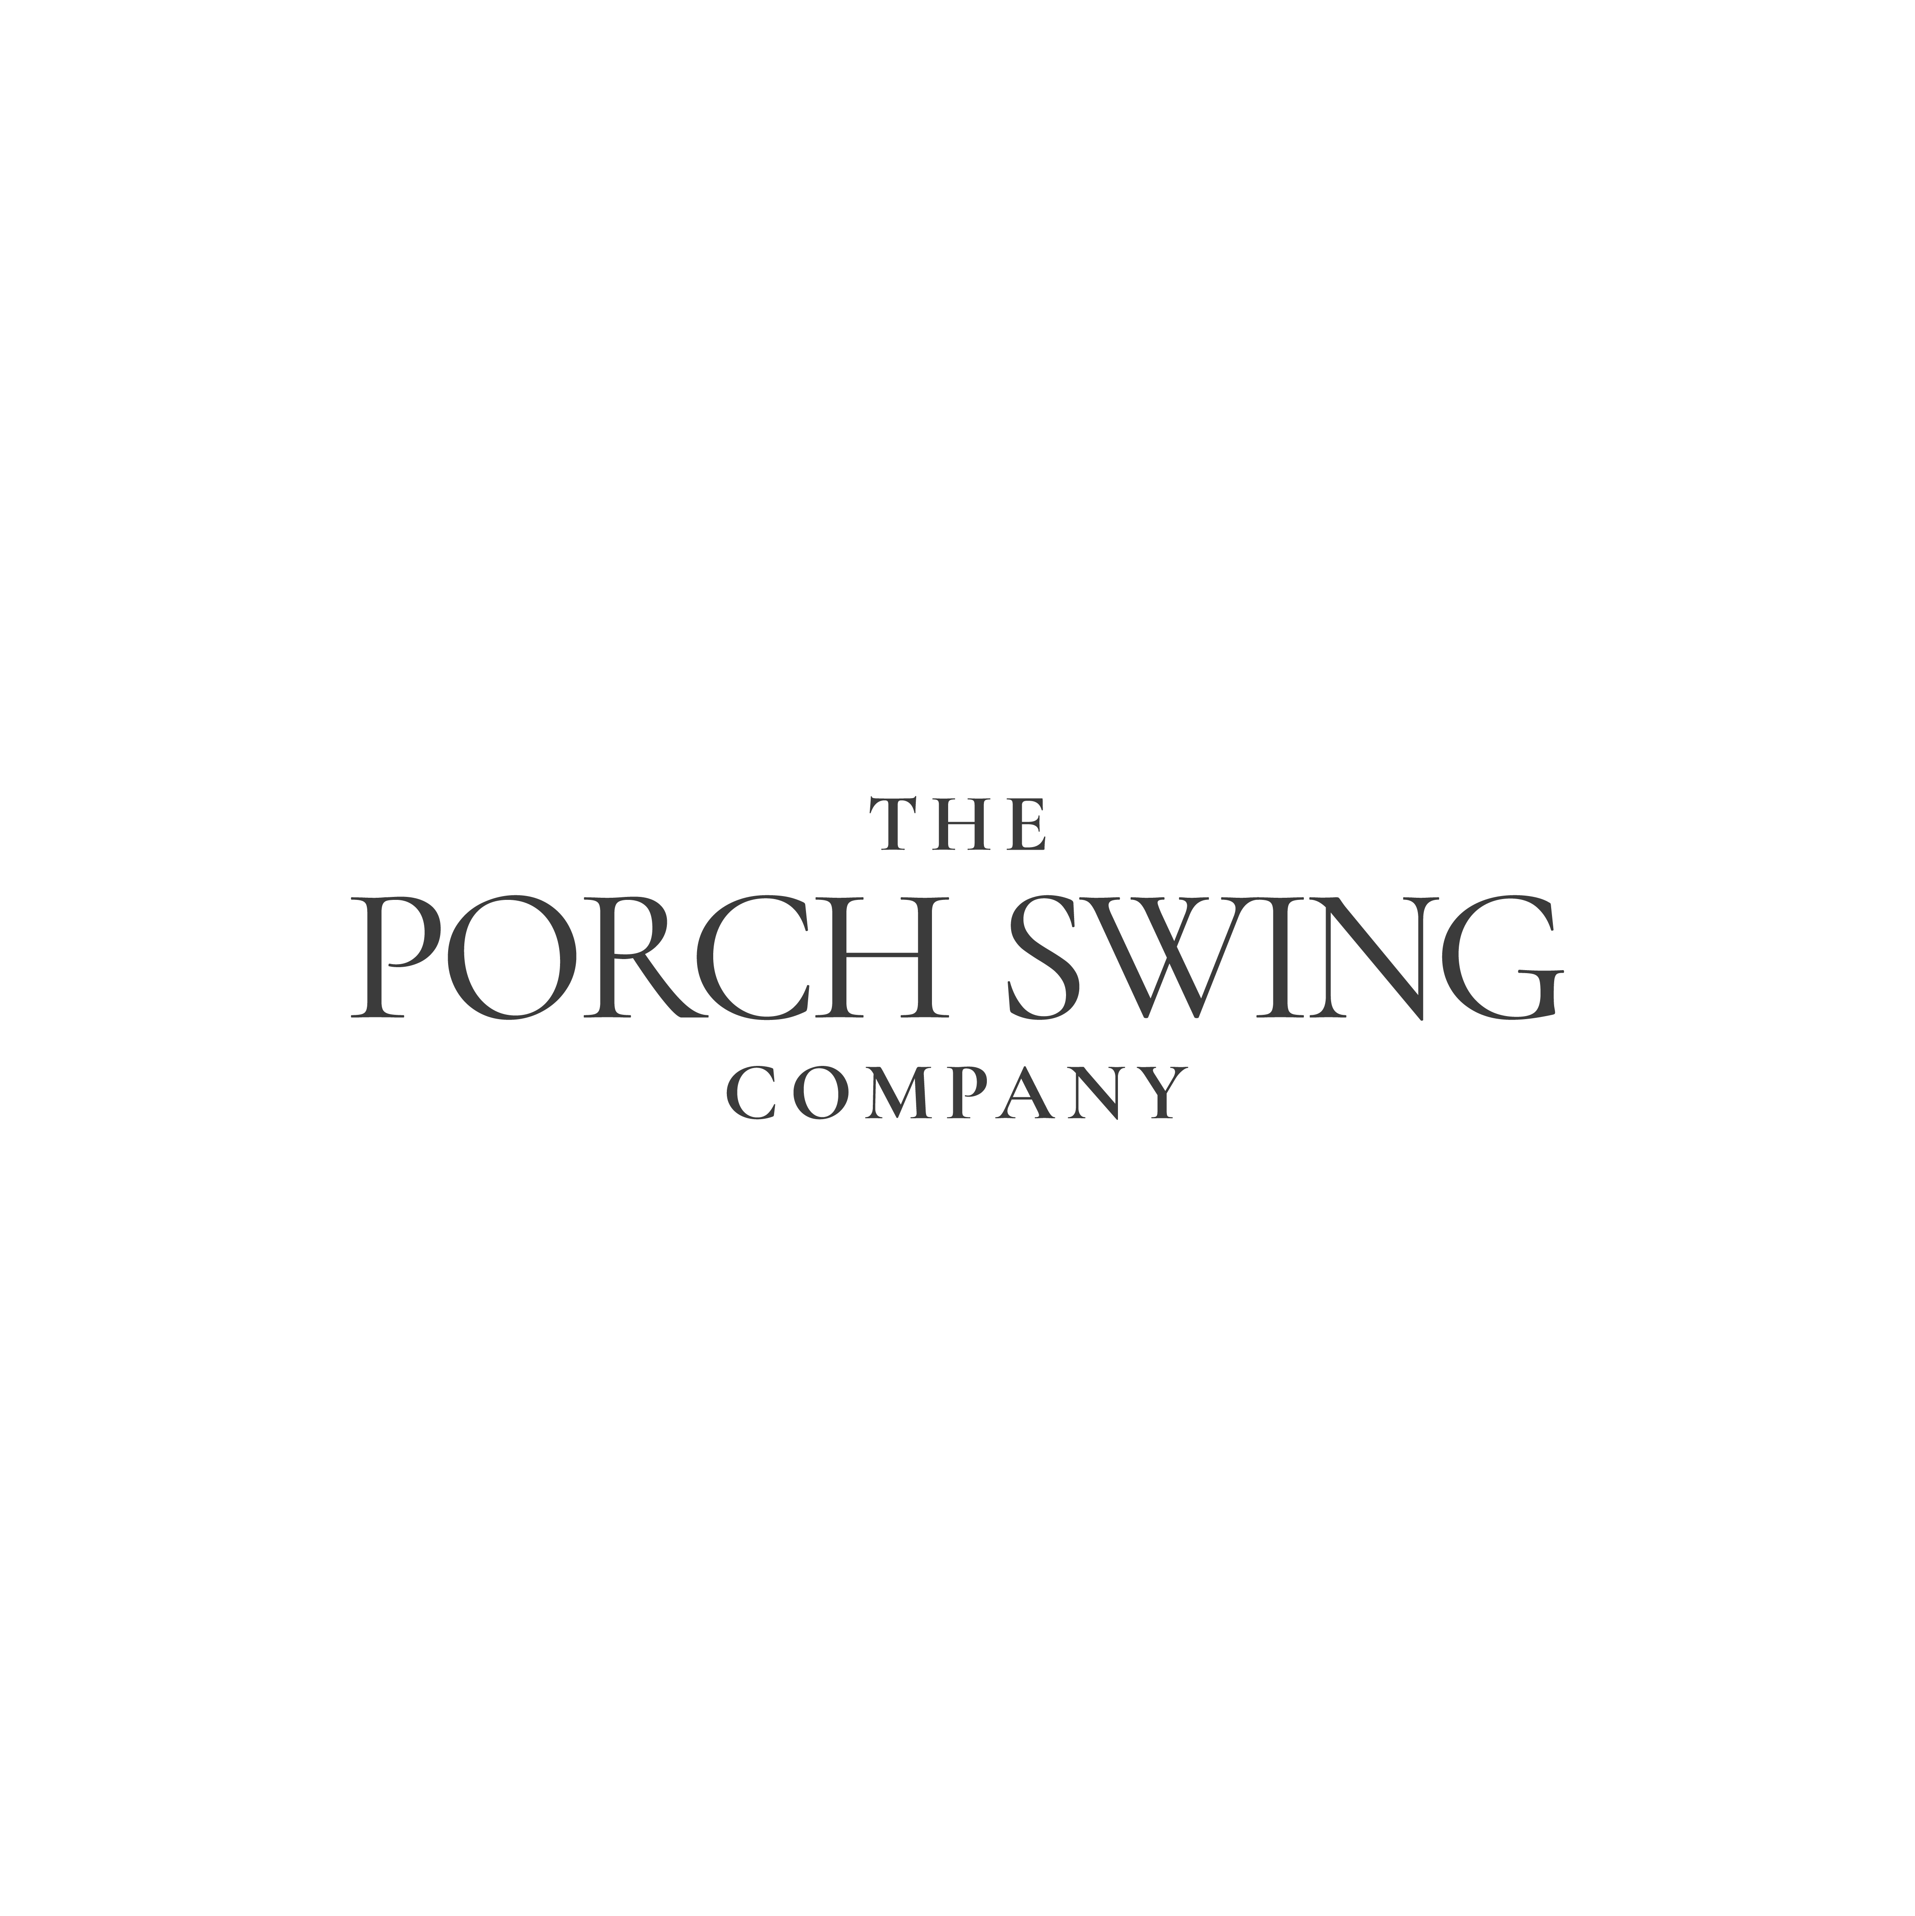

The Porch Swing Company Unveils Its First-Ever Product Collaboration

Old Hickory and Max Humphrey Join Forces to Reimagine Outdoor Living, Rooted in Americana
CINCINNATI, Ohio, September 8, 2026 – The Porch Swing Company, the go-to brand in porch swings, swing beds, and patio furniture and accessories, is proud to announce its first-ever collaboration, uniting storied heritage brand Old Hickory with designer Max Humphrey to bring a fresh and dynamic vision to outdoor living.
“We’ve always believed outdoor living should feel personal because it’s the heart of everything we make,” said Sean Fisher, CEO of TPSC. “Bringing Old Hickory’s craftsmanship together with Max Humphrey’s vision takes that belief somewhere new. This collaboration isn’t just a simple swing; it’s an invitation to feel more at home outside”.
The new Lodge Swing blends timeless craftsmanship with relaxed outdoor living, bringing comfort and character to porches, patios, and lakeside or mountain retreats. With a curated selection of premium Sunbrella® outdoor fabrics from the Max Humphrey collection, it can be tailored to complement any setting—from classic Americana to modern mountain living. Handcrafted in Indiana by the team at Old Hickory, a heritage brand manufacturing furniture since 1899, The Lodge Swing is crafted for lasting beauty and durability. With two classic finishes in Espresso and Green, slatted wood seating, and herringbone Duracane detailing and rushed chain covers, it is designed with thoughtful, rustic character.
The cushion is upholstered in a custom fit in the fabric color and pattern of choice, adding comfort while standing up beautifully to the elements. Heavy-duty hanging chains with galvanized and zinc-plated hardware provide lasting strength and superior resistance to rust and corrosion. Each swing includes black chains.
“Working on this product collaboration together opened our eyes to what’s possible when craftsmanship meets a shared vision,” said Max Humphrey, CEO at Old Hickory. “We took nostalgia as our starting point and pushed every detail to the edge of design.”
The Porch Swing Company is thrilled about this unique and exclusive collaboration: a piece designed not just for a porch, but for a way of living. For long conversations, afternoon naps, and quiet moments outdoors. To celebrate the launch of this new product collection, interested parties can view the product at High Point Market this fall – from October 17-21 – at IHFC: IH409, Commerce, Floor 1, Interhall. A special ‘Meet Max’ event will be held on Sunday, October 18, from 10:00 AM – 1:00 PM, where the designer will be on-site to answer any questions about the collection.
The Lodge Swing will be available for the consumer marketplace and the trade landscape on Tuesday, September 29th. Go to www.theporchswingcompany.com to stay updated on this new collection.

To access and download the full collection of product photography, visit here, and please credit Kaitlin Green: https://www.dropbox.com/scl/fo/3ass6eenm753gernbsvtu/AFIs463c9TO16M3LzvaIkN4?rlkey=dd7o0fz6vckq6esifjmgnsynk&st=labkye4j&dl=0

Media Contact:

Micah Paldino
PB&J
Cell: 513-668-7676
Micah@makepbj.com

About The Porch Swing Company
The Porch Swing Company is an energetic team of outdoor living enthusiasts passionate about helping homeowners and trade professionals create the perfect outdoor space. The team has built strong partnerships with talented Amish artisans across Pennsylvania, Ohio, and Indiana, offering high-quality, handcrafted furniture with exclusive designs and extensive collections that you won’t find anywhere else. In addition, The Porch Swing Company collaborates with top-tier porch furniture brands, ensuring homeowners have access to an exceptional selection from across the globe.

Follow The Porch Swing Company on:
Website: https://theporchswingcompany.com/
Instagram: https://www.instagram.com/porchswingcompany/?hl=en
LinkedIn:https://www.linkedin.com/company/the-porch-swing-company/posts/?feedView=all

About Old Hickory Furniture
Founded in 1899, Old Hickory Furniture is one of America’s oldest furniture manufacturers, known for its handcrafted rustic wood furnishings made in Shelbyville, Indiana. The company’s pieces have furnished national parks, historic lodges, private residences, and hospitality properties for more than 125 years. Learn more at www.oldhickory.com

Follow Old Hickory Furniture on:
Website: https://www.oldhickory.com/
Instagram: https://www.instagram.com/oldhickoryfurniture/
Facebook: https://www.facebook.com/profile.php?id=100082862185972
Houzz: https://www.houzz.com/pro/oldhickoryfurnitureco/

