Amp’s online tools help reps, suppliers, stores
Clint Engel -- Furniture Today, February 24, 2015
View full article here: Furniture Today

SEATTLE — Amp doesn’t offer a brand new technology, but it has seen a rapid adoption rate among industry suppliers lately.
Amp (www.amptab.com) is a digital product catalog. It’s a data standardization tool. It’s a presentation tool used by supplier sales representatives, and it’s a way for both suppliers and retailers to place orders and track order history, availability, sales trends and more.
CEO Patrick Henley and his team began selling the software-as-a-service tool at the 2013 summer Las Vegas Market and to date more than 150 industry suppliers have signed on — sources like Legends Furniture, A-America, Emerald Home Furnishings and Jofran. Most of its customers came on board during the fourth quarter of last year, so the product is on track and momentum is growing, Henley said.
Suppliers are using it to standardize or “normalize” their data, as Amp puts it, and push it out to wherever it needs to go — be it retailer, rep or company manager — in a digital, flexible, organized format.
From the retailer’s perspective, Amp is a platform accessible via the Web or an iPad that helps it gain access to all the information they need from vendors — from high-res images to business intelligence data. Retailers can track their sales and orders and check inventory. They can log onto one platform to access all their information from any supplier that happens to be an Amp client.
Henley and Amp use a solar system model to explain how the software works. It starts with the sun, the first part to be constructed — the content management system. That’s where suppliers dump their data in whatever format they have it.
“We digest it and make sense of it,” Henley said. “Once you’ve done that work, it’s repurposed for all the other planets.”
Those other planets include Venus, which represents print collateral. Suppliers and retailers can print out spec sheets, hanger tags, stickers, point-of-purchase materials and more.
Mercury is the name for Amp’s iPad or iPhone app and website that merges a customer relationship management tool with document storage, digital catalogs, presentation and proposal tools and order processing. It’s set up so the information is stored directly to a mobile device, so sales reps, for instance, don’t have to worry about a slow Wi-Fi connection when they’re trying to make a product proposal to a retailer.
Amp’s vendor customer sees everything relating to its company and controls who sees what within the company and among its retail customers. This may sound like a block on retailers, who may want to see everything a supplier has to offer, and it is. But it’s also efficient for all parties.
“Ask a retailer how many times they’ve tried to order from a catalog something that wasn’t available to them and how frustrating that experience is,” Henley said.
He said Amp is still fine-tuning its pricing model, but in general, it works like this: If a user is using Amp to buy something (a manufacturer buying fabric, for instance, or a retailer ordering a sofa) it’s free. When that company crosses the threshold and uses Amp to sell, Amp starts collecting an “affordable monthly per-user fee,” he said.
Right now, it’s the suppliers using Amp to sell to retailers, but soon the company plans to offer retailers products that tie back into its universe and leading to consumer sales. That includes both retailer and manufacturer websites coming in April; in-store kiosks, from which consumers can browse and order from a supplier’s full catalog in the showroom, coming in June; and point-of-sale multi-vendor digital catalogs, coming to stores in October.
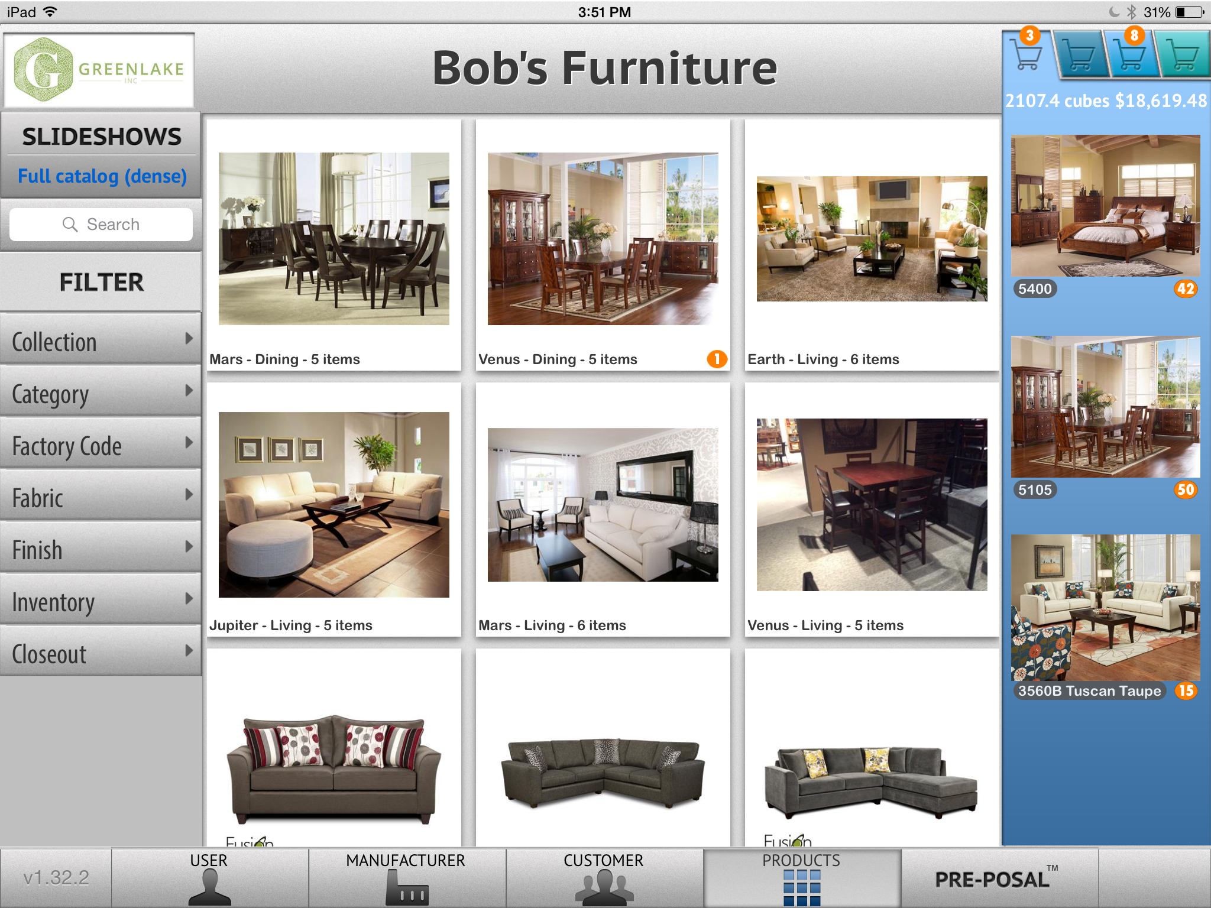
A mock screenshot representing Amp’s iPad app shows a sample “Greenlake” product catalog view for a retailer, with various filter options.

