220 Elm: Discovering Fabulous Contemporary European Style at the High Point Market
Carmen NatschkeNovember 6, 2014Spotlight: Decor & Furniture
Maison et Objet, Ambiente, International Contemporary Furniture Fair and I Saloni – all design shows at which one expects to find contemporary European furniture, decor and textiles. What I learned this fall, is that one would be remiss if they failed to add the High Point Market to that illustrious list of contemporary design shows featuring high-end European style. On the High Point Market campus there’s a building located at 220 Elm that houses a multitude of furniture vendors from a variety of countries. Some with very traditional design offerings, and some who only work directly with big box retailers. However, if you look a little closer you will learn that in that same building there are dozens of European companies being represented including Italian firms Airnova, GyForm, Presotto and Varaschin and others whose names have appeared at Maison et Objet, Ambiente, International Contemporary Furniture Fair, and I Saloni (Milan Design Fair) – all offering exquisite luxury, contemporary European design to the trade and to retailers.
For the fall market, I was invited to visit the building, 220 Elm, to learn more about the diverse group of vendors showing contemporary furniture, decor and textile designs from several European countries including Italy, Norway, Finland, Denmark, Germany, and Turkey in addition to several manufacturers from the United States and Canada who specialize in European style design.
It was a delight to see the sampling of European design throughout 220 Elm. In a way, 220 Elm is like Disney’s international village but filled with wondrous design from European countries that are celebrated for their design acumen and style – all in one place. Below I share a delicious sampling of the amazing designs from some of the fantastic European furniture companies that have a presence and/or a showroom at 220 Elm. So grab a cup of coffee and join me for a thrilling design-filled tour of Europe’s finest contemporary furnishings!

DENMARK
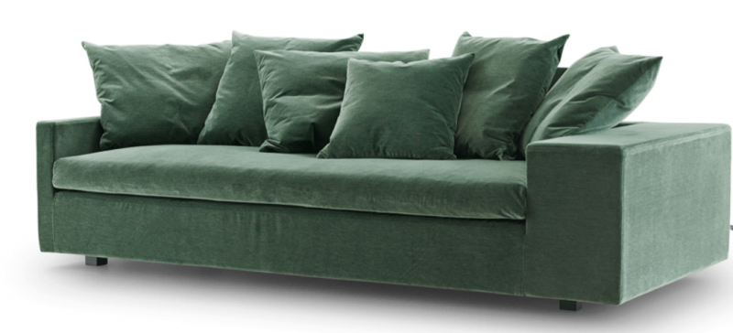
Danish design company Eilersen captivates with its gorgeous aesthetic and incredibly comfortable sofas, ottomans and chairs. Shown above the enchanting, smoky emerald Jazz sofa from Eilersen‘s fall 2014 collection.
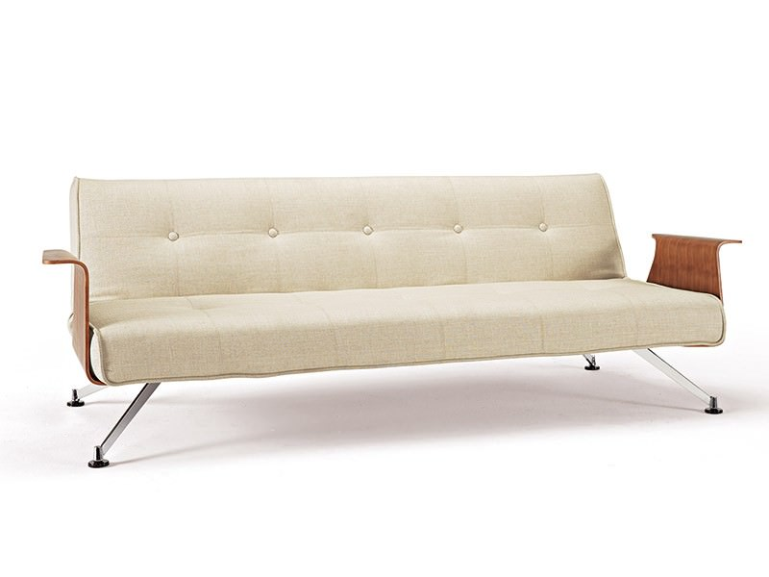
Innovation Living Inc‘s, a Danish furniture maker, brings contemporary fashion styling to daybeds/futons. The classy, mid-century inspired Clubber daybed/futon is the perfect piece for a first apartment or loft space.

FINLAND
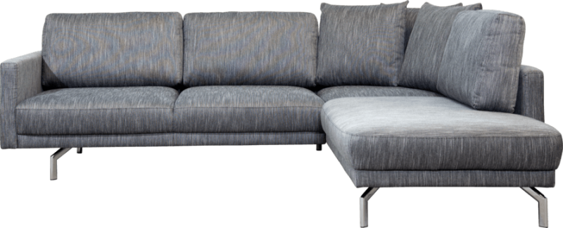
Finnish furniture company Luonto‘s Seiland sectional offers serious style with uncompromising comfort and functionality.

NORWAY
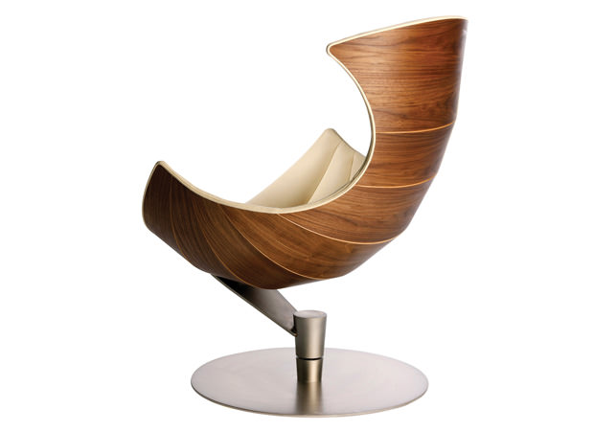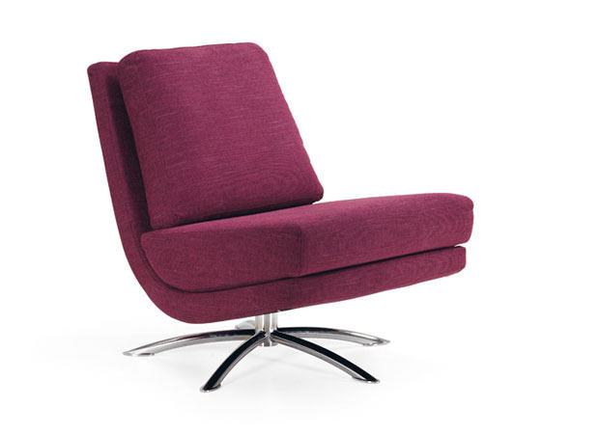
Fjords of Norway : Danish designers Olaf Lund and Eva Parmaann were inspired by the beautiful visual symmetry and embracing, yet protective, exoskeletons of sea creatures like the lobster and calm when designing two of their iconic chairs, the Lobster (shown above) and the Clam. The second chair shown is the Breeze chair designed by Norwegian furniture designer, Cajus Maehlum. Though I find the Lobster chair fascinating from a design perspective, the Breeze speaks to my personal style that blends modern aesthetics with a clear lineage of mid-century influence and just the right touch of elegant glamour.

ITALY
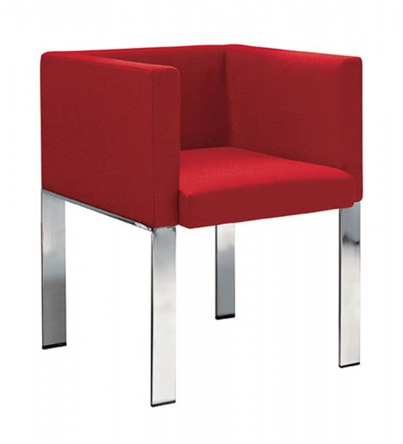
The red cube chair by Midji in Italia offers striking simplicity without sacrificing elegance or sophistication. Available through Leif Petersen at 220 Elm.
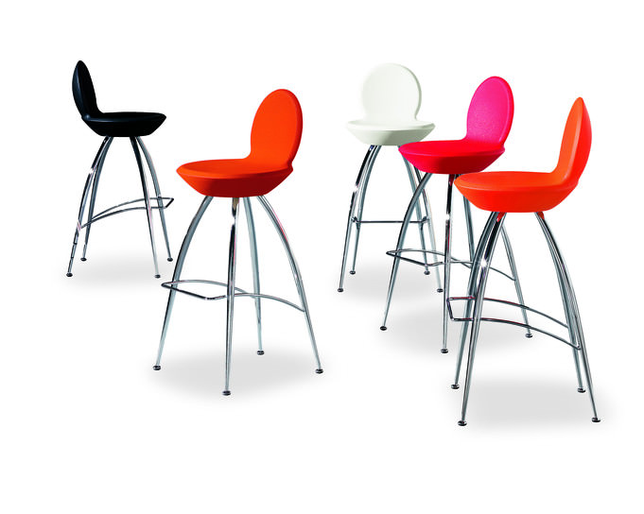
Sophisticated, sleek and so amazing – the Sphera SG65 chairs designed by Roberto Foschia for AirNova Design will certainly turn heads!
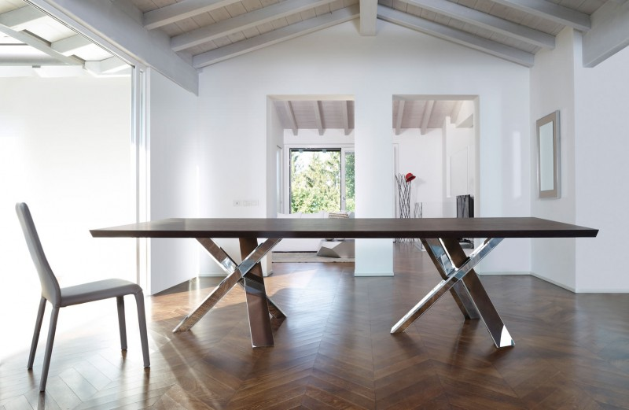
Antonello Italia‘s Twin Resort fixed dining table is a spellbinding sculptural design that redefines what a statement piece should be.
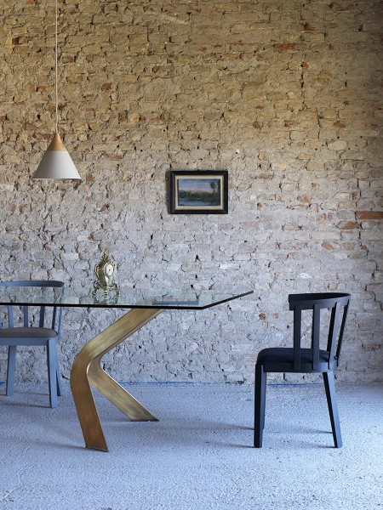
I first saw Miniforms during Il Salone del Mobile in Milan in the spring of 2014, and was pleasantly surprised to see their presence at Leif Petersen, Inc at 220 Elm in High Point this fall. Minforms’ Biped Table is yet another example of the elegant execution of art as design. I really, really, really like this table!
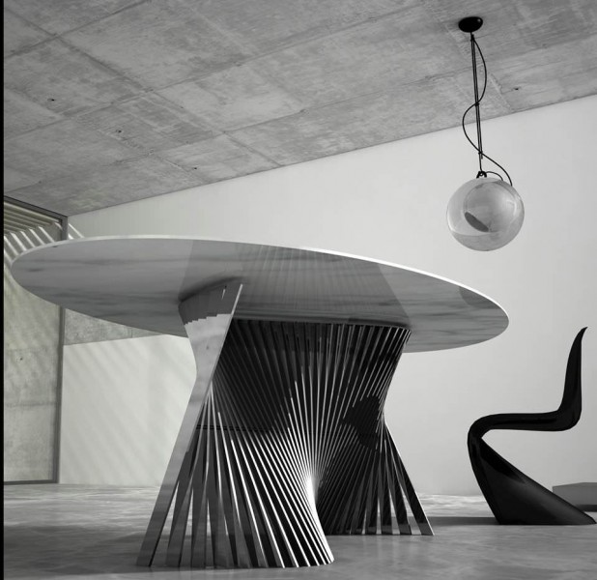
Pratelli Stone‘s exquisite sinuous Floating Blade table captures the very essence of melodious design with a splendid, oval-shaped marble top balanced beautifully atop the curvaceous metal base that conveys an undulating visual movement. Pratelli Stone’s breathtaking table was designed by Gabriele Pinca. Available via Leif Petersen at 220 Elm.

GERMANY
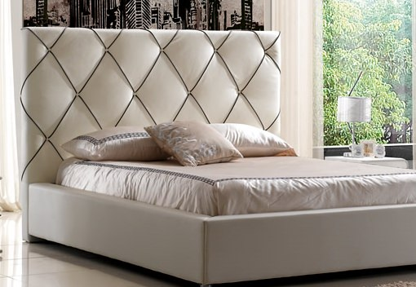
A balanced blend of glamour and storage smarts make an appearance in the Holderlin bed, a modern re-interpretation of Hollywood Glamour design, by German manufacturer, IQ Beds. The Holderlin mattress springs open to divulge a secret storage compartment. This multi-purpose design illustrates the fabulous intersection of form and function that makes this bed the ideal candidate for a small space that lacks storage capacity.
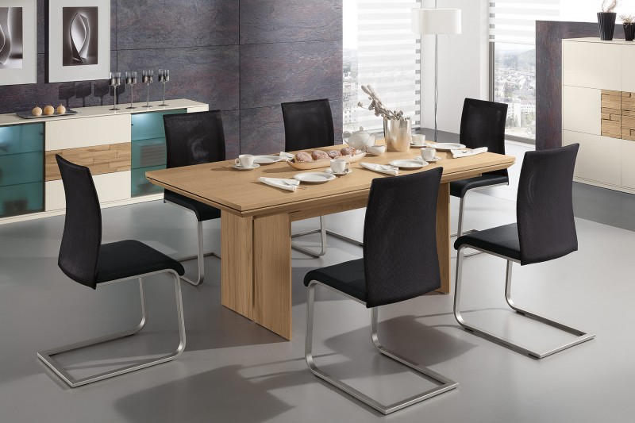
Woessner‘s Bologna dining table and chair collection highlight the beauty in tension of mixed materials, simple lines and strong design silhouettes.
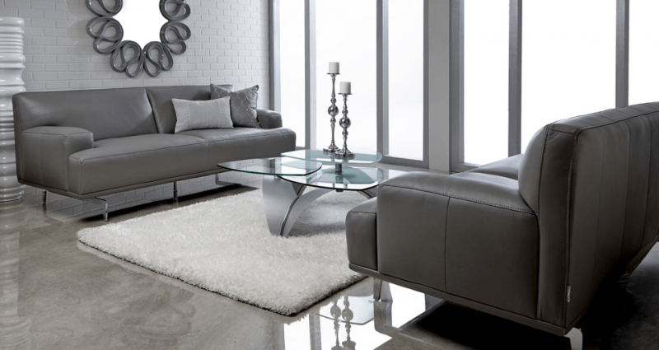
European minimalist design coupled with serious German engineering gives way to the sophisticated style and elegance of leather furniture designed and manufactured by W. Schillig.

TURKEY
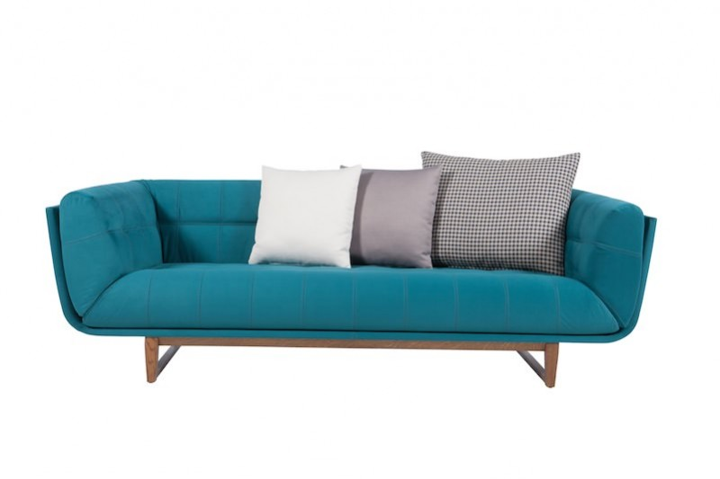
Stunning Peacock Blue Albero sofa by Turkish furniture company, Vanessa.
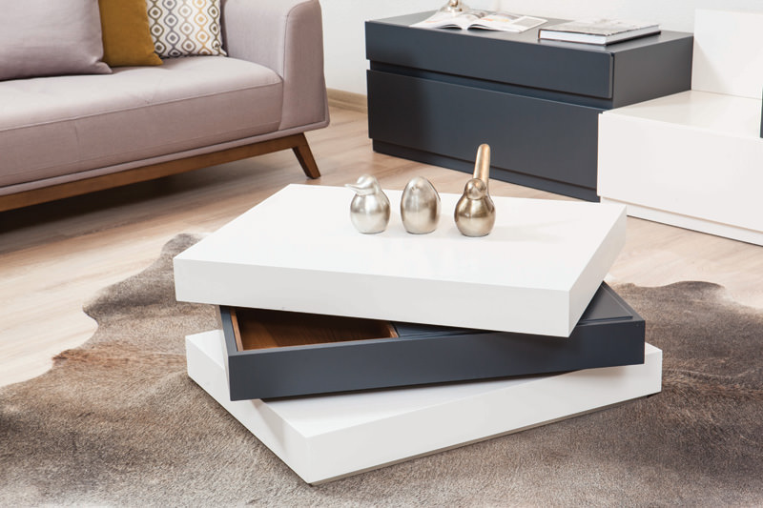
One of my favorite design finds during the High Point market was Vanessa’s Avento table which pivots open to offer hidden storage.

