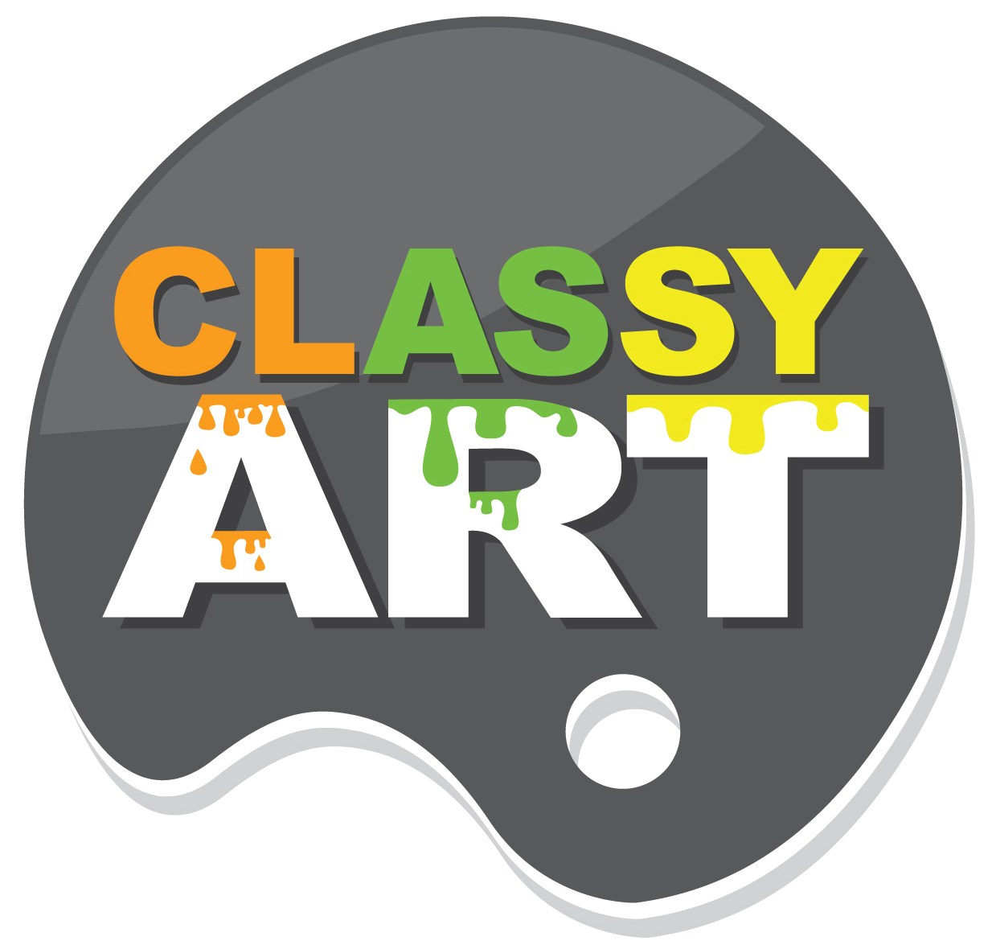

Invite to Press:
CONTACT:
Gabriel Cohen, Vice President
Gabriel@ClassyArt.net
832-256-9087
Ribbon Cutting Invitation

Please accept this invitation to join us for a celebration and ribbon cutting ceremony in our brand new showroom.

Where: Center Point Hamilton (401 S Hamilton St) Ste. 105
When: Thursday April 14, 2016 @ 10AM

We will have light bites and brunch style cocktails (mimosa and bloody mary’s)

