
FOR IMMEDIATE RELEASE
Press Contact: Suzanne Pruitt
678.285.0307 | Suzanne@marshmeadowsmarketing.com

AMBELLA HOME MOVES TO HIGH POINT’S HAMILTON WRENN DESIGN DISTRICT

New Showroom, New Designs Headline 2013 Spring Market Highlights

DALLAS (February 13, 2013) – Ambella Home will open the doors to its brand new showroom in High Point’s Hamilton Wrenn Design District – 310 North Hamilton, Suite 110 – during the April 2013 High Point Market. Formerly located in the IHFC building, Ambella Home’s new and expanded space will put the spotlight on the fine furnishings resource’s evolving product line, custom capabilities and other designer-friendly services.
Editor’s Note: High resolution versions of images shown available by request or download. See end of release for details.

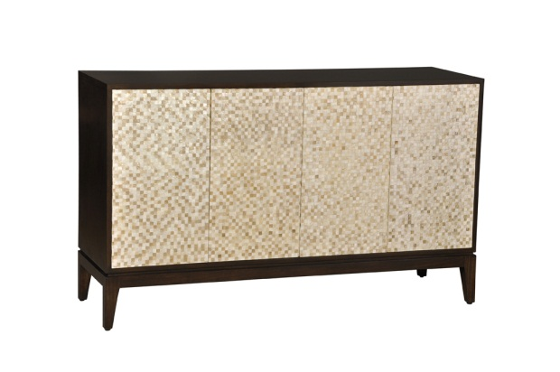
“While we will never lose sight of the richly detailed, traditional looks and styles that have defined Ambella Home, our line has evolved and grown significantly in the last two years,” explains George Moussa, president, Ambella Home. “Our move to the Hamilton Wrenn Design District represents the next step in our long term growth strategy. As a proven market destination for interior designers and innovative dealers, the Hamilton Wrenn location will help us expand our reach and communicate our line’s new directions. The expanded space also provides a chance to showcase fresh new designs and merchandising ideas to our established customers too. “
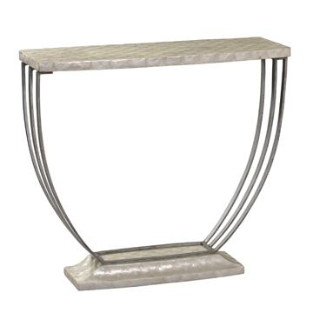
During the Spring 2013 Market, Ambella’s new showroom will highlight many of the timeless classics that remain at the heart of its full collection of accents for every room in the home. In addition, the space will also host the debut of Ambella’s newest designs -- many reflecting lighter finishes, cleaner lines and a touch of simple elegance. Details on the company’s custom capabilities, including the popular Fabric Program inviting designers to place custom fabric and leather selections on any of Ambella’s chairs, will also be highlighted in the space.

Plans for a special ribbon cutting and grand opening celebration are also in the works with more details coming soon. Among the Spring Market highlights:

#02261-630-001 Luster Sideboard (above) - With capiz shells hand-applied in a mosaic pattern, the four doors along the sideboard’s front create a richly textured, shimmering effect. Providing a simple, elegant contrast, the doors are framed by a base of Gmelina solids in a dramatic, dark finish. 60”w x 19”d x 36”h.

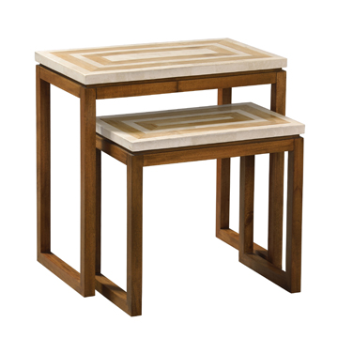
#02260-850-001 Chronos Console Table (right) – Named for the Greek god of time, this design embodies timeless style and elegance. Renowned for their translucent quality, capiz shells embedded on the top and base create a light, airy accent. A lightly finished, curved metal base completes the look. 36”w x 13”d x 32’h
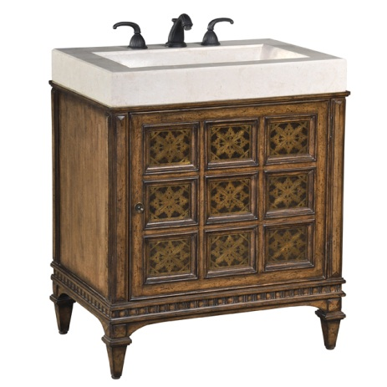
#02268-900-001 Gigi Nesting Tables(left) – Clean lines and simple styling come together to offer a versatile accent for any décor. Blending white agate fossil stone with bamboo inlay, the geometric pattern along the table tops is accented by the simple design lines on each base. 24”w x 14”d x 24”h.

06779-110-100 Jordan Petite Sink Chest (right) – Offering a rich blend of textures and tones, the base of this sink chest design is crafted from Gmelina solids adorned with etched brass detailing. A one-piece white agate fossil stone top/sink lends a rich contrast to the warm wood tones. Dimensions – 30”W x 21”D x 36” H.

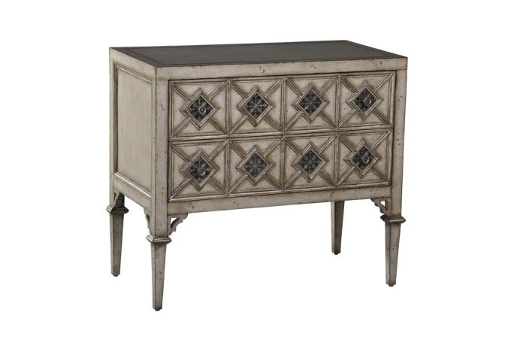
#06786-830-001 Cadella Chest (left) – Finished in a richly textured, burnished silver, this sophisticated style is crafted from Gmelina solids. Adding a touch of texture and depth, the patterned drawers are highlighted with inlaid, etched brass detailing . 38.5”w x 20”d x 34”h.

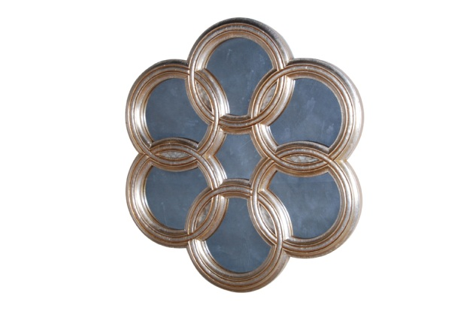

#27035-980-050 Accord Mirror (right) –A striking wall statement for any casual or contemporary setting, this versatile accent links concentric circles made from Mindi solids and finished in a burnished gold leaf. 50”w x 2.5”d x 46”h.

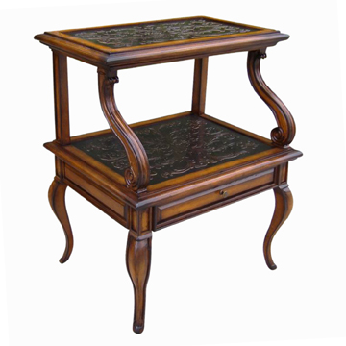

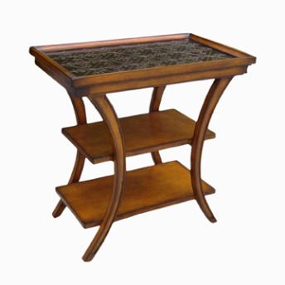
Cambridge Collection Accent Tables – Ambella’s new Cambridge Collection features a number of accent table designs in a variety of sizes and finishes – each with beautifully embossed panels inspired by English furniture designs of the 18th and 19th centuries. Shown: (left) #20097-900-001 Cambridge Step Accent Table – 21”w x 16”d x 25”h; (right) #20097-900-051 Cambridge 3-Tier Accent Table –24” x 14”d x 24”h.

ABOUT AMBELLA HOME Headquartered in Dallas, TX, Ambella Home was founded in 1995 by George Moussa, son of Best Designs Founder, Stanley Moussa. Each piece in the line is uniquely designed and manufactured. A meticulous production management process ensures that every item consistently embodies the company’s signature hallmarks of beautiful design and quality craftsmanship. Skilled carvers, craftsmen and artistic finishers use only the finest materials and best techniques to handcraft each design. Over the years, the Ambella Home line has grown to include fine furniture and home accents for every room in the home, including sink chests, dining/occasional tables, wine bars, chests, cabinets, sideboards, desks/ home office, bookcases, curios, armoires , media cabinets, seating, beds, fireplace mantles, mirrors, pedestals, columns and other designs. For more information, visit www.ambellahome.com or call 214.631.8901 or write: 4910 Lakawana Street, Dallas, TX 75247.
EDITOR’S NOTE:
High Resolution Versions of Images Shown Available Via Request to Suzanne Pruitt at Suzanne@marshmeadowsmarketing.com or 678.285.0307 or download:
Click here to download via yousendit.com link here:
http://www.yousendit.com/download/UW14SmIySytRR2NYRHRVag
Or ftp download:
Go to : ftp.spearktek.com
Login: 3mweb | Password: 3m30144
Folder: Ambella |Spring High Point 2013

