
PRESS RELEASE

Release Dates: Digital 7/26/16

Release Dates: Print - ASAP

CONTACT: Gabriel Cohen, President
Gabriel@ClassyArt.net
832-256-9087 cel.
Classy Art introduces its Rose Gold Collection

Houston, TX July11, 2016—Classy Art is pleased to announce its newest collection. With the latest Classy Art “Soothing Elegance” ad campaign they are introducing a whole new look to the world of wall décor.



With all the craze surrounding the latest Rose Gold trend, Classy Art has stepped out of their box in a “BOLD” way.

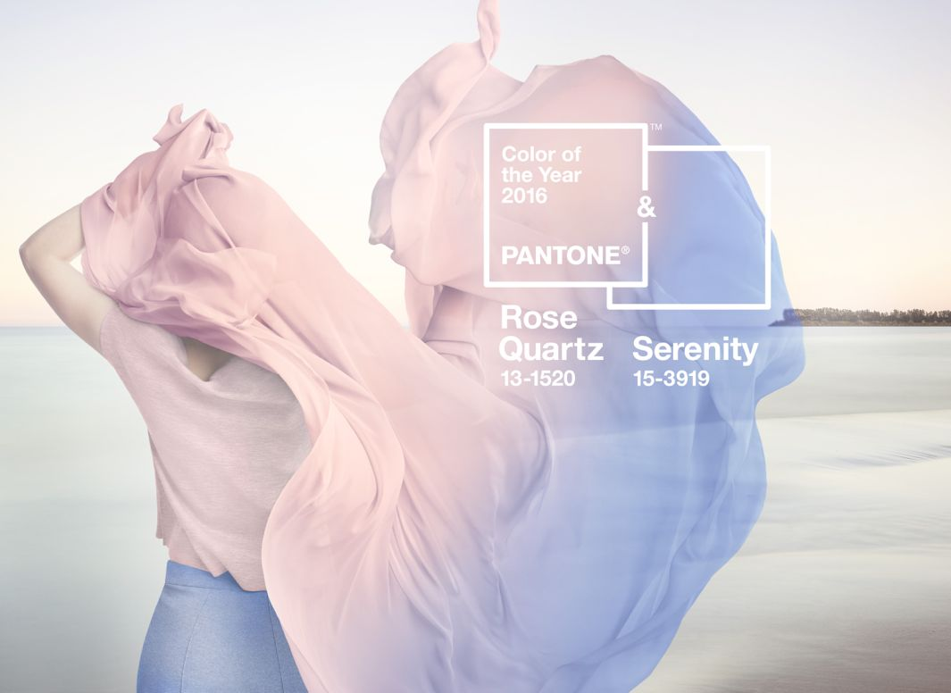
When used by jewelers the term “Rose Gold” refers to an alloy of gold to which copper is added. The New Yorker says, “Rose Gold is decadent. Flattering to most skin tones-a youthful-seeming blush is highlighted, or perhaps induced, by rose gold-the shade has spread to fashion, accessories, and beauty.” Pantone’s colors of the year Rose Quartz is a seemingly nonmetallic version of the Rose Gold that is growing popularity, as well as its perfect opposite Serenity. Coincidence? We think not. Leatrice Eiseman, Executive Director and color expert at the Pantone Institute says, “There’s a lot of research that goes into what color means, and how it makes a statement to most people.” Rose gold has the same effect on almost everyone. “When we get to the rose family, we get these same kinds of verbiage: Compassion, composure, warmth, something that draws you in that has great appeal.” Eiseman says, “Rose gold is compelling, because it offers a subtle sense of peacefulness. It’s soothing and calming.”

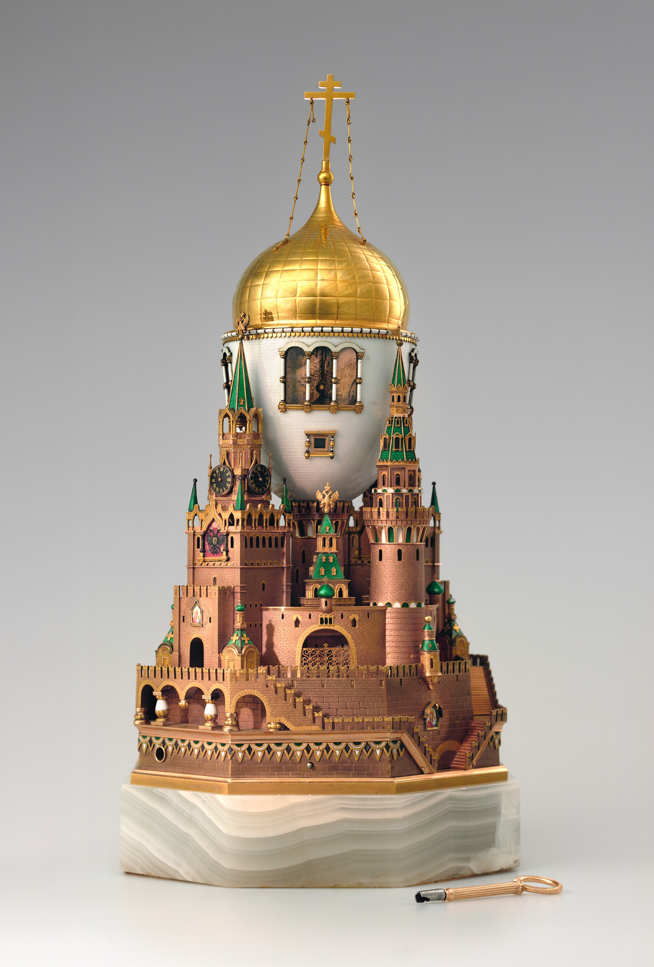
Though this gorgeous new metallic finish is setting shelves on fire, it is far from new. Rebecca Mead from The New Yorker explains, “Carl Fabergé, jeweler to the Czars, put rose gold to spectacular use in many of his most ornate decorative eggs, including the celebrated “Moscow Kremlin” egg—a gold-and-white enamel egg set into a replica of the fifteenth-century Spasskaya Tower, overlooking Red Square. Commissioned by Nicholas II as a gift for his wife, the Empress Alexandra, the egg cost 11,800 rubles—Fabergé’s most expensive commission among many costly ones.” It was later popularized by jewelry designs like Cartier in early Art Deco period.

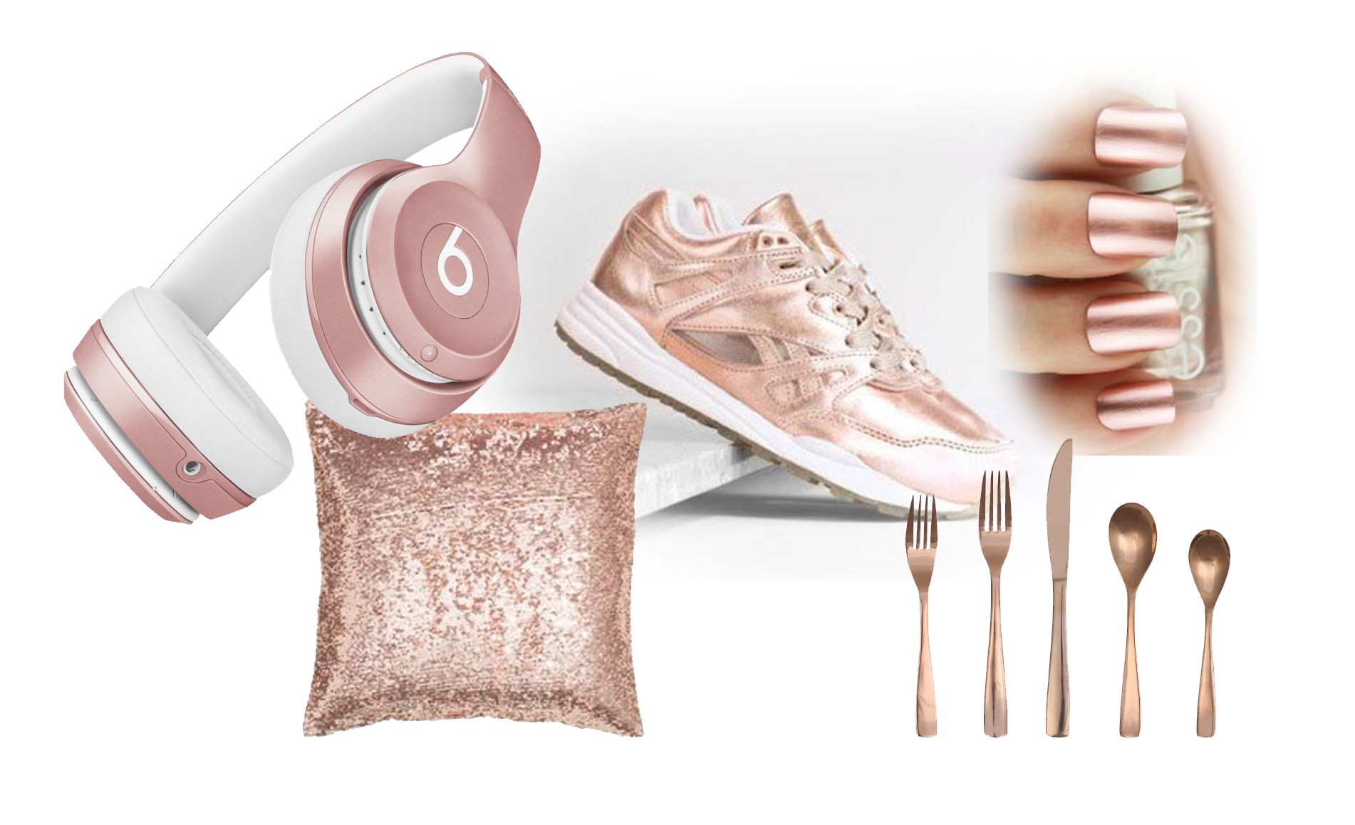
Manufacturers in this millennium have been using Rose Gold to bring new appeal to products with various levels of success. Some would say that Motorola did well when they introduced their pink Razr flip phone, but maybe they would have been more successful using more elegant name like Rose Gold. Michael Kors has also made quite a splash making Rose Gold a household name with their watches and jewelry. Then Apple released its Apple Watch in a very limited Rose Gold version with a hefty price tag of $10,000 that people started to really pay attention. It wasn’t until they released an open edition Rose Gold iPhone that headlines read, “The Internet Has Lost its Damn Mind About the New Pink iPhone,” as the article was titled in Buzzfeed. It was a genius marketing tactic by Apple, and it has paved the way for today’s hottest trend across so many different markets. From apparel to gadgets and cosmetics to cutlery, Rose Gold is taking retail by storm.

You can buy a Rose Gold crocodile-embossed clutch from Diane von Furstenberg, a satchel from Alexander Wang, or even a floor length version of Herve Leger’s legendary bandage dress in Rose Gold. Need a cuff? For only $25,000 Tiffany has the “bone” cuff designed by Ela Peretti.

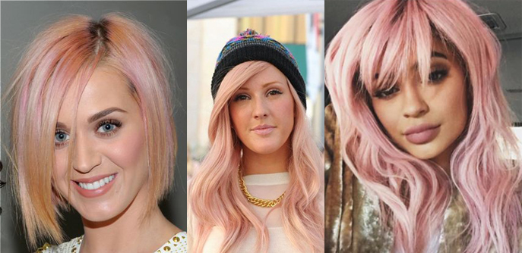
Not convinced yet… Here are just a few celebrities sporting their new Rose Gold hair styles. A-listers Katy Perry, Kylie Jenner, and Drew Barrymore are among many getting in on the trend. From casual to the red carpet, InStyle magazine says, “Kate Bosworth Looks Like a Real-Life Princess in a Rose Gold Jason Wu Dress.”
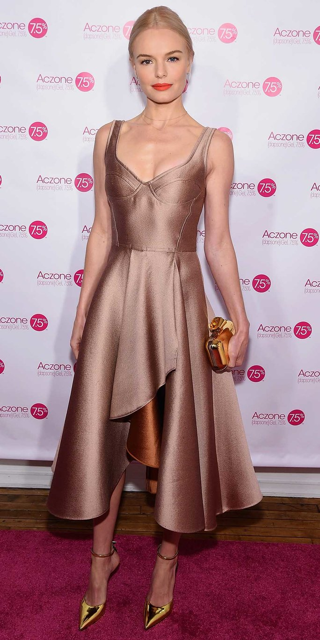
For decades, Classy Art has been known as the place to get promotionally priced wall décor, and though they do not intend to get away from the aggressive pricing strategy that their customer know them for, the company has made a commitment to bringing fashion forward products to a broader mass market price point. This hot new collection is going to be released at the same promotional price points that Classy Art’s customers are accustomed to.

“I think there is a major gap between what people want and what they can afford in this country. Marketers and advertisers across all industries whether, apparel, tech, or even real estate, present us with celebrities wearing jewelry, using gadgets, and living in houses most of us can’t afford. By the time the trend has moved through its life cycle and finally made it to a popular price point for the masses to afford, those same marketers and advertisers are showing us new trends. We are simply trying to close that gap.” –Gabriel Cohen, President, Classy Art LLC.

Classy Art’s latest rebranding at the April High Point market stunned retailers, reps, and press alike, in their first big push towards the fashion side of the business, and this collection is sure to capture their attention again.

