

FOR IMMEDIATE RELEASE:
CONTACT:
Gabriel Cohen, Vice President
Gabriel@ClassyArt.net
832-256-9087
Pokémon Go and Classy Art

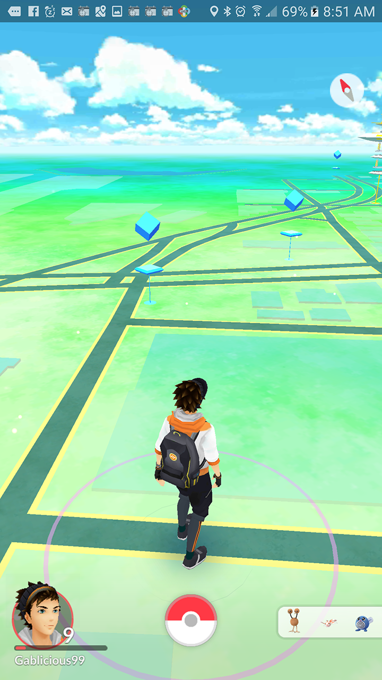
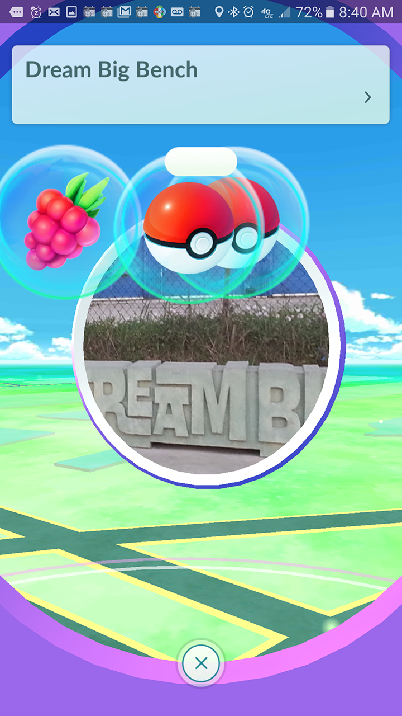
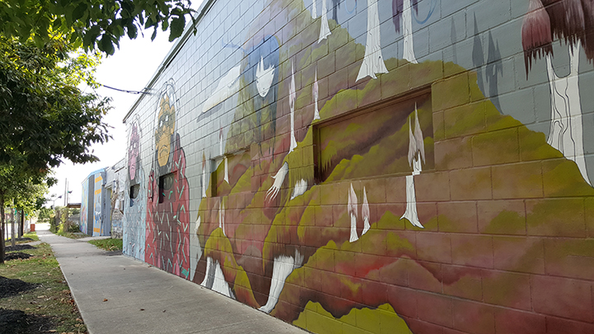
Houston, TX July 18,2016—Classy Art is pleased to announce its new Pokémon Go collection. Yes, the world has gone crazy with this new phenomenon. Definitely setting the new record for quickest user adoption in history, this new game is attracting kids and adults alike. Though men and women of all ages are playing, because Pokémon was a game developed and popularized in the 90’s, the primary demographic is the elusive Millennial that marketers everywhere are after. With so much marketing emphasis on attracting Millennials, especially in the furniture industry, this is a perfect opportunity for retailers to be the right place at the right time. The biggest question in everyone’s mind is how do I use this to attract people to my business. Well, the answer is in Lure Modules. Users can buy and place a Lure Module at any Poké Stop for as low as $0.59 each when bought in bulk. They last for 30 minutes at a time, and when one is set off people can see it for miles in the game map. Everyone knows when to head that way because these Lure Modules help to generate lots of Pokémons and other items people are trying to collect. It is true not everyone has a Poke Stop at their business, but there are definitely some near. Set off a couple of these lures around your business and watch the people flock. Classy Art just happens to have 2 on the premises, as you can see in the upper right image (blue cubes), because they are usually around mural, statues, or other public points of interest. The image to the right shows one of the many murals that covers the Western facing wall of the Classy Art factory. Above is a concrete bench at the bus stop outside of Classy Art that has been carved to say “Dream Big”. Unfortunately, Classy Art is not open to the public, so there is no marketing edge here. However, if there is one on or near a furniture stores property, they should definitely be taking advantage.


So now that you have that Millennial in your store, do you have the right product for them? Classy Art will be releasing its latest collection specifically for this customer. That’s right, Pokémon Go wall décor. “We’ve always been known for being an agile company and responding to market trends, but I think we able to react to this craze much faster than anything we’ve done in the past,” says Gabriel Cohen, President at Classy Art. He continues, “we understand that this will be an in and out trend, so we have to move quickly as does the retailer. Not only does this show how quickly we can respond, but it will also give us the opportunity to prove our promised one week lead times.”

