
Siscovers Launches Exclusive Revolution Plus Performance Bedding Collection
Minneapolis, MN — July 2017
Siscovers has developed an exclusive bedding collection line, introducing Revolution Plus® Performance Bedding.
Life is messy, but paw prints, juice spills and even permanent marker will disappear! Soft to the touch, inherently stain resistant and bleach cleanable...even the dark colors. They are made in the United States with upcycled fibers and no chemical treatments making them easy on the environment.
At the Las Vegas Market, Siscovers will showcase the fifteen new collections and demonstrate how easy it is to remove stains from any Revolution Plus fabric. “It is really amazing to see how this soft this performance fabric is, but any type of stain can be removed with minimal effort.” said Shari Hammer, president and owner.
Not only is the bedding inherently stain resistant and machine washable, it is made in the United States. The fabric is milled in North Carolina, and the bedding is cut and sewn in Minnesota. “We know how important it is to our retailers to be able to offer ‘Made In USA’ bedding product to their customers.” Shari commented.
Siscovers showroom is located at B1012. See the variety of colors, stripes and patterns available. Customize your personal bedding collection, or find one that you love featured in the Revolution Plus Performance Bedding Look Book. The 24-page Look Book will be available to pick up at market.

About Siscovers:
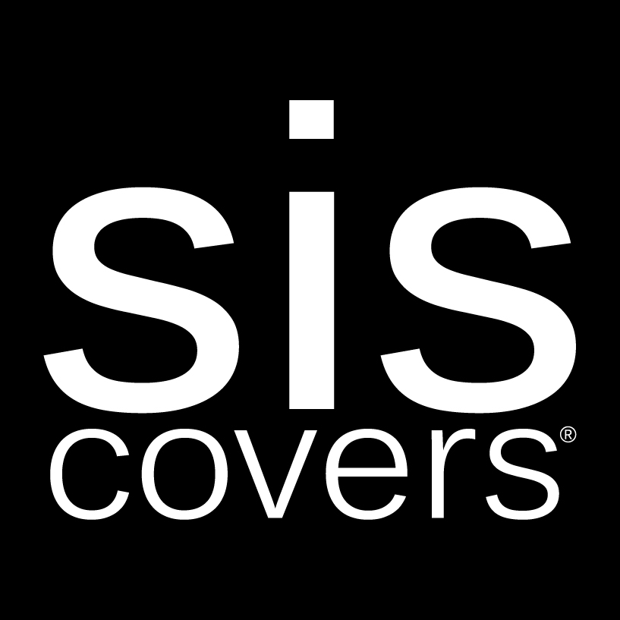
Siscovers, based in Minneapolis, MN, is the best-made bedding brand in the industry, manufacturing top-of-bed, decorative pillows, outdoor pillows, daybed covers, futon covers and curtains. Siscovers delivers fine craftsmanship, exceptional value and individualized service to fine retailers and interior designers nationwide and internationally. For more information see www.siscovers.com or contact LeeAnne Harris at lharris@siscovers.com or call 800-989-5435.

