
Mary Jessen
Team Leader
Bader Rutter
262-938-5425
mjessen@bader-rutter.com
Jon Mattrisch
PR Counselor
Bader Rutter
262-223-5723
jmattrisch@bader-rutter.com

FOR IMMEDIATE RELEASE
Home Is In: Sauder’s Fall High Point Market Introductions Make Home the Desired Destination
Cozy, Nordic-inspired collections, clever youth bedroom pieces and casual dining options
invite interaction with approachable designs

ARCHBOLD, Ohio — Sept. 26, 2017 — The context of staying in has shifted for consumers. Dining out is on the decline, and staying in to enjoy life’s simple pleasures with friends and family — whether entertaining or unwinding — is on the rise. At Fall High Point Market, Sauder introduces approachable designs that create a cozy, comfortable home oasis that encourage gathering and interaction.
“Consumers are spending more time at home — hosting parties, making home-cooked meals and enjoying time as a family,” says Mike Lambright, director of marketing at Sauder. “They’re using their furnishings to create a warm, welcoming and relaxed environment. Our new designs help transform a space into the ideal destination to gather and unwind so you don’t feel bad about staying in, because home is in.”
At High Point Market, Sauder will display:
  - Anda Norr Collection — Nordic designs influence this collection’s warm, approachable, Soft Modern style.
  - Pinwheel Collection — Playful youth bedroom products feature ArtaGraph™ patterns and clever functions.
  - Casual dining pairings — Table and chair combos to match the growing popularity of at-home dining and entertaining.
  - Entryway and everyday storage — New features and functions add versatility and solve familiar storage challenges.
  - Boulevard Café Collection —Refined, casual industrial styles are available this fall in small-scale, mobile, versatile pieces.
Anda Norr prototype collection
Inspired by Scandinavian travels and Nordic designs, the Anda Norr prototype collection embraces simple shapes and tactile materials to create Sauder’s newest Soft Modern style debut. The collection features wool and felt surfaces, faux leather drawer pulls, natural light wood tones, and white and navy blue finishes to create an approachable contemporary design.
“Nordic designs traditionally favor function first — it’s about creating modern appeal without sacrificing cozy comfort,” says John Amell, trend and design manager at Sauder. “By bringing in soft textures and subtle curves, the pieces in the Anda Norr Collection are inviting and approachable; they evoke feelings of warmth and security in a casual and familiar environment.”
Products feature a lower saturation of colors in blues and grays and exaggerated woven materials. The visually light profile and minimal use of materials offer a small-space solution, resulting in pieces with an intentionally smaller scale that are perfect for intimate gatherings and events.
The collection contains living room and accent pieces, including entertainment credenzas, coffee and side tables, shelving and storage pieces, wall-mounted and pedestal desks, and upholstered seating. Pieces start at $69.99.
Pinwheel Collection
Designed with safety, fun and function in mind, the Pinwheel Collection of gender-neutral youth bedroom furniture features versatile items for children ages 4 to 12. Six of the 11 items feature ArtaGraph patterns, some with reversible features for added customization. The playful collection proves sophisticated design can include children’s furniture, adding clever details and unique functions that transition as needs change.
A Dollhouse Bookcase includes reversible, ArtaGraph-patterned back panels and can evolve in purpose — from toy to book storage — as children age. The Kids Open Storage piece has open hanging and shelves for dress-up clothes in a playroom or in place of a closet in a bedroom. A three-drawer Chest incorporates cubby storage and a shorter design for safety, and the Rolling Toy Box has an ArtaGraph design and rope handle so kids can help with cleanup. Items retail as low as $79.99.
Three youth seating options, with patterned and solid upholstered designs, also are included in the Pinwheel prototype collection. This addition aligns with the steady growth of Sauder’s accent seating category and ability to leverage domestic and import capabilities for a comprehensive product portfolio. Pinwheel seating items retail starting at $99.99.
Casual dining pairings
As meal planning, dinner-in-a-box and entertaining at home increase in popularity, Sauder expands its small-scale and casual dining options. Table and chair prototypes round out popular lines, including New Grange, Harvey Park, Cannery Bridge and the new Boulevard Café Collection, helping consumers create a welcoming space that meets their lifestyle demands.
Sauder’s dining products highlight the home as a desired destination for entertaining and everyday living. Surveys show millennials enjoy entertaining more than any other generation — 93 percent like hosting friends and family in their home. Even when not hosting guests, consumers are staying in — more than 80 percent of meals are consumed or sourced at home.
The Midcentury Modern Harvey Park Collection adds a rectangular table and dining chairs in Grand Walnut finish. The New Grange Collection adds a round dining table with faux concrete top in the Modern Farmhouse style, and the rustic Cannery Bridge Collection introduces a rectangular table in Lintel Oak finish. Completing the style portfolio, the Boulevard Café Collection Dining Table brings amber glass, metal and casters together for a refined industrial aesthetic. Dining pieces begin at $149.99
Entryway and everyday storage
Sauder introduces new functions and features to solve familiar home storage challenges.
The minimalist, contemporary North Avenue Collection grows with the addition of folding shelving and desk pieces featuring pre-hinged frames for easy, tool-free assembly. A combination of lightweight panel construction and hinged frames means pieces can be disassembled or folded flat for transport as part of a nomadic, mobile millennial lifestyle. Items retail at $89.99.
The popular Cottage Road and New Grange Collections expand with Entryway Storage pieces that include three tip-out shoe storage compartments with reversible chalkboard or woodgrain panels. Two lower storage cubbies also serve as bench seating to create a space-saving, all-in-one entryway product. Items retail at $299.99.
Boulevard Café Collection
Following a successful spring debut, the Boulevard Café Collection will be available to purchase in late 2017.
Sauder brings a refined coffee shop aesthetic to small-scale, mobile and versatile pieces in the Boulevard Café Collection. Inspired by the trend of mobile working in shared spaces and community gathering areas, the addition of casters, modular designs and minimalist use of materials imply movement and highlight the collection’s mobility and versatility within the home.
Amber glass and metalwork in the form of bent tubing, perforated, woven and metal grid patterns contribute to the retro-industrial feel, while the Vintage Oak finish provides a more relaxed and inviting aesthetic. The collection features dark, moody finishes juxtaposed with open silhouettes, resulting in pieces that weigh less and are easier to assemble.
Accent tables and entertainment, shelving, storage and seating pieces will be available on Sauder.com starting at $59.99.
Visit Sauder at High Point Market
Sauder’s newest collections and prototype pieces will be available Oct. 14-18 in its High Point Market Showroom at 220 Elm St., High Point, North Carolina, one block west of Main Street between West Commerce Avenue and West Green Drive.
About Sauder
Manufactured in America’s heartland for more than 80 years, Sauder Woodworking Co. is the leading North American producer of ready-to-assemble furniture. A family-run business based in Archbold, Ohio, Sauder embraces sustainability measures that reuse and recycle more than 98 percent of its solid waste materials. The company currently offers nearly 50 furniture collections that enable everyone to experience the joy of affordable style. Follow us on Instagram, Pinterest, Facebook, Twitter and YouTube. For tips on affordable style, visit the Put Together Lookbook, Ideas blog or Expedition Design style lab. Learn more at Sauder.com.
###
DOWNLOAD IMAGES
NOTE: Link will expire October 20, 2017.

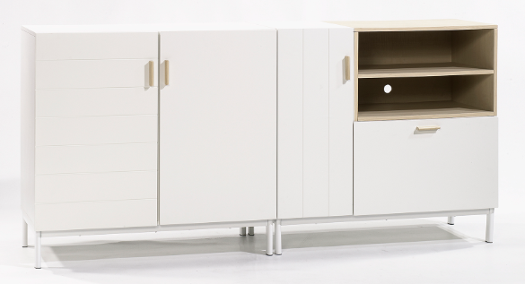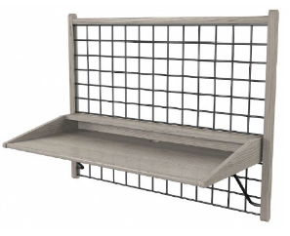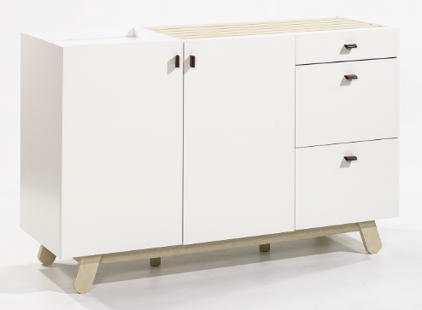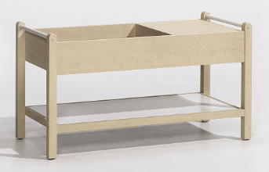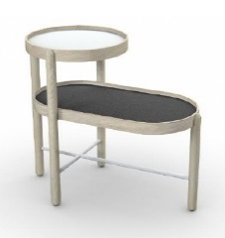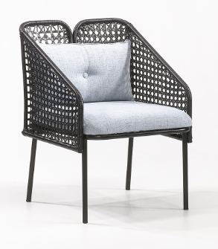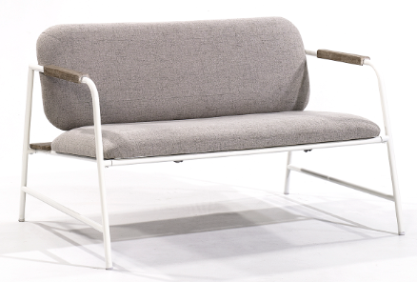 | Anda Norr prototype collection  - Entertainment Credenza, $299.99 (422048)  - Wall-mount Desk, $109.99 (422053)  - Storage Cabinet, $269.99 (422071)  - Coffee Table, $129.99 (422055)  - Side Table, $69.99 (422073)  - Accent Chair, $189.99 (422115)  - Bench, $289.99 (422117)
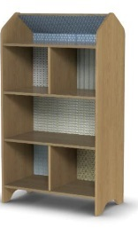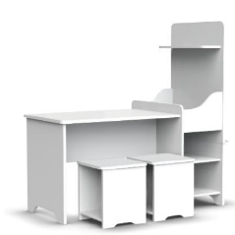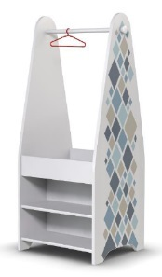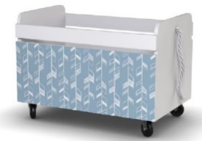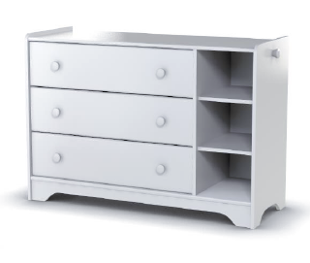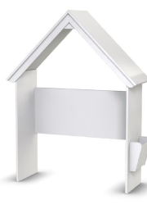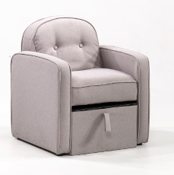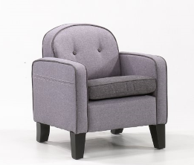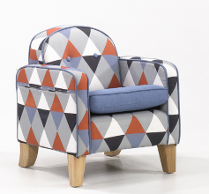 | Pinwheel Collection  - Dollhouse Bookcase, $149.99 (422430)  - Kids Activity Center, $219.99 (422467)  - Kids Open Wardrobe, $139.99 (421886)  - Rolling Toy Box, $99.99 (421888)  - Chest, $199.99 (421884)  - Headboard, $159.99 (422823)  - Youth Arm Chair with Storage, $109.99 (422275)  - Youth Arm Chair, $99.99 (422276)  - Youth Arm Chair, $119.99 (422465)
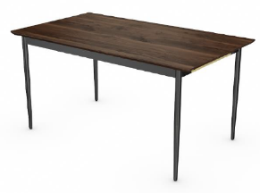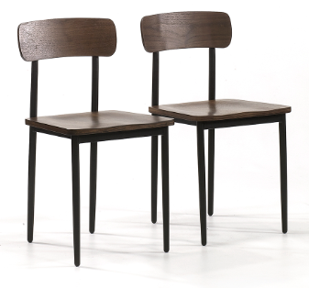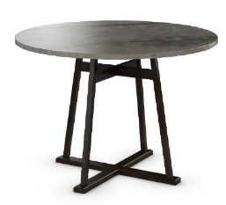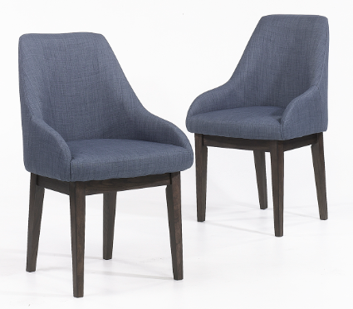  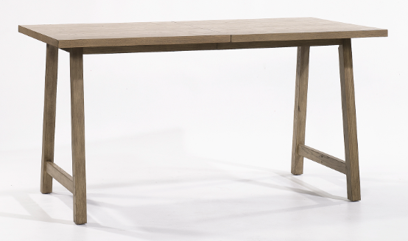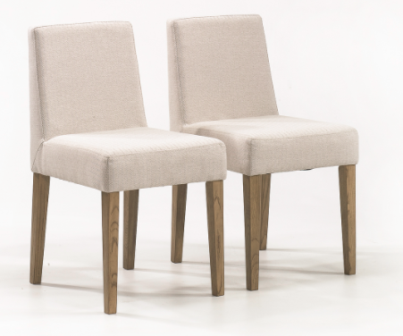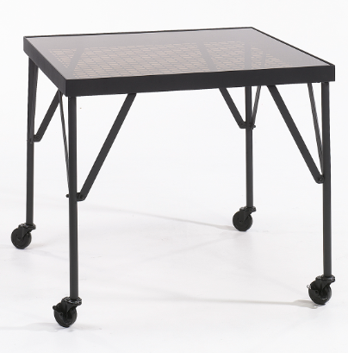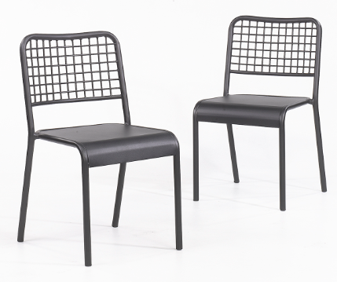 | Casual dining pairings  - Harvey Park Rectangle Dining Table, $319.99 (420303)  - Harvey Park Dining Chair, $189.99/2 pack (420821)  - New Grange Round Dining Table, $329.99 (422160)  - New Grange Dining Chair, $239.99/2 pack (422161)  - Cannery Bridge Rectangle Dining Table, $299.99 (422166)  - Cannery Bridge Dining Chair, $199.99/2 pack (422167)  - Boulevard Café Dining Table, $179.99 (422420)  - Boulevard Café Dining Chair, $149.99/2 pack (422280)

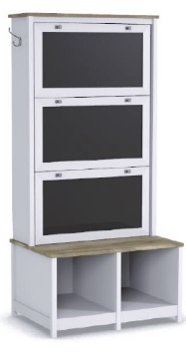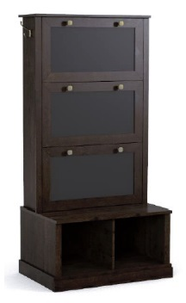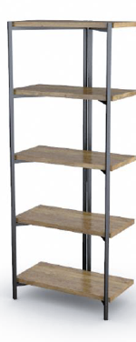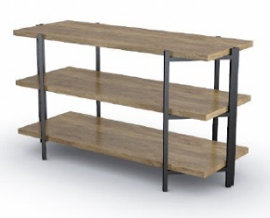 | Entryway and everyday storage  - Cottage Road Entryway Storage, $299.99 (422181)  - New Grange Entryway Storage, $299.99 (422180)  - North Avenue Folding Bookcase, $89.99 (422095)  - North Avenue Folding Console, $89.99 (422313)
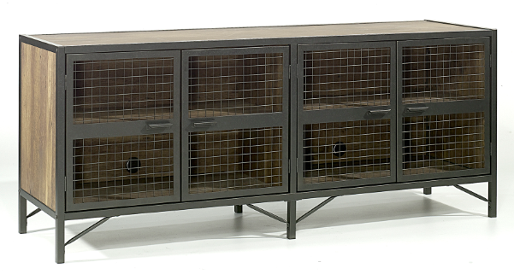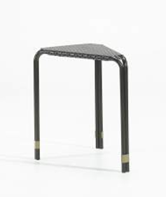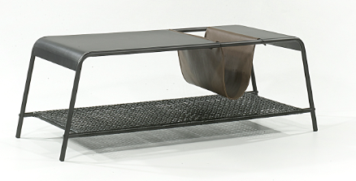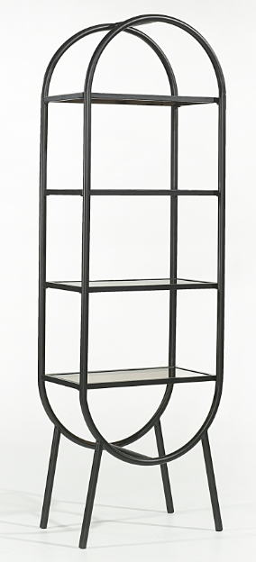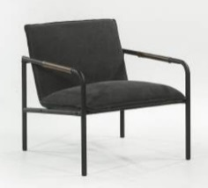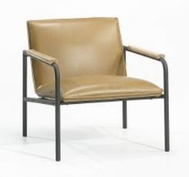 | Boulevard Café Collection  - Entertainment Credenza, $329.99 (420649)  - Triangular Side Table, $59.99 (420666)  - Coffee Table, $99.99 (420722)  - Open Shelving, $159.99 (421957)  - Accent Chair, $139.99 (422355)  - Accent Chair, $149.99 (422356)

DOWNLOAD IMAGES
NOTE: Link will expire October 20, 2017.

AllRecipes, The Measuring Cup: Entertaining Trends, December 2016
NPD Group, Top 6 Home Entertaining Trends of Holiday 2016

