HIGH POINT FURNITURE MARKET 2018
Design Center D729

FLAMINGO - Chair
Design Giorgio Soressi

Its name predicts the formal lightness of this chair, characterized by the design of the back legs. Their compass shape impresses a sense of dynamism: they rise upwards, drawing a soft curvilinear shape on their inside, in contrast to the essential trait of the backrest on which they engage. The result is a model with an original character, which enhances the quality of Costantini Pietro woodworking.
Flamingo is made of solid beech wood and is available in 40 finishes.
The seat, generous and softly padded, can be customized in 265 different coverings.

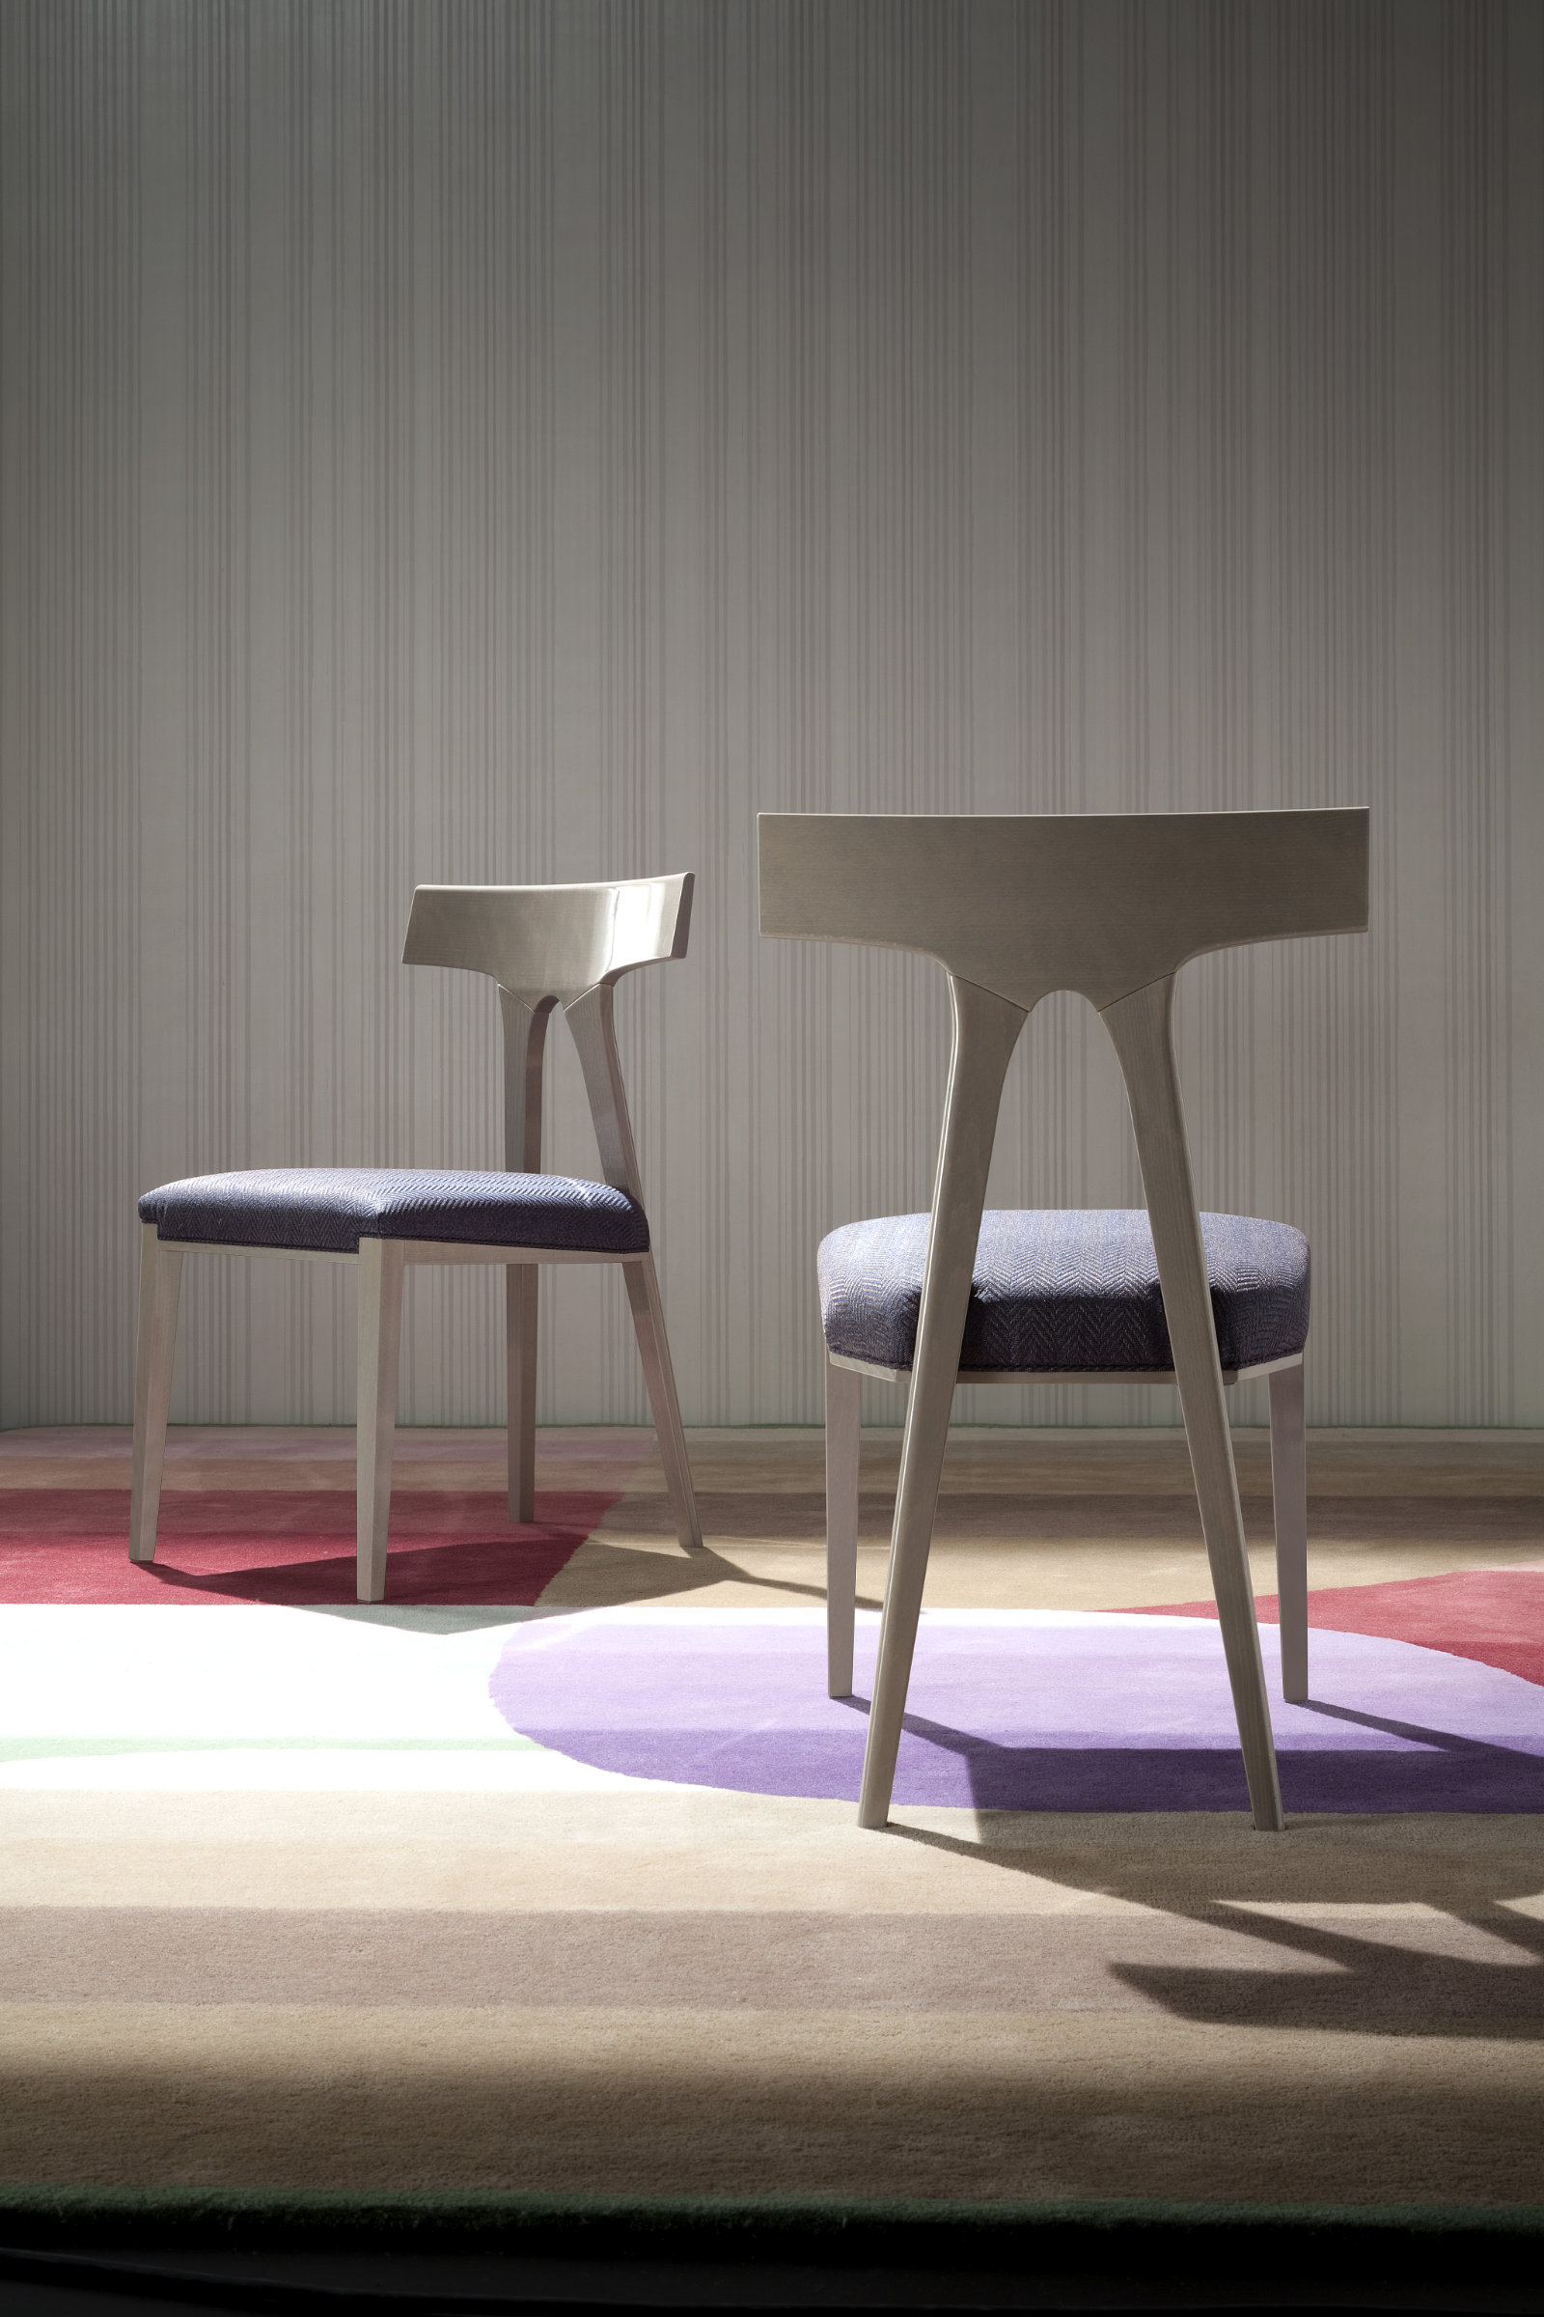

In photo:
Flamingo; Beech wood structure stained high gloss Stone, upholstery in fabric Bressay Crovie F2023/10.

COSTANTINI PIETRO PRESS OFFICE
Adriana Cruciatti
acruciatti@caltpr.it
tel. +39 335 6853775

