HIGH POINT FURNITURE MARKET 2018
Design Center D729

VERA – Chair, chair with armrests
Design Giorgio Soressi

A chair for elegant and scenic spaces, Vera enhances the balanced combination between the warmth of wood, a living material of which its structure is made, and the tactile softness of the upholstery that envelops the entire backrest and seat, an additional detail of sophistication.
The distinctive feature of the design is the backrest: the rigor of the shape is interrupted by a slight, unexpected shaping that offers a pleasant support and creates a small intimate space, adding a functional value to the decorative code.
Vera is available in the side chair and armchair version. The structure is made of solid beech wood. The seat is wide and softly padded. Like all Costantini Pietro's proposals, it is customizable in 40 finishes and 265 different coverings, sewn with sartorial accuracy and revealing Costantini's special attention to quality details.

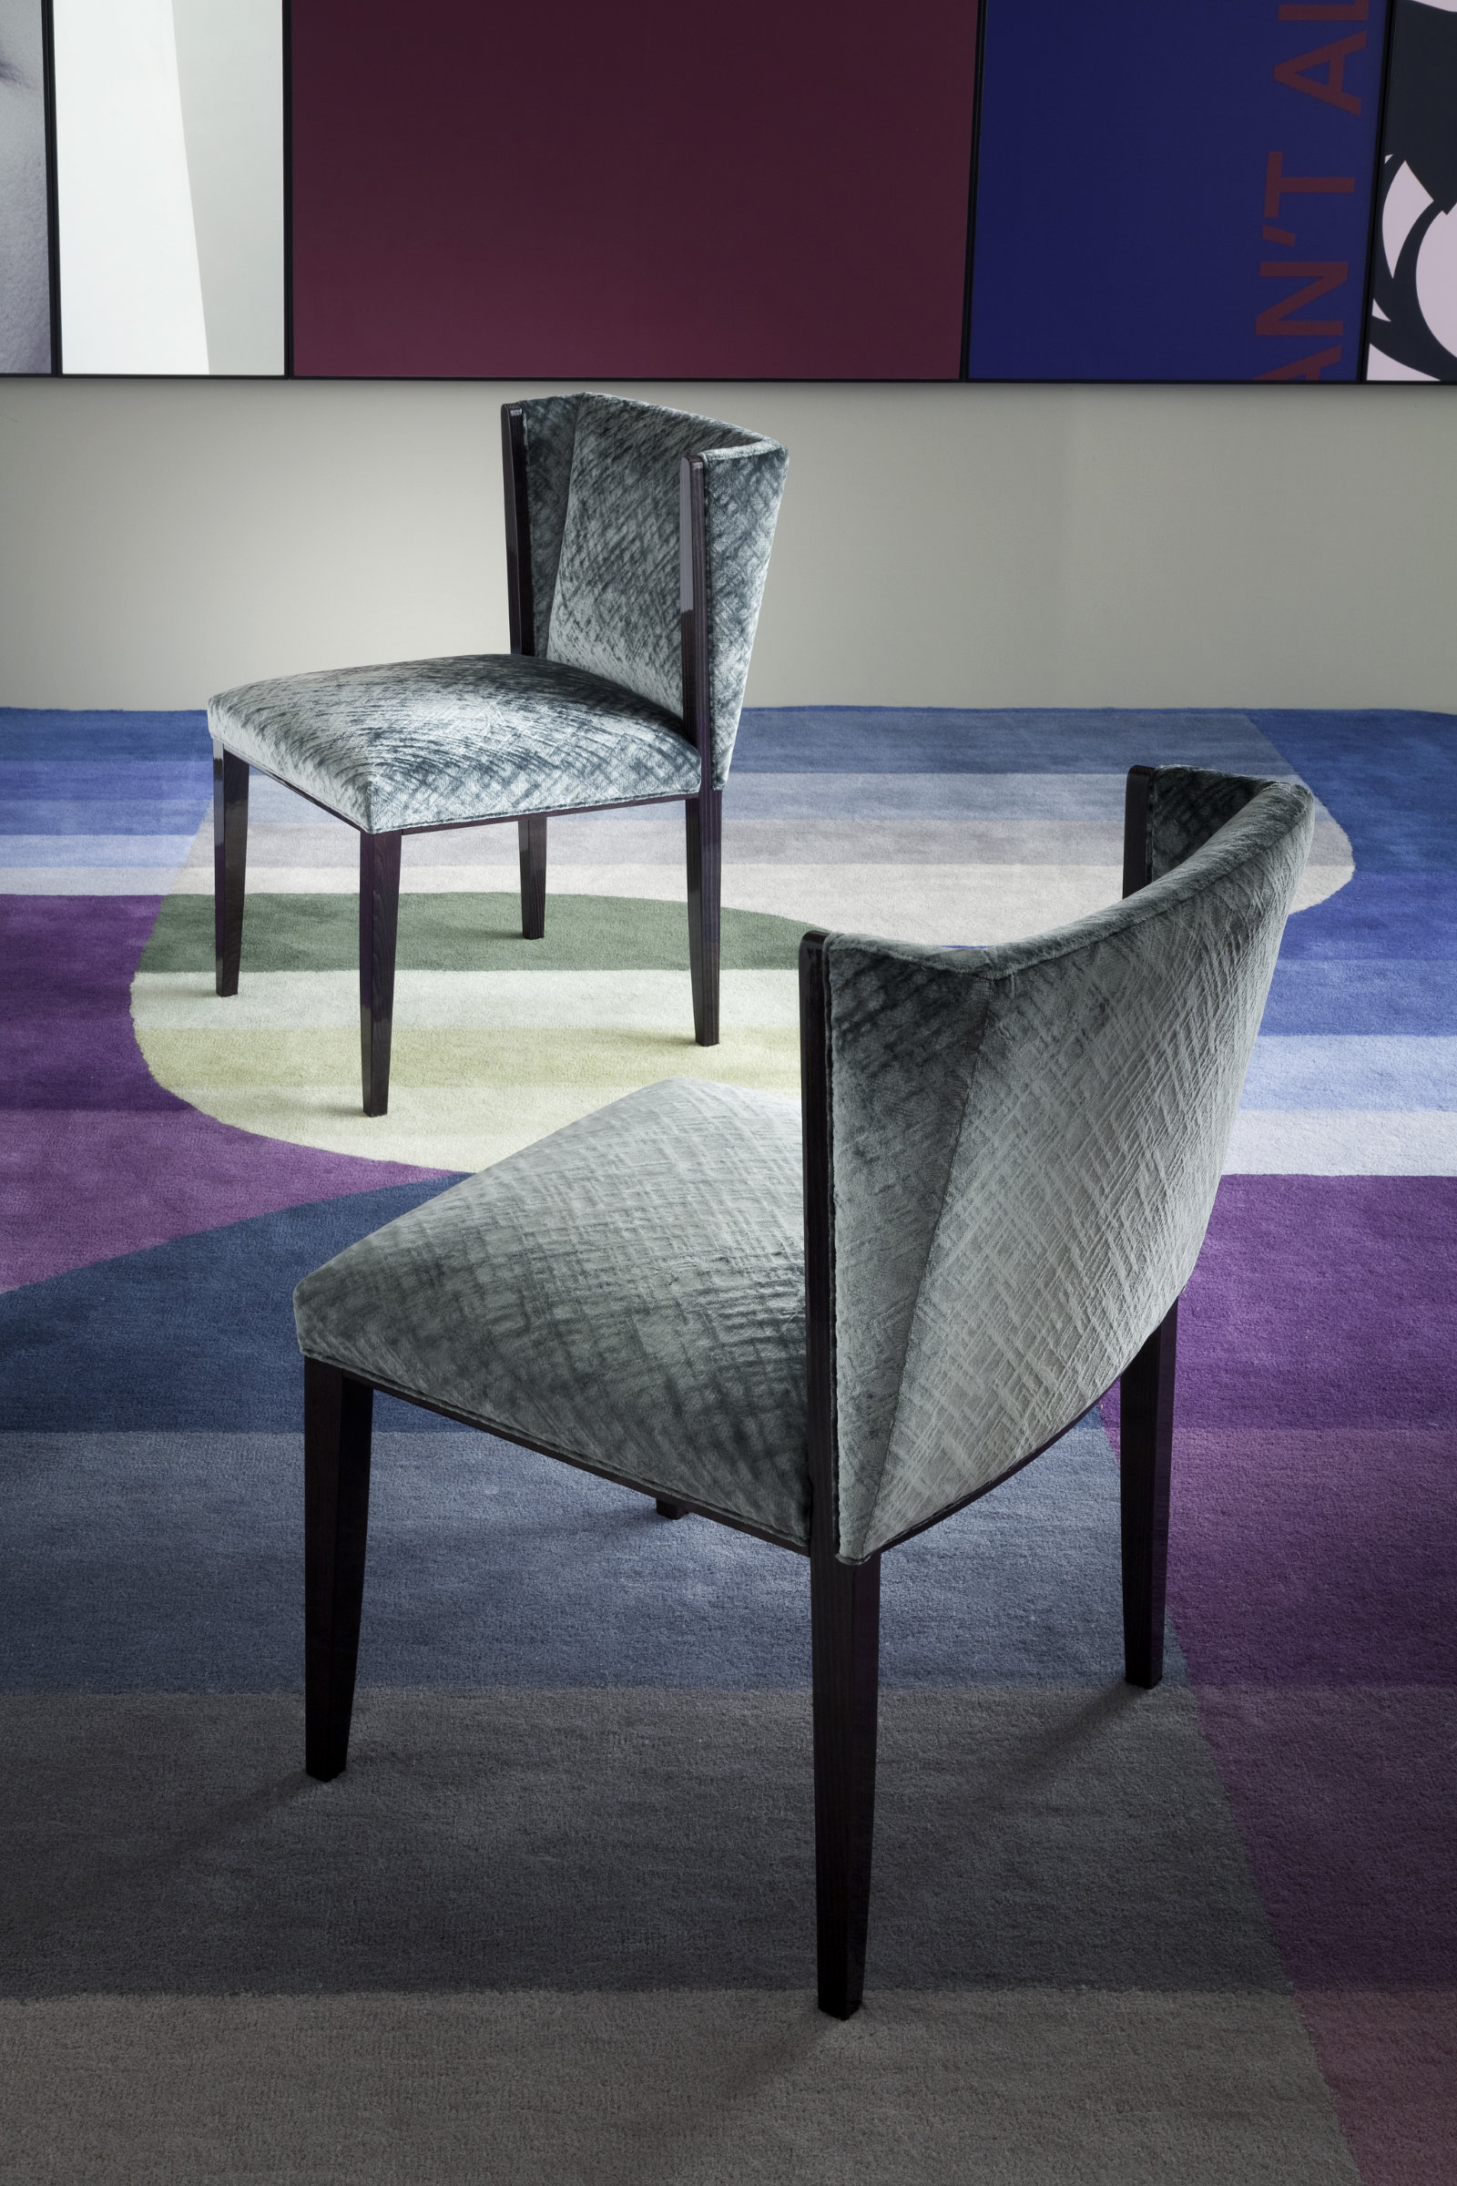

In photo: VERA, beech wood structure stained high gloss Carbon, cover in fabric G81.

COSTANTINI PIETRO PRESS OFFICE
Adriana Cruciatti
acruciatti@caltpr.it
tel. +39 335 6853775

