

FOR IMMEDIATE RELEASE Media Contact: Ellen Gefen
ellen@gefenmarketing.com
336.884.5020

ALDEN PARKES HITS THE REFRESH BUTTON AT SPRING 2018 HIGH POINT MARKET
New Statement-Making Pieces Bring Leading Trends Home

Jacksonville, Fla. (April 12, 2018)—Alden Parkes, a high-end furniture maker known for its fine finishes and deft mix of materials, is introducing a series of stand-alone pieces designed to refresh and rejuvenate home spaces.

“Good design is always in a process of evolution,” said Lynne McArdle, President of the Jacksonville, Florida-based company. “Our customer is confident in their own taste, but they are also very aware of the latest design trends. We see our introductions this market working like a beautiful scarf or a great pair of shoes: they take it up a notch.”

Among the important trends Alden Parkes is tapping into at the April 2018 High Point Market is the renewed interest in embellishment. The company’s expertise in fine finishes is showcased in the Virginia Bedside Chest, a small-scale three-drawer chest with a linen-like finish on the drawer fronts and blackened brass hardware. The top of the four-door Wallace Sideboard, available in satin white or walnut, is inset with blue Galaxy glass, framed in brass. The dramatic Fortune Sideboard is faced with a raised veneer in a flowing floral design and finished in glowing silver leaf.

The trend towards embellishment is balanced by the growing interest in clean-lined geometry, often applied with a nod to Mid-Century Modern. The beautifully spare Galaxy Collection has been expanded to include the Galaxy Cocktail Table and the Galaxy Desk, both with the graceful crisscross bases that are a signature of the collection. The new Galaxy pieces are complemented by the Clifton Mirror, a simple frameless rectangular mirror held in place with handmade clips in a brass leaf finish.

And after many seasons of dark wood and nickel hardware, the design pendulum is swinging back to warmer woods and touches of gold. The walnut Wallace Sideboard is supported on slender legs wrapped in brass ferrules; the new round Curtis Dining Table, also in walnut, has inward curving legs connected with a matching stretcher. Both the sideboard and the table are also available in a clean satin white finish.

###

About Alden Parkes:
Alden Parkes is a high-end furniture manufacturer based in Jacksonville, FL owned by entrepreneurial veterans Lynne and Khrys McArdle. Alden Parkes offers an extensive line of home furnishings: upholstery, occasional tables, dining, cabinetry, mirrors, accessories and lighting. Their commitment to quality begins with materials. Premium woods, from solid mahogany to weathered driftwood acacia, are masterfully carved by hand and paired with solid brass hardware. Finishes range from deep brilliant sheens to subdued, casual distressed applications.

Alden Parkes Product Information
Link for images: https://gefenmarketing.sharefile.com/d-s57fd04a772c40a89
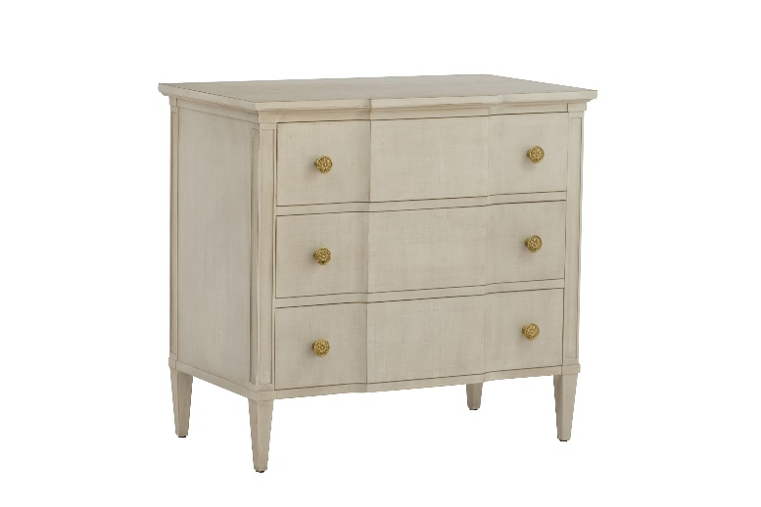

Virginia Bedside Chest

Product Description: This lovely bedside chest offers plenty of room for storage with three curved front drawers and highlighted by blackened brass hardware. The drawer fronts appear to have a subtle linen like finish. The finish pairs well with warm walnut wood tones.

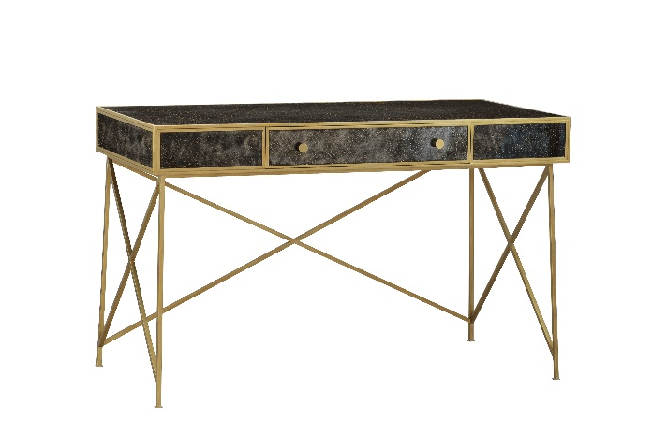

Galaxy Desk

Product Description: With its many connecting lines, the Galaxy Desk is finished in brass leaf on the iron base and accented with painted glass reminiscent of the limitlessness of the galaxy. This desk has one center draw for computer and essentials. Use this piece as a small desk or dressing table.

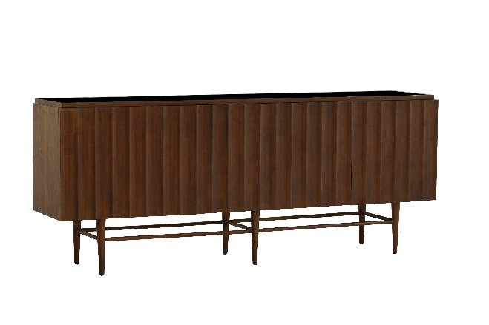

Wallace Sideboard

Product Description: The Wallace Sideboard features 4-ribbed front doors accented with an inset black glass top and legs with stretchers for a fresh new look. Finished in walnut.

