|  |  |
| --- | --- |
|  | FOR IMMEDIATE RELEASE  **FOR MORE INFORMATION AND IMAGES** |

|  |  |  |
| --- | --- | --- |
|  | Edward M. Tashjian  Company Spokesperson  Tashjian Marketing  (828) 320-0117  ed.tashjian@gmail.com | Laura White  Vice President of Marketing & Creative  Vanguard Furniture  828-328-5601  lwhite@vanguardfurniture.com |

**Introducing *Modern Retreat* by Michael Weiss for Vanguard**

*Simultaneously sophisticated and laid-back luxury*

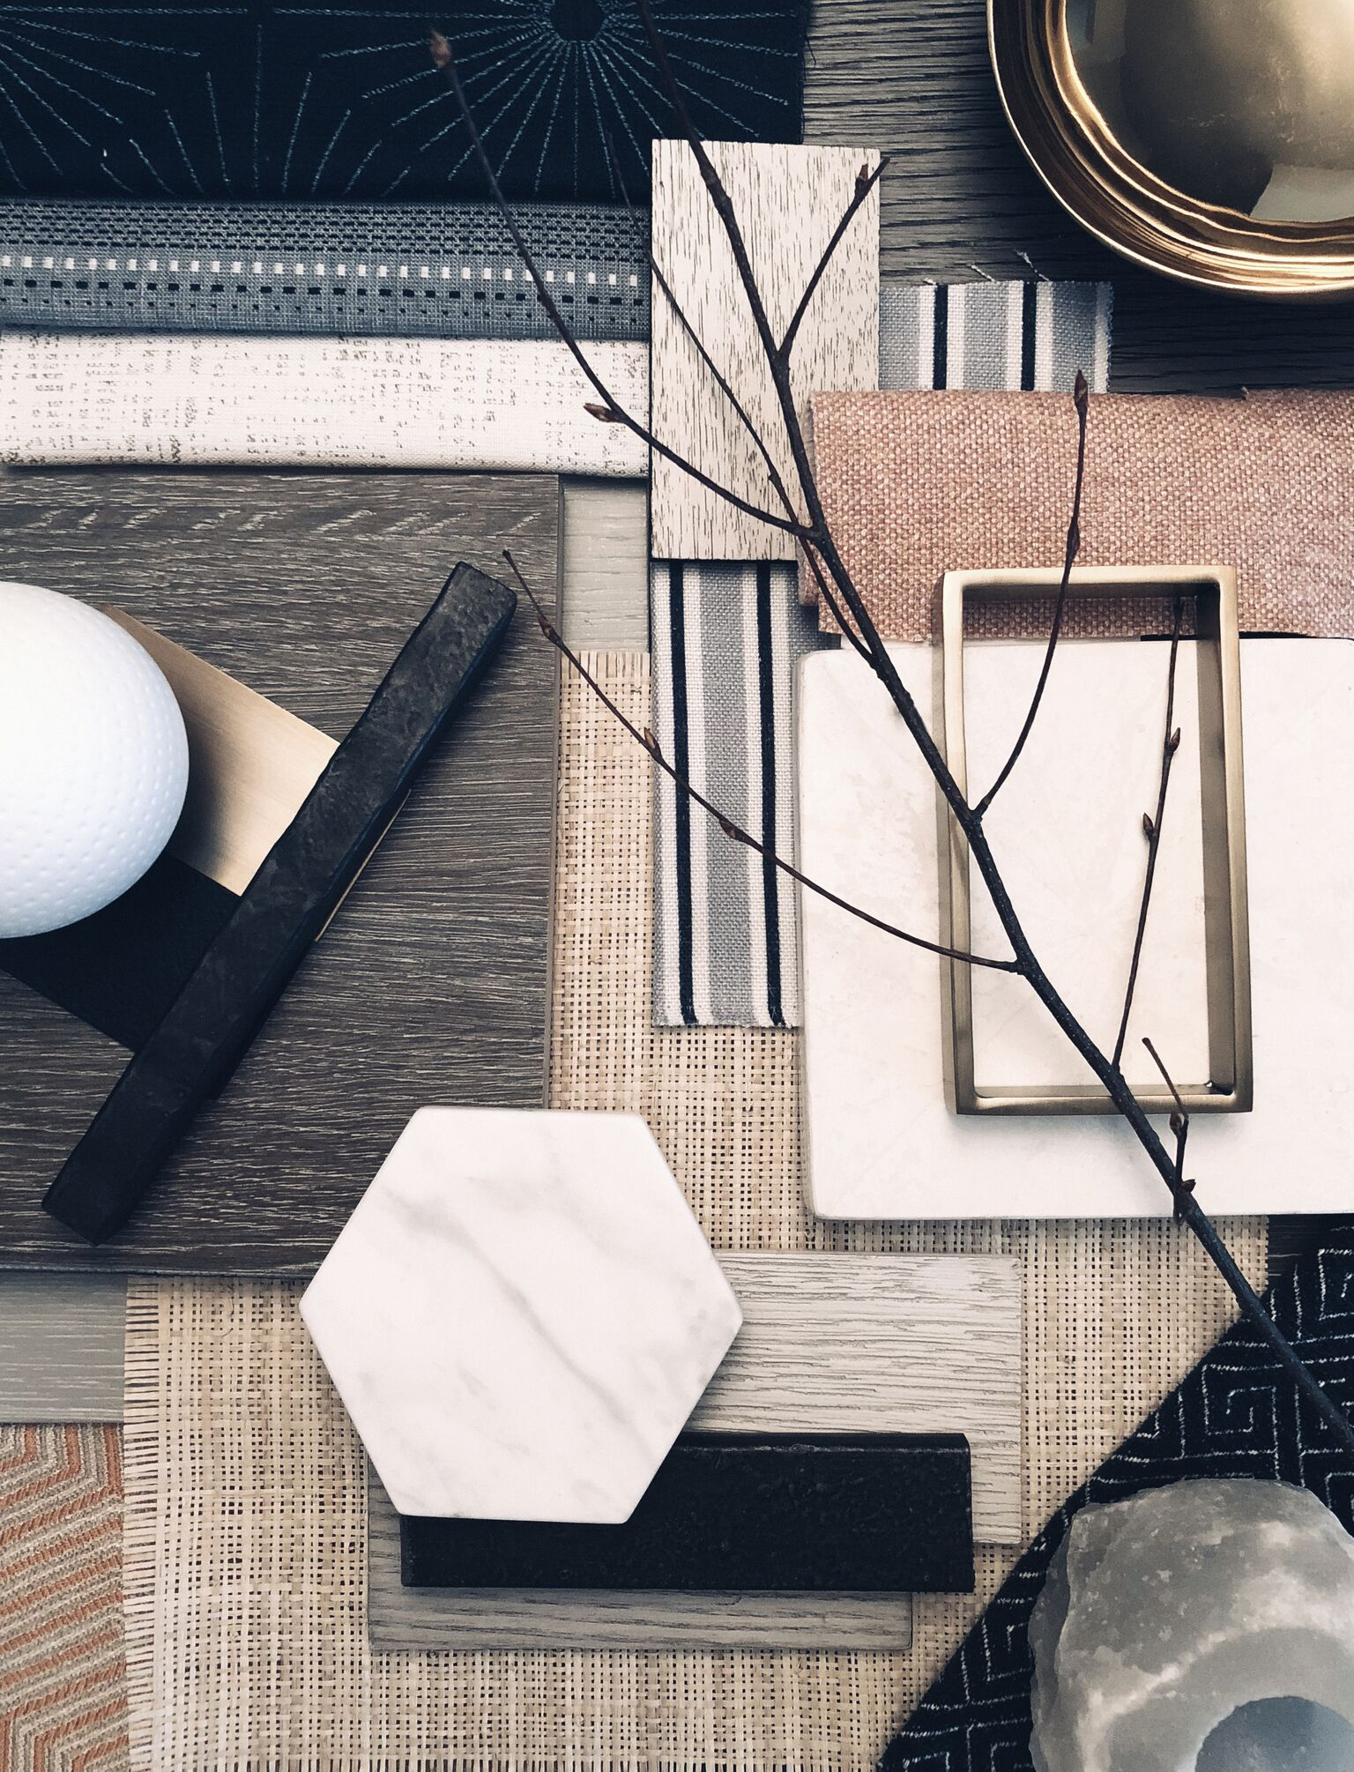

**New York, New York** (October 2, 2018) — Michael Weiss reprises his iconic furniture collection with "Modern Retreat”, a new comprehensive assortment designed to mix and compliment with his core collection.  Michael addresses the lifestyle trend of informal, relaxed and freeform living, while at the same time retaining a sense of sophistication and luxury.  The effect is welcoming and effortless, inviting us into a comforting retreat.

According to Weiss, “We embrace the natural world more than ever before, bridging outdoor and indoor design inspirations into one holistic haven. We strive to design our homes as a sanctuary, conceptualizing spaces in a new way, and seeking refuge from the complexity of modern existence. I am aiming for relaxed, comfortable and calming spaces.”  Modern Retreat captures the essence of getting away from it all. With a playful mix of materials and relaxed styling, this distinctive collection creates the ideal environment for laidback luxury. Wire-brushed finishes, white travertine, forged metal, and glass elements combine to create a youthful yet sophisticated aesthetic. Modern Retreat conveys the feeling of being on vacation without ever leaving home.

Andy Bray, Vanguard’s president responded explains, “there is a playful mix of materials that belies the complexity of each design. Though the pieces are modern, some feature weathered matte finishes that make them more relaxed. Some pieces show wire brushed wood and worn through metal. Forged textured hardware makes them feel more casual. The scale is ample, but not oversized allowing the pieces to hold their own in a large open room yet are small enough to fit into an urban space.”

**About Vanguard Furniture**

Vanguard Furniture is a manufacturer and marketer of case goods and upholstery. It is a family held company, employing 600 associates and operates out of six manufacturing buildings in Hickory, North Carolina, and a 40,000-square foot showroom in High Point, NC and Hillsville, Virginia. Its mission is to lead home furnishings in style, value and service with a vision to enrich lives through custom-crafted furniture. Vanguard is a founding member of the Sustainable Furniture Council and its green initiatives include recycling 95% of all post manufacturing waste; recycling paper, fabric scraps, metal, wood scrap, plastic and corrugated products. The showroom is located at 301 N Hamilton St, in High Point. For more information, see [www.vanguardfurniture.com](http://www.vanguardfurniture.com)

**About Michael Weiss**

Since the 2001 launch of his collection with Vanguard, Michael Weiss has prevailed as a leader in modern furniture design. His signature style, defined by clean lines and architectural simplicity, expresses an acute awareness of the evolution of design. The Michael Weiss collection by Vanguard continues to grow and evolve, while remaining a trusted and enduring resource of classic forms and original signature pieces.