FOR IMMEDIATE RELEASE:
Wexel Art Displays
High Point Showplace: #2335
Brynne Wong
877-609-1920x3
brynne@wexelart.com
The Return of The Silk Scarf
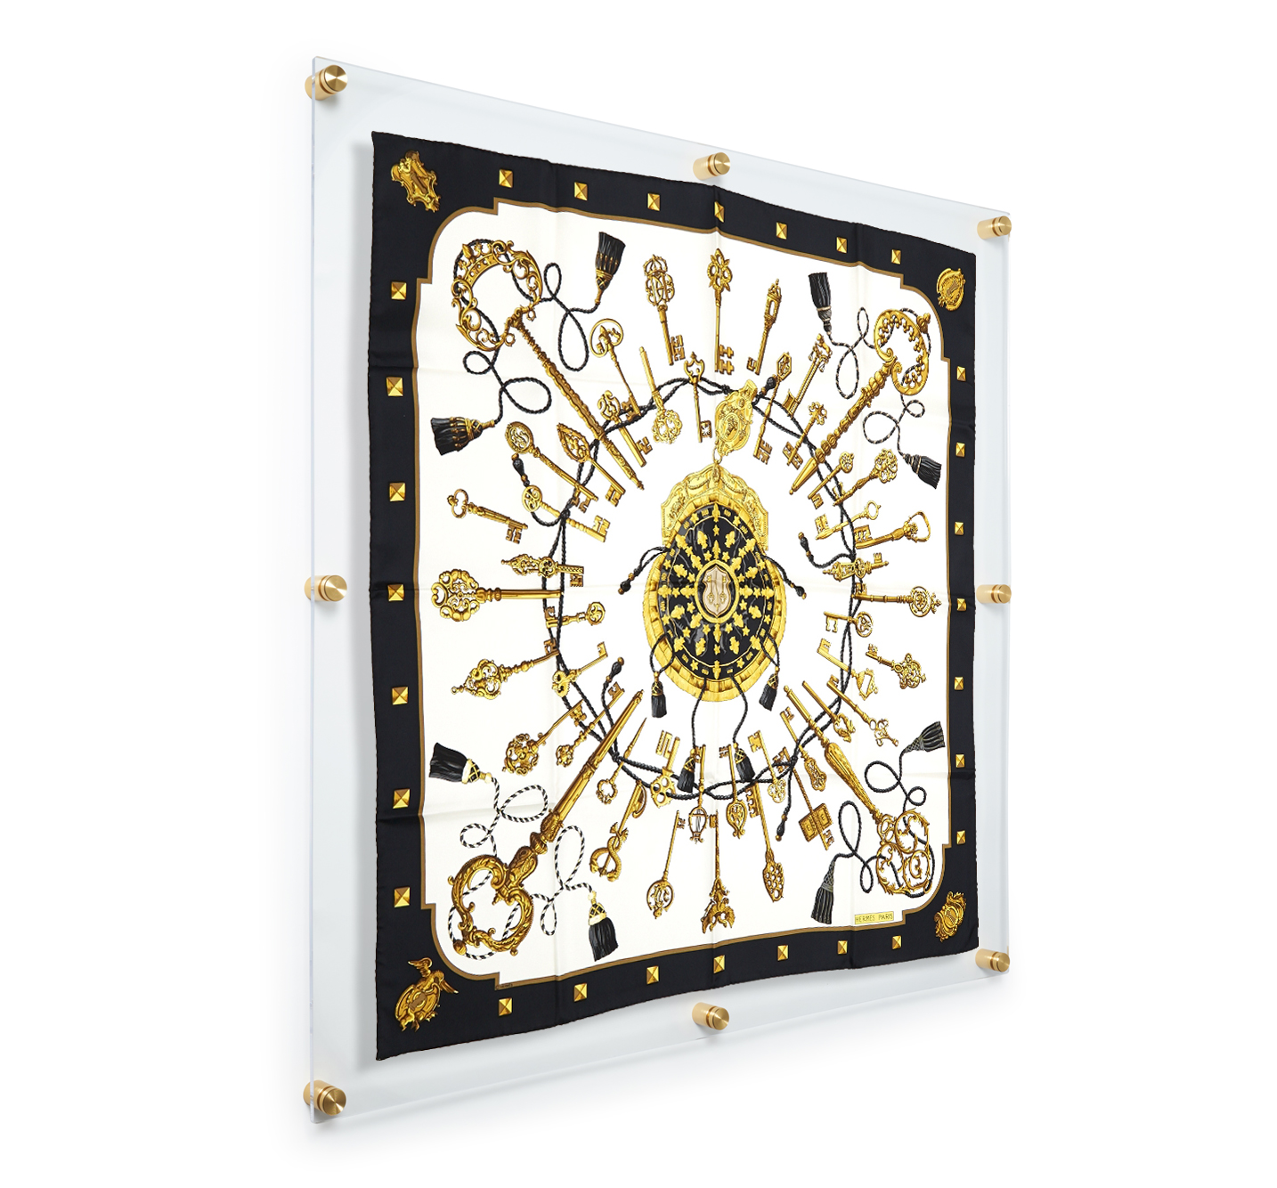
In 2017, Vogue announced the comeback of the silk scarf and since then the fashion and interior design industries have been incorporating them into their designs and making them the center of attention in their merchandising.
Scarves are made to be worn, and are made to be showcased; Our newest frame measures 40" x 40", displays the standard 36" x 36" scarves in the same modern look as our double panel floating wall frame.
Join us in Showplace #2335 on Monday, October 15th at 11AM for a demonstration on how to frame your scarf and a chance to win the Hermès scarf used in the demo.

“Never in one season have we seen so many silk scarves,” said Ellie Pithers, Fashion Features Editor, Vogue.

“Sometimes a vintage silk scarf is simply too stunning to hide in a closet. Instead, make it a staple art piece in your home” - Deborah Harris (ChicCity Vintage).

Keeping in line with the Wexel Art goal of making framing easy, this scarf frame comes with everything you need to hang. Included is: a precut foam sheet to help secure the silkiest of silk scarves, an easy hang template, 8 wall mounts with screws and anchors, step by step instructions and a lifetime warranty.
About Wexel Art
Wexel Art frames offer a contemporary way to showcase art, photos and keepsakes and the ability to change them easily and often, without the expense of traditional framing. Wexel Art was thoughtfully founded on the commitment that products should make showcasing life’s little pleasures such as photographs, kids paintings, and holiday cards in a clean, modern sustainable way. For more information, visit www.wexelart.com.

Facebook | Instagram | Twitter | Pinterest
@wexelart
-end-

