FOR IMMEDIATE RELEASE:

Wexel Art Displays
High Point Market Showplace 2335
Brynne Wong
877-609-1920x3
brynne@wexelart.com

Finally a Way to Frame Your 3D Art
With Ready-Made Shadowboxes

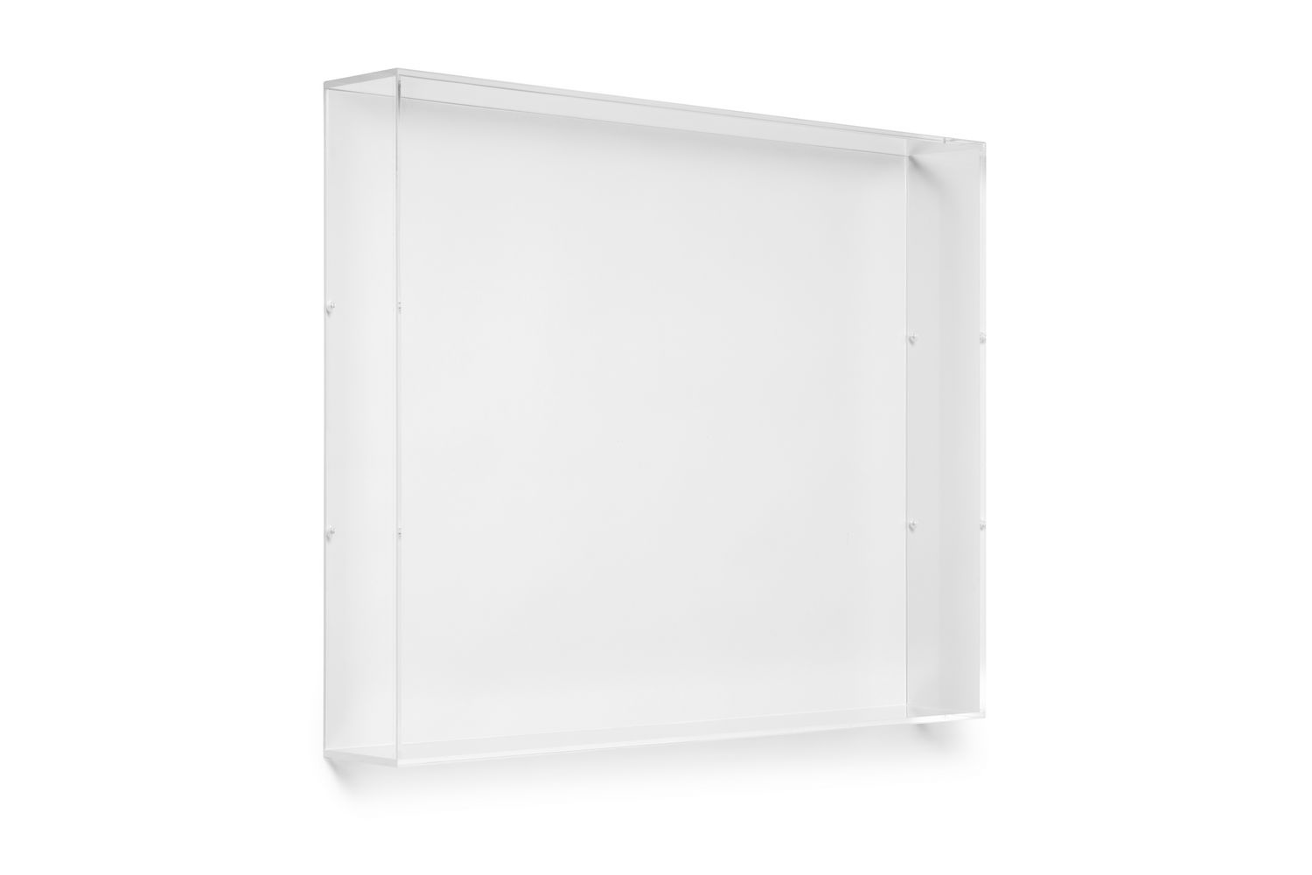
New York, NY – August 8, 2018 – Wexel Art is no stranger to innovation in personalizing your wall display. The shadowbox lid is the first of its kind and was created to offer a turnkey solution to 3D framing without the time or expensive cost of a custom made product. These shadowbox lids are just that - lids, completely customizable, you choose whatever backing works best with your 3D object. Made to fit standard canvas sizes, includes: 6x6, 12x12, 16x20, 20x20, and 18x24.

Creative freedom is booming, as the value of the DIY market has never been higher, according to Statista, The Statistics Portal. Wexel Art has simplified the most complicated part of 3D framing by offering standard sized shadowboxes. Each box is designed with precision cut holes and includes screws to safely attach your choice of backing.

“Being first to market and providing innovation for design-driven consumers is one of Wexel’s key principles,” said co-founder, Natasha McRee.

Art comes in many shapes and sizes. Framing your mementos with a modern, contemporary, acrylic Shadowbox Lid by Wexel Art lets anything become a centerpiece.

About Wexel Art
Wexel Art frames offer a contemporary way to showcase art, photos and keepsakes and the ability to change them easily and often, without the expense of traditional framing. Wexel Art was thoughtfully founded on the commitment that products should make showcasing life’s little pleasures such as photographs, kids paintings, and holiday cards in a clean, modern sustainable way. For more information, visit www.wexelart.com.

Facebook | Instagram | Twitter | Pinterest
@wexelart

-end-

