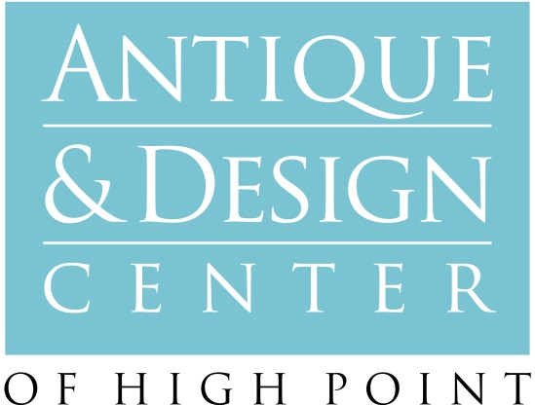

For immediate release Media Contact:
Karen Luisana, Managing Director
336-908-2735 www.hpadc.com

ANTIQUE & DESIGN WELCOMES NEW EXHIBITORS TO HIGH POINT
Eclectic Mix Supports Growing Reputation as Nexus of Leading Edge Design, Luxury and the Unexpected

High Point, NC, March 31, 2014—The Antique & Design Center at Market Square is welcoming a series of new exhibitors this Spring that support the venue’s growing reputation as the Market’s nexus of design, luxury and the unexpected.

“The complexion of Market has changed significantly in the four years since we launched the Antique & Design Center here,” says Karen Luisana, managing director. “It’s amazing how many designers come in and say, ‘I haven’t been to High Point for five years, but I hear it’s really changed. And it has changed in no small part because the antiques are attracting sophisticated buyers who are not interested in brown boxes, but the exceptional and the extraordinary. They come here searching for things they just can’t find anywhere else. They also come to find others like themselves, people with which they can engage in provocative exchanges of ideas that inspire them creatively, whether as part of our seminar series, or the myriad social events here. The Antique & Design Center is an energized community at Market unlike any other.”

Kevin Johnson, Peridot, who works exclusively by appointment with clients in Savannah, GA, and has never once advertised his business, named for his grandmother’s birthstone, echoes this thought. “I deal in unique, statement pieces,” Johnson reports, “and my clients know they will never see the same thing twice. It’s all unexpected and unique and weird and decorative and creative: Furniture, lighting, objects, art, it’s a crazy, eclectic mix of everything.”

Also new this season is the mother-and-daughter team of Lola & Bess, most recently of London. Specialists in period antiques, the pair began collecting in the markets of France, Denmark, Sweden and Italy. “We’ve always attended the High Point Market and admired some of the wonderful people who have been exhibiting at the Antique & Design Center like Caroline Faison,” says Bess Lee. “We’re really looking forward to networking and meeting with new clients and customers and some of the movers and shakers in the design world that we’ve admired for so long.”
Lee, who learned to love classic period styles while working for designer Charlotte Moss, says the design team has been collecting over the past year in preparation for Market. “We’ll be showcasing some incredible Swedish, Gustovian pieces, including a beautiful, painted bureau secretaire, and some rich French pieces, including a stunning Regency table that’s mid to 18th century French. We’ll also be showcasing an artist from the U.K., Henriette Dubrey. We’re proud to exhibit a fresh sort of mix and to be there as a mother and daughter team, which I think is quite unique in the antique world these days. Mom and I have always been fans of the great Miles Redd and Billy Baldwin, the really interesting and wonderful talents in the world of interior design who mix styles so perfectly.”

Taking inspiration from the mid-century modern style, A/S Home furniture designs incorporate lacquer and Lucite in its sleek, clean pieces, all custom made in the U.S. The new exhibitor also offers a wide selection of colors and textures in its pillow-cover collection, “designer fabrics at an amazing price,” according to owner Amy Sims, as well as both new and vintage lamps and one-of-a-kind pieces from or inspired by the mid-century. “A/S Home is excited to exhibit our colorful pillow collection and the sleek designs of our lacquer and Lucite pieces, all made right here in North Carolina,” Sims says. “Watch for new desk designs, tables and consoles.”

Lannie Cunningham, founder with Jazmine Giovanni of Trinka 5 Designs, is headed to High Point with a unique collection of specimens, artifacts, relics, natural elements and worldly treasures such as bejeweled rams horns and nautilus shells. The design team is particularly fond of coupling very old relics with new, ultra-sleek contemporary touches (think antiquated meets modern age). Each exquisite piece is handcrafted in their LA design studio.

Michael Weaver Fine Silver is a family-owned concern that has dealt in antique sterling silver for three decades. “We have a full-line flatware matching service for all sterling patterns, and specialize in antique sterling tea sets and trays, Victorian and English silver-plated trays, sterling candelabras, antique and contemporary mint juleps, and a full line of sterling flower vases, ranging in size from six-inches to two-and-a-half feet tall,” describes Weaver. “A few are Tiffany, and all are mint condition. There are also antique silver biscuit boxes, goblets and a tremendous offering of two-piece sterling baby sets and INFA feeding spoons, baby cups and rattles.” Weave is particularly excited about a museum-quality, Kirk Repousse, five-piece sterling silver set in an extravagant floral pattern that he will showcase, in addition to a tea set fashioned from American silver dollars minted more than two decades before the Civil War. “It’s the kind of tea set you would see in Winterthur or Biltmore,” he says. “It’s a piece of American history that truly belongs in a museum.”

Vickie Kienast Designs specializes in an eclectic mix of antiques, ranging from an Art Deco mirrored chest from the 1920s, and a rare, large apothecary cabinet from the 19th century, decorated with wallpaper from the 18th century. Also included in her offering are chandeliers, mirrors and sconces and French mid-century pieces, “by names that a lot of people will recognize,” she promises.

Finally, for the DIY-crowd and artistically inclined, comes Farmhouse Paint. According to Susie Goldenberg, the company has created a unique furniture paint that can be used on almost any surface without prepping or priming. Available in 28 different, French-inspired colors, Farmhouse Paint does not need a top coat, or wax. “It’s extremely durable and it’s probably the easiest paint on the market to use,” Goldenberg says. “When it’s dry, if you lightly sand it with a find sandpaper, it will shine like a waxed, burnished finish.”

Goldenberg says Farmhouse Paint can be used “right out of the can, and we also offer antiquing gel that will darken crevices and make a piece look a little more aged. We’re also coming out with some wonderful, extremely vibrant metallics.” Farmhouse Paint will be sold at the Market in quarts and six-ounce samplers.

About the Antique & Design Center:

About the Antique & Design Center at Market Square:
A favorite venue of the world’s hippest retailers and leading-edge designers, this extraordinary show-within-a-show at the High Point Market features exquisite antiques, original works of art, and one-of-a-kind finds from dozens of premiere dealers. Housed in historic Market Square on the ground level, just beyond the Suites and Salon, exhibitors' spaces change daily as pieces are sold and replaced. Buyer amenities include free parking on Tomlinson Street and a private entrance at 316 W. Commerce Avenue between Tomlinson and Jacob’s Place. For more information about the Antique & Design Center at Market Square, visit www.hpadc.com.

