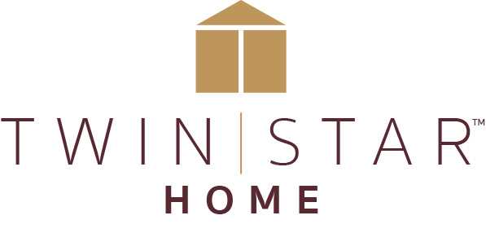

FOR IMMEDIATE RELEASE Media Contact: Calla Starr
calla@gefenmarketing.com
336.884.5020

TWIN STAR HOME BRINGS SUCCESSFUL ‘STYLE TAKEOVER’ TO HIGH POINT
Three Lifestyle Designers Will Stage Twin Star Home Showroom Through Lens of Consumer Segments

Delray Beach, FL (March 13, 2019)— Twin Star Home is bringing their successful Showroom ‘Style Takeover’ to the High Point Market. Three lifestyle bloggers, influencers and designers will each be given areas in the Twin Star Home showroom to stage and show how a consumer would use pieces in their home.

That’s where the thinking began at Twin Star Home, which will put consumer needs front and center in this innovative ‘Style Takeover’.

Each of the three designers—Charlotte, North Carolina-based Lisa Mende; Atlanta-based TV personality Michel Smith-Boyd and Pasadena, California-based Jeanne Chung, who was a part of the January ‘Style Takeover’ team in Las Vegas; —was challenged to accessorize and decorate Twin Star Homes’ extensive line of fire and furnishings. The influencers were provided with different segments of the consumer market identified through the company’s research. All three are trusted experts on stylish and unexpected home decor.

Twin Star Home and the three designers will document the takeover process from beginning to end, and the photos, interviews, and design ideas generated during the ‘Style Takeover’ will be used throughout the year on Twin Star Home’s websites, blogs and social media platforms as well as be made available to dealers who carry Twin Star Home products.

“We wanted to partner with designers who have a clear point of view but are in constant touch with real-life consumers,” said Lisa Cody, Twin Star Home’s Vice President of Marketing. “It’s exciting for us to see our products come to life through their perspective and get a truer view into how they will look in consumers’ homes.”

In all the excitement of the furniture market it’s sometimes too easy to overlook the end users--the consumers who in just a couple of months will be shopping these same products for real life solutions for their homes and families. The ‘Style Takeover’ also engages retailers who visit the showroom and allows them to gain ideas, inspiration and content to present in store to their consumer.

The company is the market leader in electric fireplaces and electronic desks, including the ActiveLife™ series of adjustable height desks, and functional, design-rich furniture for the living room, office and bathroom. The company’s consumer-driven approach has garnered numerous awards for home furnishings products that marry on-trend styles with innovative patent-pending fireplace, media, and workplace solutions.

“Twin Star Home provides innovative solutions to every day issues in the home. The Twin Star Home TV stand with integrated Bluetooth speakers and fireplace (especially the ones with cooling) are ingenious. This is a great example of multi-function and it clearly speaks to how consumers live today. We all want to have less clutter and more efficient spaces,” stated Chung.

“The idea of ‘Style Takeover’ can be leveraged by retailers and is an example of our focus on sharing ideas with retailers to help them bring excitement into their stores to inspire and engage consumers. We love partnering with retailers and bringing not only products, but innovative new approaches to bringing our products to life,” said Cody.

###

About Twin Star:
Twin Star Home of Delray Beach, FL is an award-winning manufacturer of home furnishings, including electric fireplaces and furniture, many with integrated media solutions. Twin Star Home combines the latest trends with consumer-driven innovation and design-rich style to create lasting products that enhance consumers’ lives. Twin Star Home is recognized for its trusted national brands: ClassicFlame®, Duraflame, Bell’O, Tresanti and ChimneyFree. Find out more at www.twinstarhome.com.

Sharefile link for image: https://gefenmarketing.sharefile.com/d-sf631e11b37c4b4f8

