Press Release: August 23rd 2019

Need Manufacturing in Vietnam? We can Help!
Maxwood specializes in Solid Wood furniture manufacturing in Vietnam and offers an extensive selection of Youth, Master Bedroom and accent furniture. With our new factory, that started production in the fall of 2018, comes ample capacity and new capabilities, enabling unique styles, colors & finishes. Explore new Youth Products, Master Bedroom Collections & Custom Manufacturing Capabilities in Maxwood’s expanded showroom.

Youth Brands (Showroom 226):

This Fall market explore the latest products to launch, including the new Jackpot staircase bunks & new finishes, including the popular Clay & White Wash (available factory direct). Blue was the fifth color to be introduced to Jackpot & M3 in 2019, in addition to new finishes & styles.

- New Jackpot Products: AOI lofts with legs provide an AIO solution at lower price point
- New M3 Products: House Bed & Low Bunk
- New Colors & Finishes: Blue in stock & ready to ship. New finishes available factory direct
- Coming soon: Jackpot Staircase Bunk coming October 2019



Master Bedrooms (Showroom 222):

In 2019 Maxwood took it’s passion for quality, functionality & timeless design into the adult space. From rugged weathered finishes with glam accents, to Scandinavian Style modern two-tone designs, all collections are available factory direct & can be customized to design preferences. Select from a wide variety of wood & laminate finishes, metal accents & custom hardware to create the perfect product!
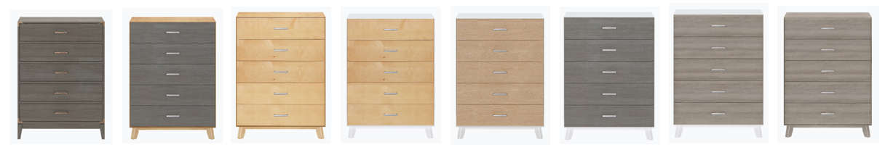

All Maxwood products are quality engineered in our dedicated factory in Vietnam. Diverse retail & commercial clients leverage our design & manufacturing capabilities to produce & ship custom products direct from our factory. From large Retailers looking for private label products to Turn-Key companies furnishing Senior Living accommodations, we love creating the perfect products!

- Save & Ship direct from our factory in Vietnam
- Youth & Master Bedroom Collections - customized to design preference
- Custom Products - also available factory direct

Come see us at Center Point on Hamilton, 401 S. Hamilton Street High Point, NC 27260
Contact Peter at 203.916.2075 or pvs@maxwoodfurniture.com or submit an online enquiry http://www.maxwoodfurniture.com/dealer-information

