Tavolo Clessidra - Midj
design Paolo Vernier

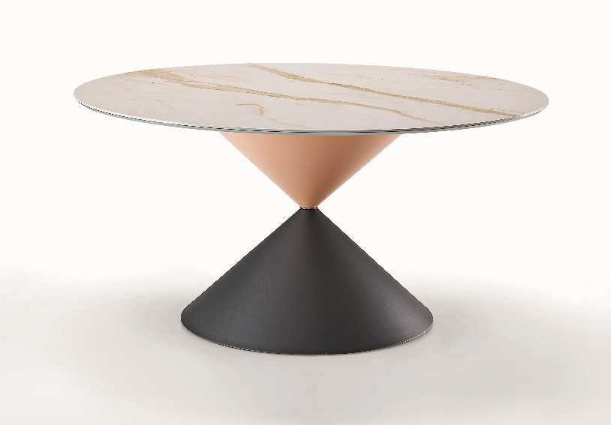

Solid, curious and particular, ClessidraTable by Midj applies to the round shape the idea of the passing of time ("clessidra" is the Italian name for hourglass). With a diameter of 150 cm (59’’), it consists of two conical elements that intersect each other with a thin metal ring, recalling a real hourglass. Customization is possible: the table is available entirely in wood or in a two-tone version, with ceramic-glass top and a wooden or metal base.
The variety of 15 matte and 3 glossy colors also distinguishes the small metal ring, junction point and heart of the entire structure.

www.midj.com

***
Since 1987 Midj has cleverly combined design and the art of modeling the raw material with the creation of custom-made furniture and accessories, to emphasize modernity and elegance in every environment.
From chairs to coat hangers, from tables to armchairs, each product features a concentrate of Made in Italy mastery, which is characterized by a soft and refined design. Thus colorful and versatile ideas come to life, which easily adapt to public and private spaces, guaranteeing a delicate but at the same time hi-tech character.
From the development of the design of the model to the industrial print run, every phase of production is scrupulously followed by master craftsmen of iron, wood, leather and plastics, to combine craftsmanship, creativity and technology into furnishing elements aimed at the highest quality and resistance over time.
To support the philosophy of the Friulian brand, the Integrated Management System certified according to ISO 9001: 2015 and the ISO 14001: 2015 certification, for compliance with environmental regulations, reduction of consumption and pollution. The Code of Ethics is so important: promoting virtuous behavior and processes aimed at combining the correct conduct of the company with the expectations and interests of individual employees.

