

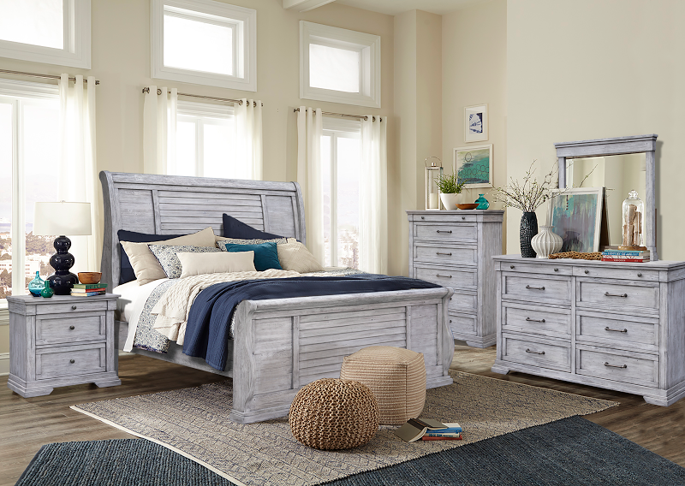

The Cottage Lake Collection is both singular and rustic. At first sight, one sees the flair of the angled slats on the sleigh-styled bed, which impart the biggest personality. Additional and attractive details include the linear handles, which add a clever, neat look with a hint of freshness. And both the tops and bottoms of most pieces feature smart-looking fluted layers that deliver a solid, grounded look to the whole outfit. All drawers are soft closing. As well, the drawers along the top are slenderer, adding quick accessibility to smaller items used most often.

High Point Showroom: Warehouse:
The Profit Center 3415 Hwy 53
156 S Main St. Huntsville, AL 35806
Show Phone Number: Office Phone Number:
561-339-1268 256-852-9777

