

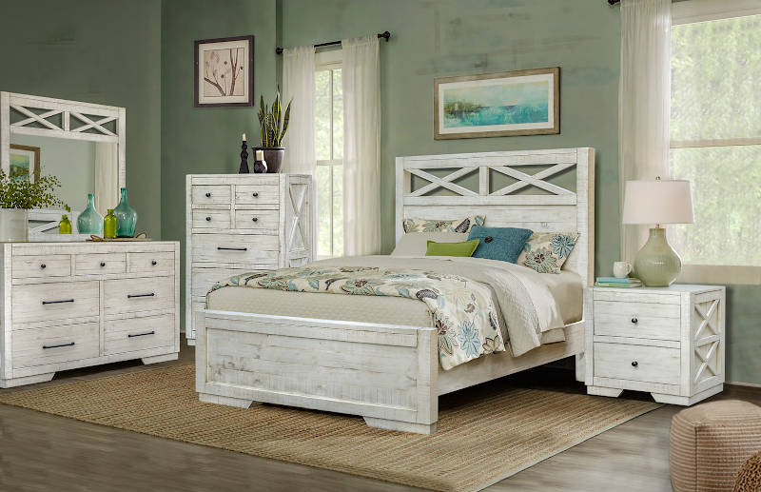

The Crescent Collection, with all the usual case goods, is made with solid timber, and features soft closing drawers. Presenting a slightly distressed hand done finish, this group is a perfect addition to your master suite or guest room. Its appearance and construction impart a warm, cozy, feeling that works well on the coast or in the farmhouse. The separated, smaller drawers in the top row of the dresser and chest allow better organization of oft-used items so they’re quicker and easier to find.

High Point Showroom: Warehouse:
The Profit Center 3415 Hwy 53
156 S Main St. Huntsville, AL 35806
Show Phone Number: Office Phone Number:
561-339-1268 256-852-9777

