

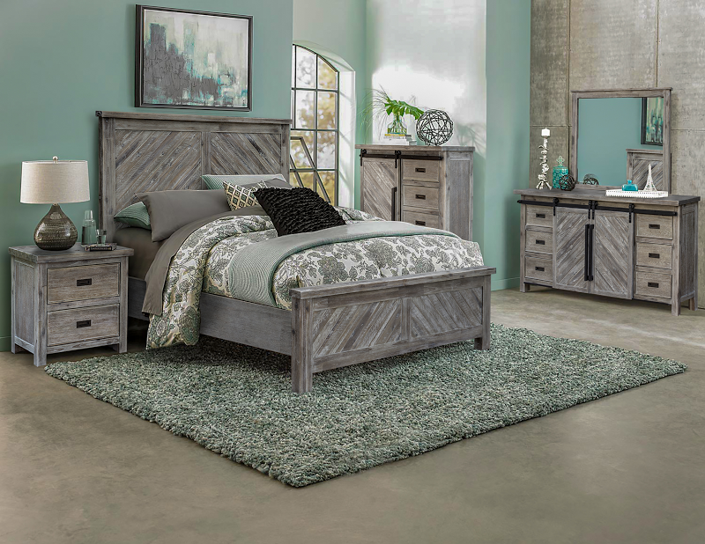

The Saddle Bunch Collection has pastoral and sophisticated elements that allow for casual or formal accents. The angled planks and the dresser/armoire combination piece, for instance, add a modern flair, while the supporting, peripheral construction is solid and unassuming. With a lightly distressed, frosted, and bluish-grey finish, this warm, inviting ensemble will fill any room in the home with a fashionably rustic vivacity.

High Point Showroom: Warehouse:
The Profit Center 3415 Hwy 53
156 S Main St. Huntsville, AL 35806
Show Phone Number: Office Phone Number:
561-339-1268 256-852-9777

